Reports in GRIN-Global

Revision Date
February 9, 2024

Author
Martin Reisinger

Document Overview
When speaking or reports and Grin-Global, people frequently use the word “reports” in different ways. This document documents GG Public Website reports and SQL queries.
Click on the report type to jump to the respective documentation:
- Curator Tool reports (link to the online guide)
- Public Website reports
- SQL queries

Comments/Suggestions
Please contact Martin Reisinger at either marty.reisinger@ars.usda.gov or mar@rrginc.com with any suggestions or questions related to this document. The Appendix contains revision notes pertaining to this document.

Table of Contents

Public Website Reports 3
Public Website Reports Menu Option 3
SQL Queries (“Reports”) 5
Overview: SQL and the Public Website 5
Appendix A: Document Revision Notes 6

Public Website Reports

Public Website Reports Menu Option
The Public Website (PW) Reports menu option displays a dropdown of reports. What is listed in the dropdown depends on the user account. Genebank staff users who are logged in and who have had their CT account connected to their PW account will have access to “internal” reports. Typically, only a genebank’s staff will have access to these internal reports.
Public Reports (visible to everyone)
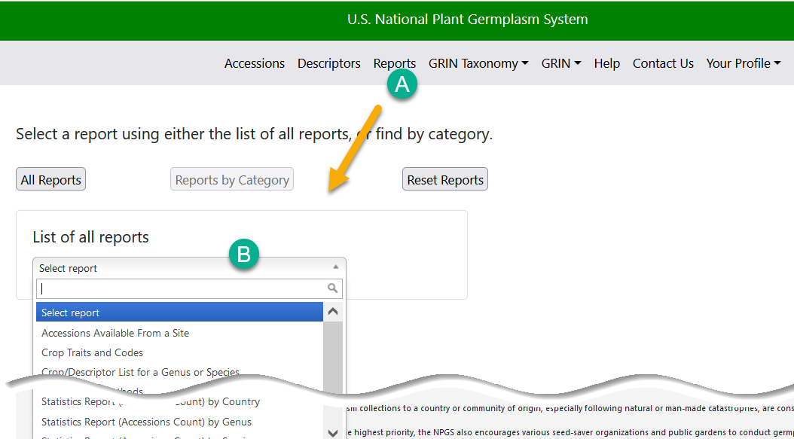

Internal Reports
Note that the Reports by Category button is activated. This will happen only when (a) you are logged in and (b) your account has been enabled by the GG database administrator for these internal reports.
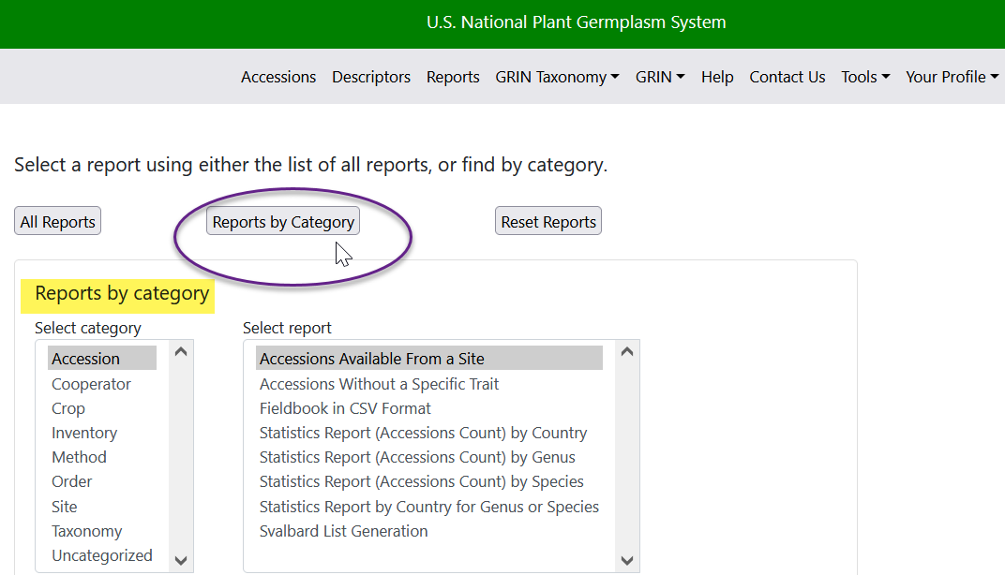
[This note is for GG administrators.] In the Admin Tool, the dataviews for Web Reports have a “Configuration Options” parameter on the Properties tab. The text “external” indicates that this is a report that will be listed for all PW users. If “external” isn’t specified, the report may be listed for users who are considered “internal.” In order to see these internal reports, the user must be logged in with a Public Website account that has been associated to his CT user account (via the Web Login tab on the user’s cooperator Information window).
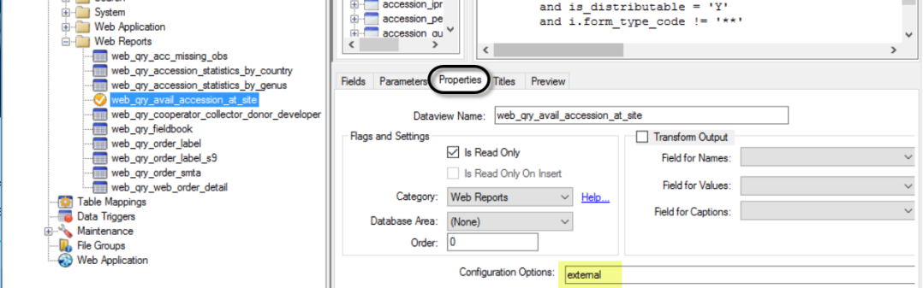

SQL Queries (“Reports”)
This feature is only available to internal users, that is, users who have had their Curator Tool account connected with their Public Website account. Only the GG DBA can connect these accounts, via the Admin Tool.
When a user has access to the Web Query feature on the Public Website, the user may submit SQL queries that do not update data.
It is recommended that organizations consider creating a library of these SQL queries for users to share. The U.S. NPGS has an introductory guide to writing SQL and a sample library online at https://www.grin-global.org/sql_examples.htm

Overview: SQL and the Public Website
Genebank staff who have had their Public Website account connected to their Curator Tool account, when logged into the Public Website, will have the Tools option visible on the menu. From there, select Web Query to display the box for inputting SQL:
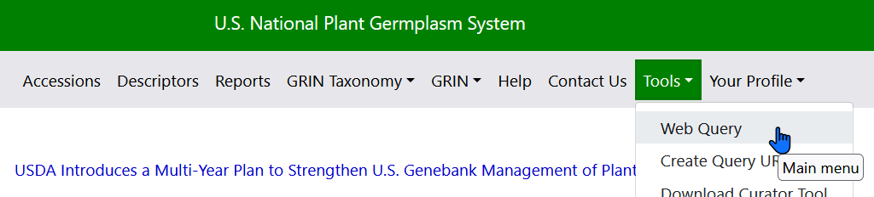
(for GG administrators) The organization’s GRIN-Global administrator is the only person with the authority to connect the two accounts (via the GG Admin Tool). Generally, users do not see the Tools menu option, but an organization’s GG administrator can enable specific internal users to have access to Tools, which includes the SQL query feature. (The administrator adds the user to the Web Query Users group.)
Log in; select Tools | Web Query You can copy or type valid SQL in the box as shown:
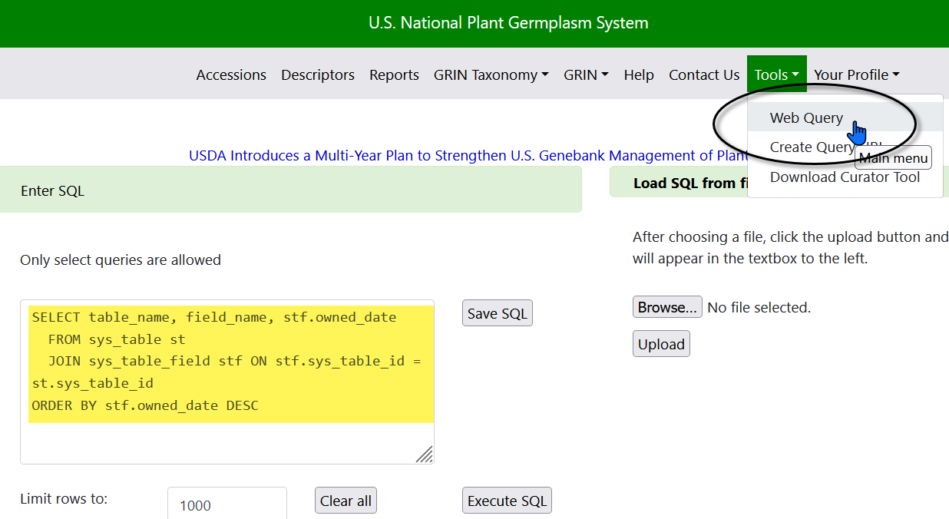

Appendix A: Document Revision Notes

– February 9, 2024
- removed CT reports to avoid redundancy with the CT Report guide

– June 15, 2023
- Major rewrite with many new images to reflect the changes implemented in v1.23.1.26

– April 28, 2023
- Included new information on file locations impacted by changes implemented in v1.23.1.26
- Included directions on using the CT’s new Reports Manager

– November 29, 2021
- updated PW images and minor text revision regarding internal reports

– May 18, 2021
- updated link to the Reports Installation Guide text and illustrations

– October 26, 2020
- added notes regarding the new Create Local Reports Table feature added in 1.9.9.8Elaborated section on report mapping with additional text and illustrations

– June 4, 2019
- Elaborated section on report mapping with additional text and illustrations

