Seasonal Availability

Revision Date
July 14, 2022

Beginning with the GG Server Release 2.3, it became possible to manage the time of year when NPGS material is displayed as available for requesting. This seasonal availability concept is particularly applicable to temperate clonal collections where dormant vegetative material is the form most frequently distributed.
This document includes the changes pertinent to this new capability. The main Inventory Guide [http://grin-global.org/docs/gg_inventory.pdf] contains details on inventory records. The two documents are complementary.

Please send any questions related to the wizard to marty.reisinger@usda.gov or feedback@ars-grin.gov.

The Appendix contains change notes pertaining to this document.

Author
Martin Reisinger

TOC

Background 3
The Basics 4
New Inventory Maint Policy Season (IMPS) Dataview 5
New IMPS dataview fields explained 5
Seasonal Inventory Examples 7
Not in season 7
In season 7
Appendix: Change Notes 8

Background
By their nature, clonal crop sites typically distribute cuttings when fulfilling germplasm requests. In most cases, cuttings can only be distributed within specific time frames, depending on the taxa, the growing conditions, and whether the cuttings are dormant or softwood.
GRIN-Global was enhanced to include a new procedure to enable the “seasonal availability” of germplasm for specific inventory. Seed germplasm would be unaffected by this code change.
Previously, in the GRIN-Global environment, inventory records had seasonal start and end date fields, but no logic existed to work with those dates. Data in these fields in any inventory records served as a note and had no impact with the distribution requests or the GG Public Website.
New programming logic and a table were developed to implement a process so that each inventory record could have its own availability date range. For example, cuttings may be distributed only two months a year, but leaf tissue for the same accession can be delivered over a different time range.
Also, a new dataview was developed: “Get Inventory Maint Policy Season.” Using the new table (in the Curator Tool via the new dataview), it is now possible to indicate the starting and end dates for any inventory form.
Note that you can have only one seasonal policy per form.
As previously, general availability is on/off, depending on two flag fields – Is Available? and Is Auto Deducted? – both must be Y and then the germplasm form is typically listed as “Available.” Prior to implementing this new seasonal enhancement, the curator would be required to manually edit the respective inventory records and switch their flags to make the accessions available or conversely, “Not Available.” With the new seasonal availability feature, the two original flag fields must still be set to “Y,” but now the PW also evaluates the form and then evaluates the starting and ending dates when that inventory has a corresponding Inventory Maint Policy Season record.
Another drawback with the original scenario was that GG public website viewers and requestors might conclude that an active accession is no longer managed in the system because for a substantial part of the year the accession would be listed as unavailable when actually the accession was live and well; it simply could not be distributed at certain times. Although sites typically use note fields to indicate when cuttings are available, that note is text, does not control the flags or the public website, and may not even be noticed by the requestor.

The Basics

Create an imps Seasonal Dates
To establish seasonal dates, a “season” record must be created using the Inventory Maint Policy Season (IMPS) dataview. In turn, this season record requires an existing Inventory Maintenance Policy (IMP) record. To work properly, three records must be related:
- Inventory
- Inventory Maintenance Policy
- Inventory Maint Policy Season
Two field items in the three records relate:
- The Inventory record’s Inventory Maintenance Policy ties the inventory to the IMPS.
- The Inventory record’s Standard Distribution Form – must match the IMPS Distribution Form.
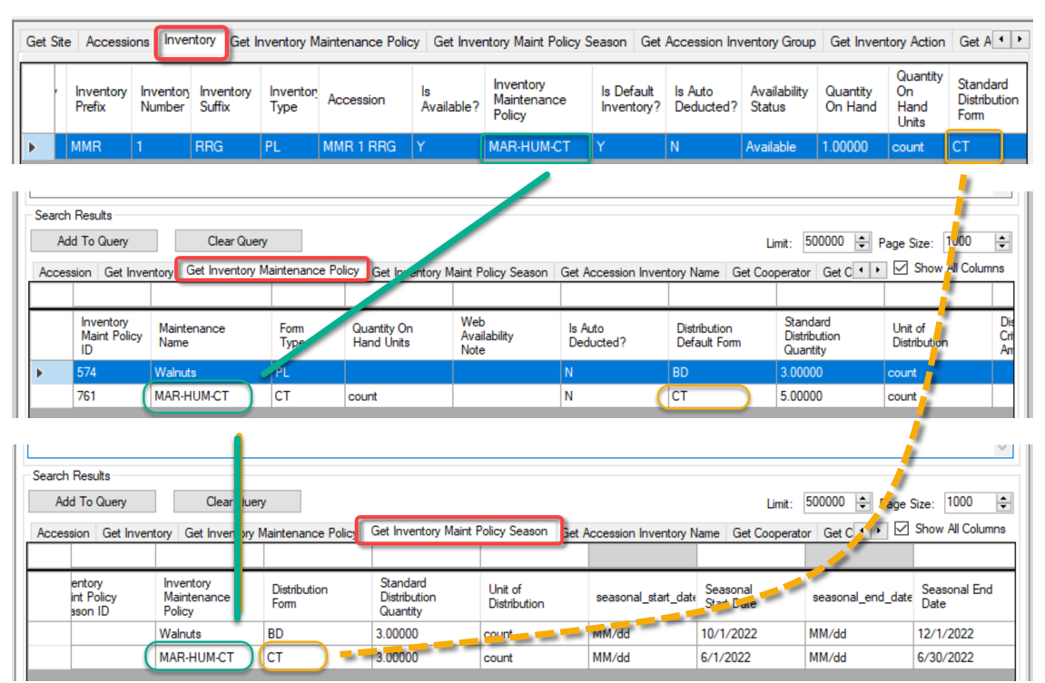

New Inventory Maint Policy Season (IMPS) Dataview
To open the Get Inventory Maint Policy Season dataview, select Inventory in Area.
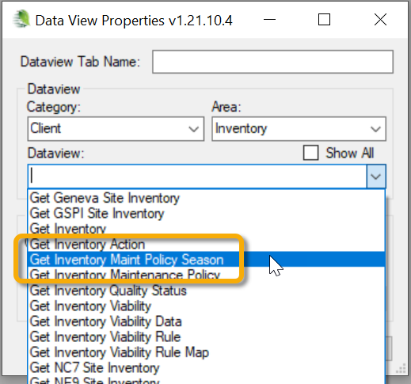

New IMPS dataview fields explained
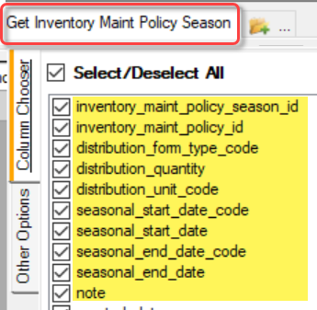

Required Fields
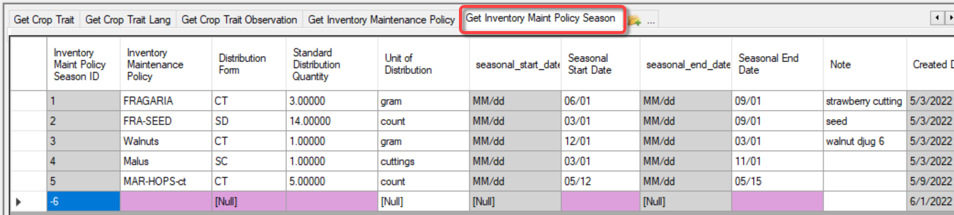
- Inventory Maintenance Policy
- Distribution Form
- Standard Distribution Quantity
- Seasonal Start Date
- Seasonal End Date
Date and Date Format fields – when you enter a full date including the year, only the month and day is used. This is intentional, so that a curator will not need to manually change the dates every year, with the assumption that the same seasonal timeframes are consistent year after year. If necessary, the dates can be changed by the record owner or someone with the proper Update permission.
The Note field is an internal note and does not display on the website.

The IMPS Standard Distribution Quantity overrides the Inventory record’s Standard Distribution Quantity.
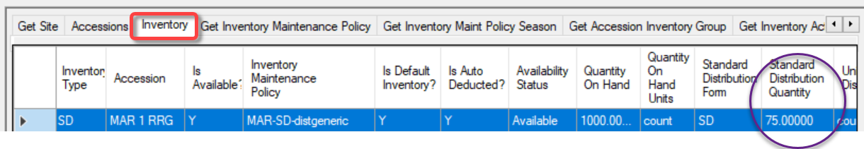 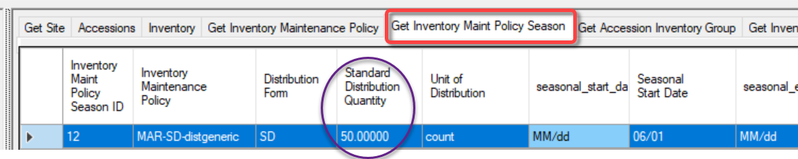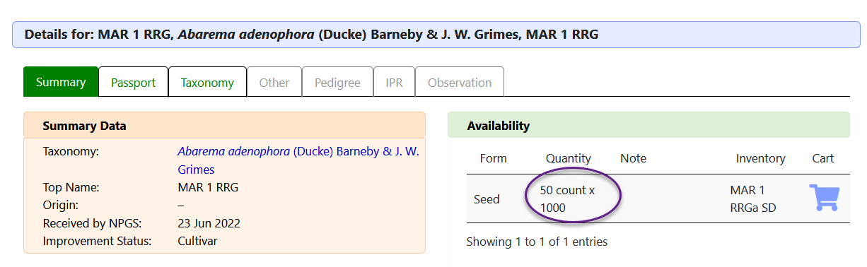

Seasonal Inventory Examples

Not in season
IMPS was set for the date range June 1 thru June 15; request date was June29.
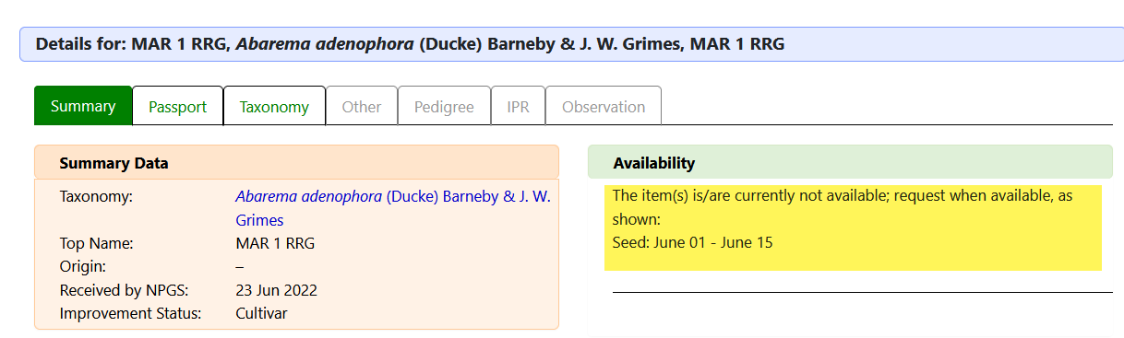

In season
IMPS was set for the date range June 1 thru June 30; request date was June29.
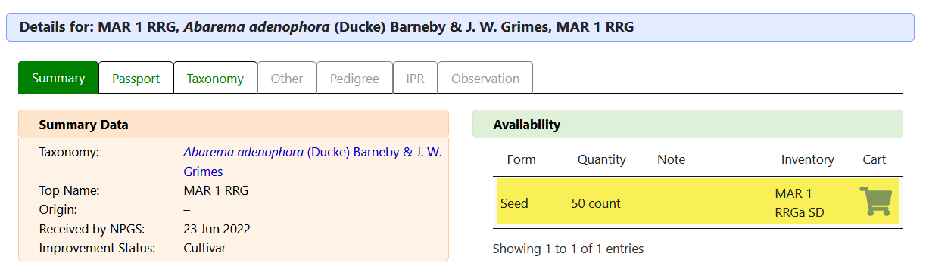
The Note field in the PW’s Availability table displays the text stored in the inventory record’s Web Availability Note field.
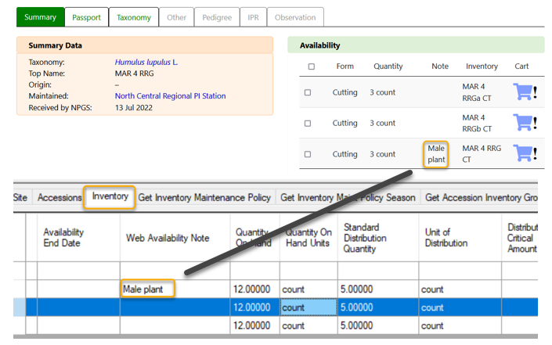

Appendix: Change Notes

- June 30, 2022
Initial document
- July 14, 2022
added note re Note in table

