Grouping Accessions and Inventory

Revision Date
October 25, 2023

Appendix A contains this document’s revision notes.

This guide explains five methods which are useful for grouping accessions (and inventory) in GRIN-Global. Click on any link to jump to the respective section. However, consider first reading the table on page two.

- Name Group
- Accession Inventory Group
- Inventory Maintenance Policy
- Method
- Core (a Descriptor Group)

In GG, two “GROUPs” are similar, but each was originally designed for a different purpose and they work very differently. The word “GROUP” is often used interchangeably and can confuse the usage.
The two groups I am referring to are get_accession_inventory_group “Accession Inventory Group” and
get_name_group “Name Group.” The following table compares them:
 | Accession Inventory Group | Name Group
Database Area | Accession / Inventory | Accession
Dataview Name | get_accession_inventory_group | get_name_group
Dataview Title | Get Accession Inventory Group | Get Name Group
Group is available for Web Searches | Yes  (when the flag is set to “visible”)  using the PW Advanced Search: “accession group name” PW  “Accession Group” PW2 | No  but searchable within the ST/CT
Create the group name… | use the get_accession_inventory_group dataview;  add records  (…indicate if Web Visible or not) | use the  name_group dataview; add records
Associate records… | map Inventory records to a group using the accession_inv_group_map table | using Accession_Inv_Name records, complete the Name Group field
Recommended Uses: | - Establish accession groups which can be found (and ordered) on the PW as a group.  - Others? Use for printing labels, etc. | - A method for organizing accessions for internal purposes  - Name Group groups plant names. An Accession Inventory Name can belong to just one group; the group usually refers to the source of the name or identifier

Name Groups

Create
Use the Name Group dataview from the Accession area to create or edit group names:
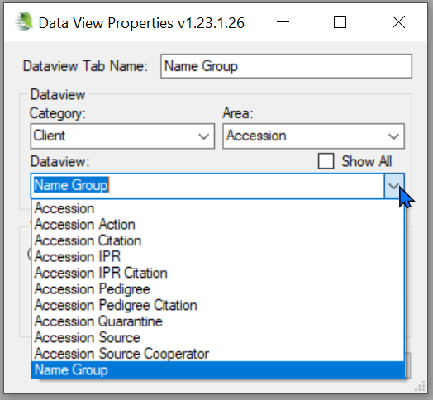
Only the Group Name field is required. The other two fields document the name:
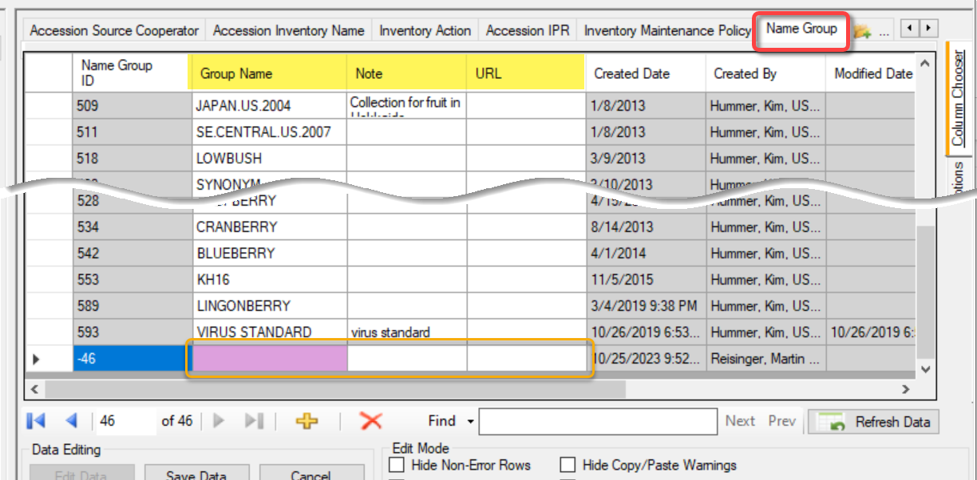

Apply the Group Name to Records
When naming an inventory record, supply a Name Group:

via the Accession Wizard (Names tab):
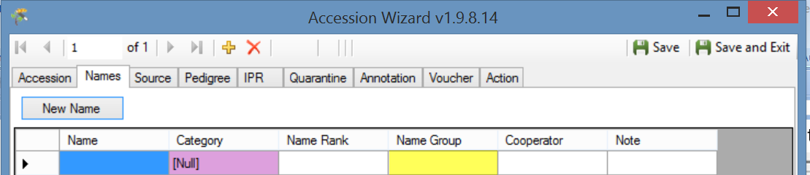

or the Accession Inventory Name Dataview:
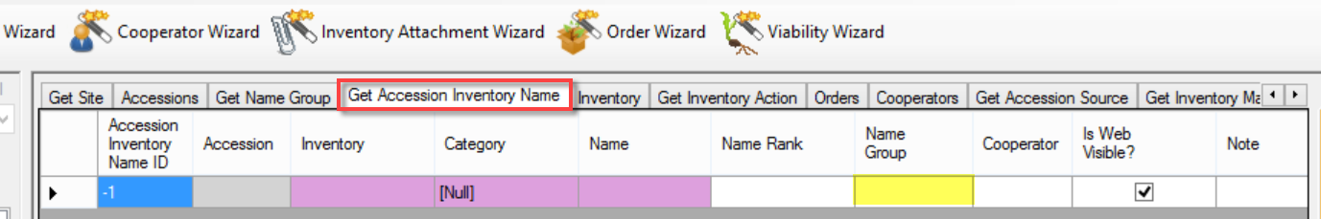

Searching by Name Groups
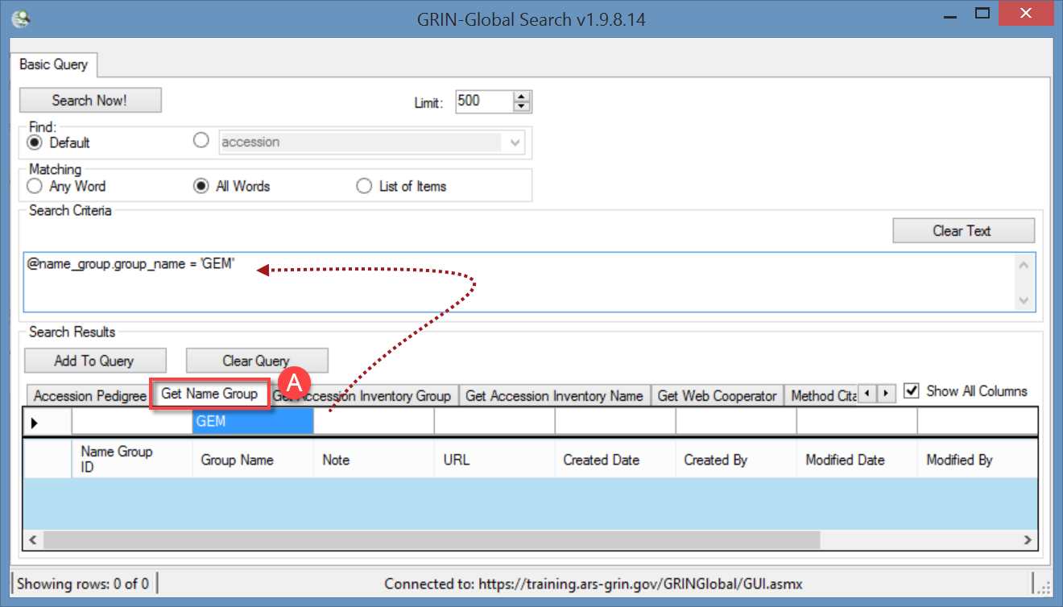
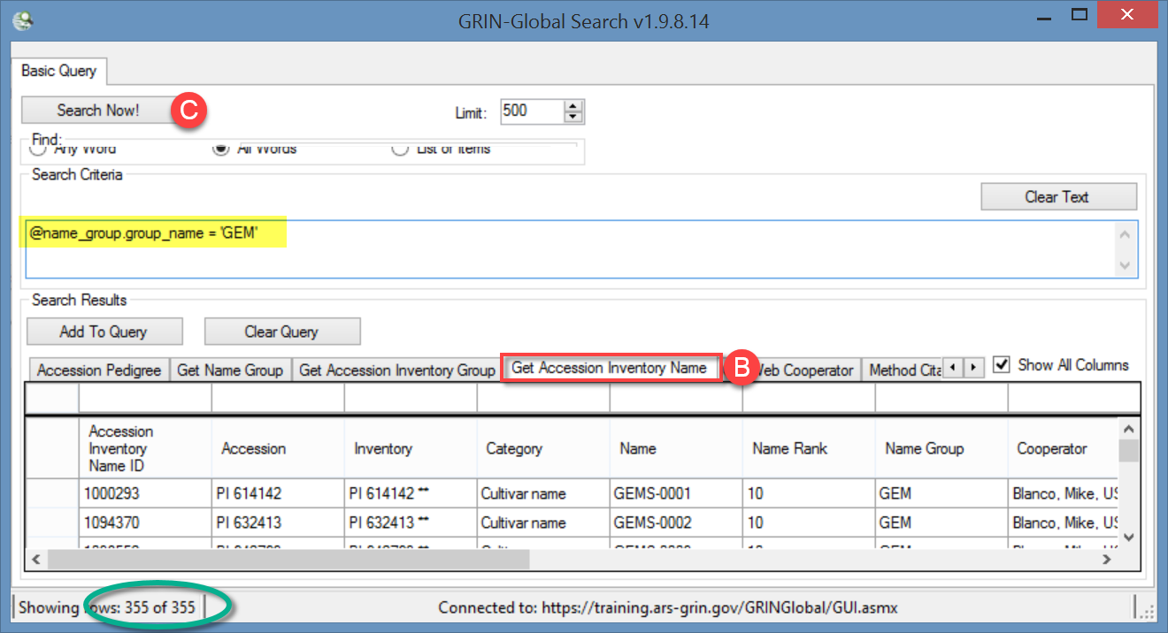
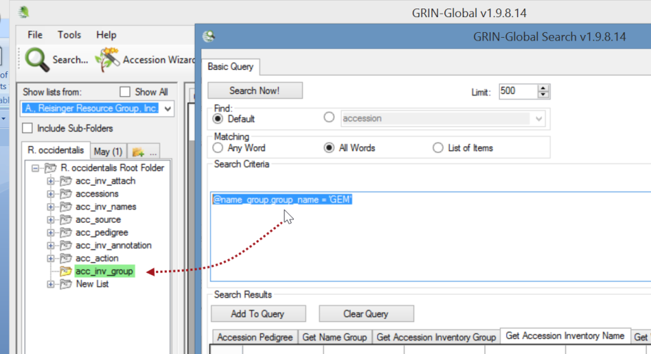
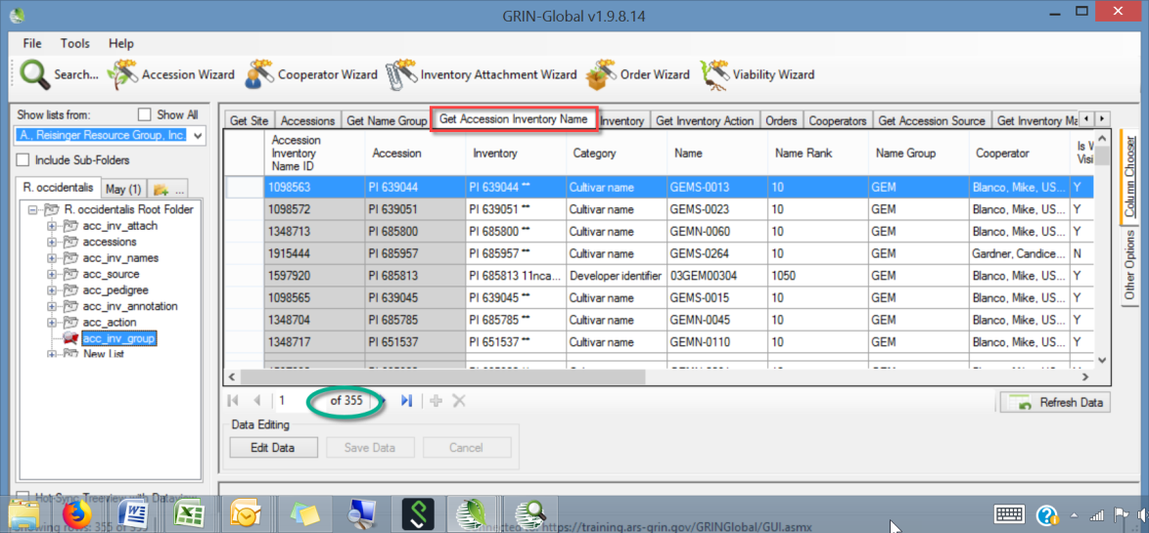

Another Group Name Example to find “like” Accessions
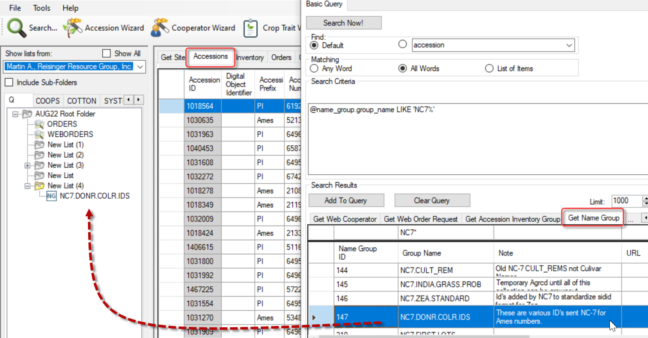

Accession Inventory Groups
Accession Inventory Groups are available for searching via the Public Website by selecting an accession group name (the Accession Inventory Group name).
PW:
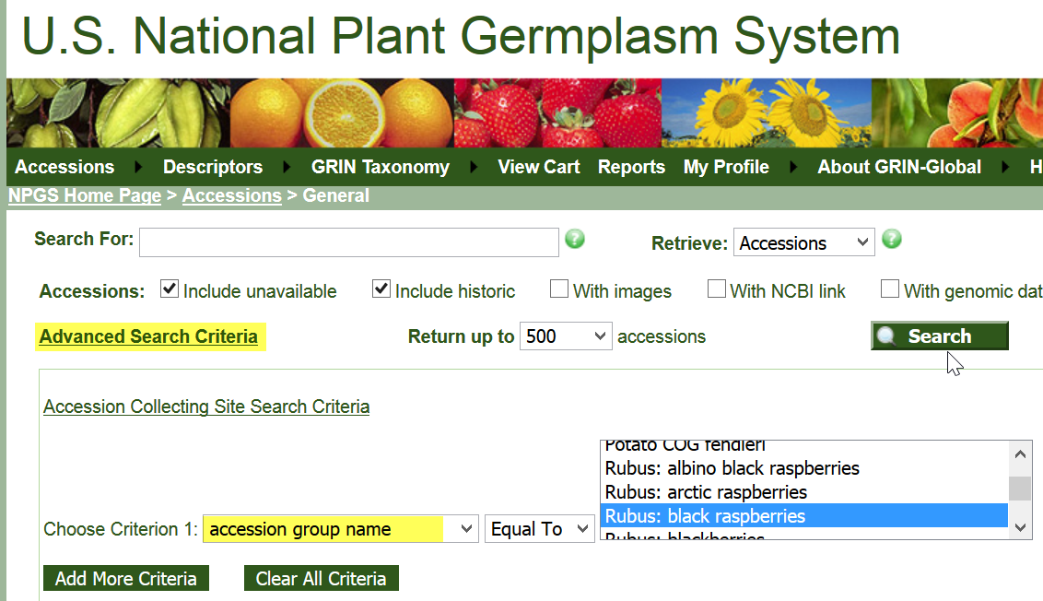
PW2:
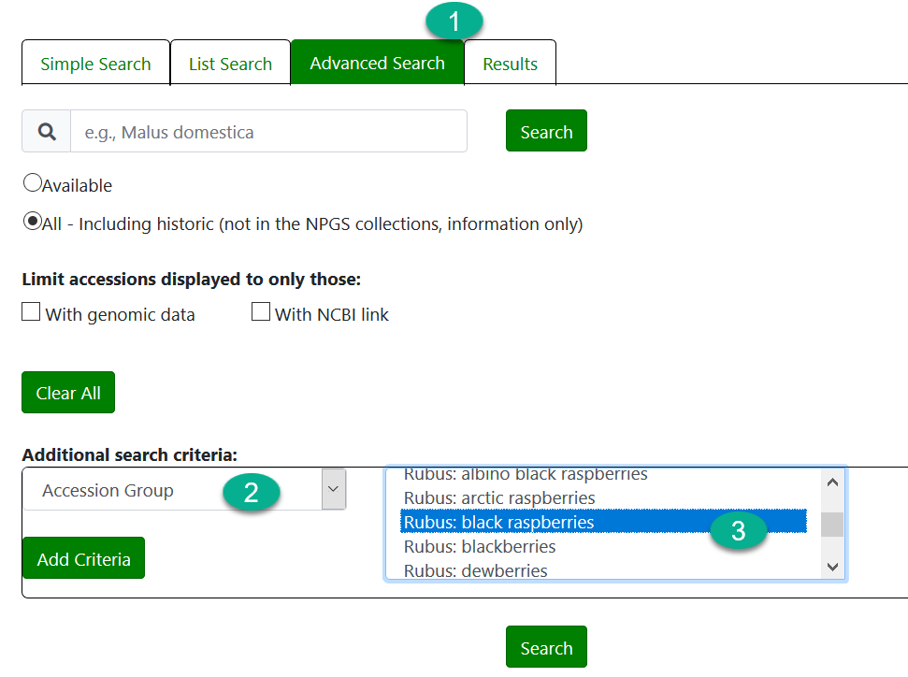

Create the Accession Inventory Group Name
Use the get_accession_inventory_group dataview (from the Accession / Inventory area); add records (supply a Group Name; select Is Web Visible? when desired):
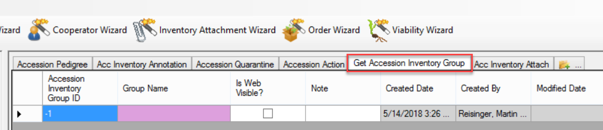

Associate Inventory (or Accessions) to an Accession Inventory Group
Use the Accession Inventory Group Map dataview; add records:
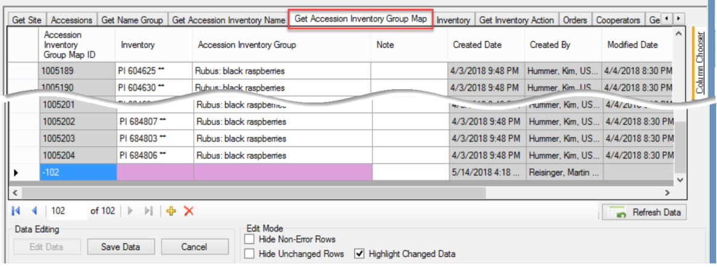
Inventory records can be in more than one group.

Accession Inventory Group Attach Dataview
In server release 1.10.3, the Accession Inventory Group Attach dataview was added to allow documents to be attached to a group of accession/inventory records. (Note: in the CT, the Attachment Wizard has not been programmed for this functionality as of December, 2018. It is possible for the DBA to upload the files and then indicate the virtual path.)
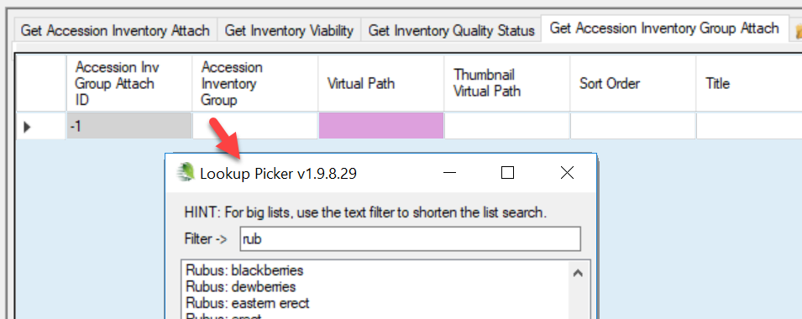

Inventory Maintenance Policy
Inventory Maintenance Policies are explained in detail in the online Inventory guide at https://www.grin-global.org/docs/gg_inventory.docx
In the Curator Tool, use an Inventory Maintenance Policy or Method to filter records. Several different approaches can be used.

Drag Maintenance Names to a CT Folder
In the Search Tool, find the desired policy name(s) in the Inventory Maintenance Policy dataview, and then drag the records to a folder in the Curator Tool:
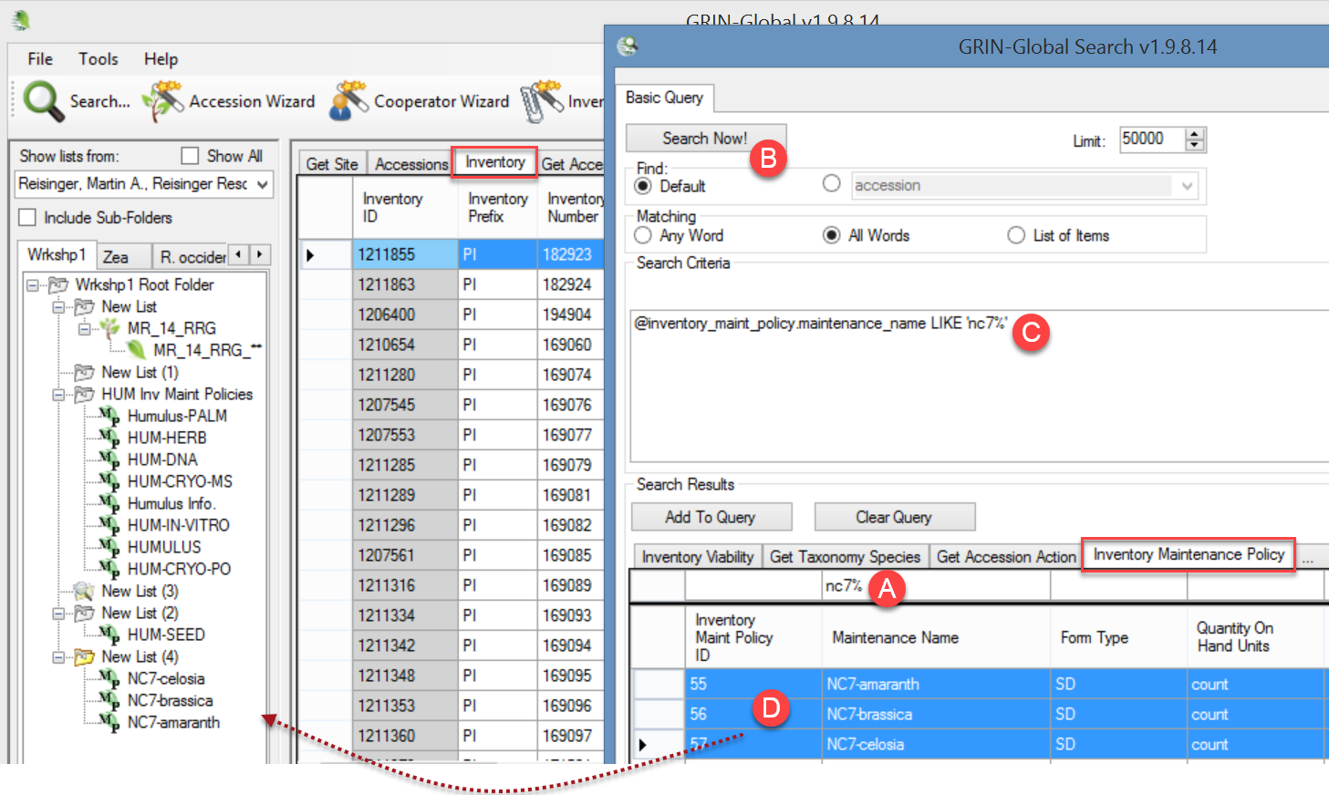The List Panel displays the objects for the maintenance names, and in the Curator Tool’s datagrid you can switch between dataviews, such as inventory or accessions, to see related records. For example, in this case, the list of inventory records shown in the background all were created with one of the three maintenance names listed under New List (4). (Use a more meaningful list name than this!)

Drag the Code to Build a Dynamic Folder
You can create a dynamic folder, that uses code based on an Inventory Maintenance Policy name. An advantage of this method is that you can easily edit the properties and replace the policy name as desired. (2nd screen below)
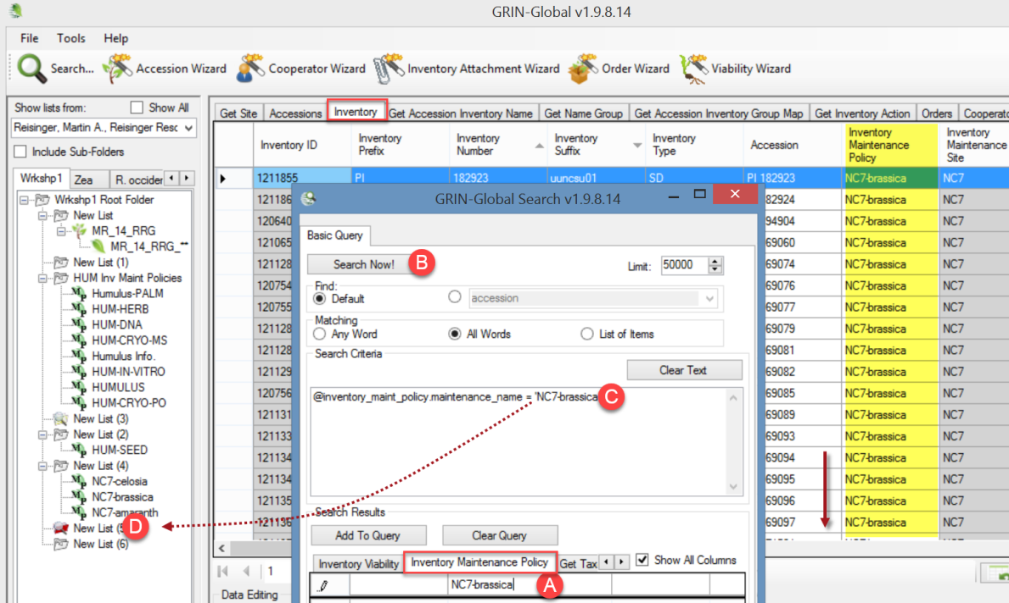
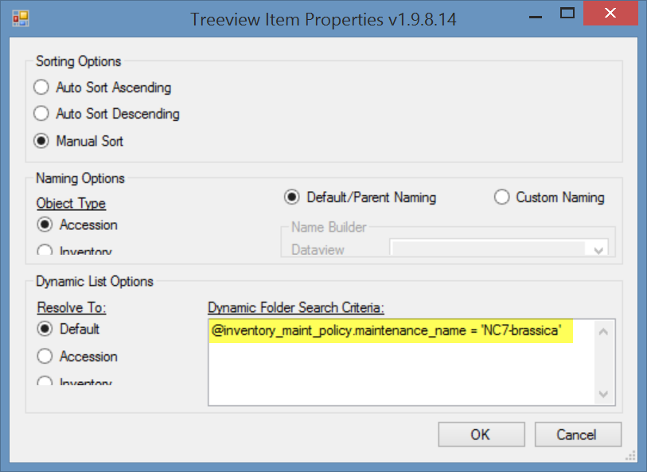

Method
The Method dataview accesses the table of methods and procedures. One example of methods is those used in determining the crop specific attributes of the germplasm. Each environment used in an evaluation should have its own method record.
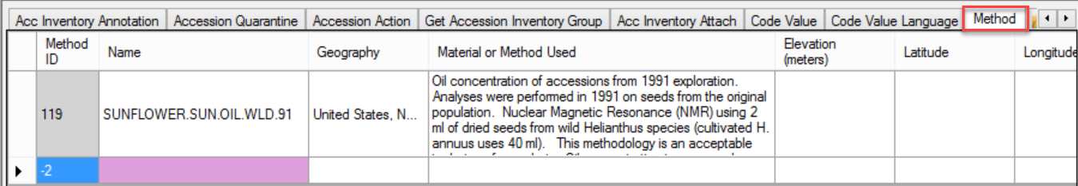
A Method item in a CT list is an excellent way to filter records:
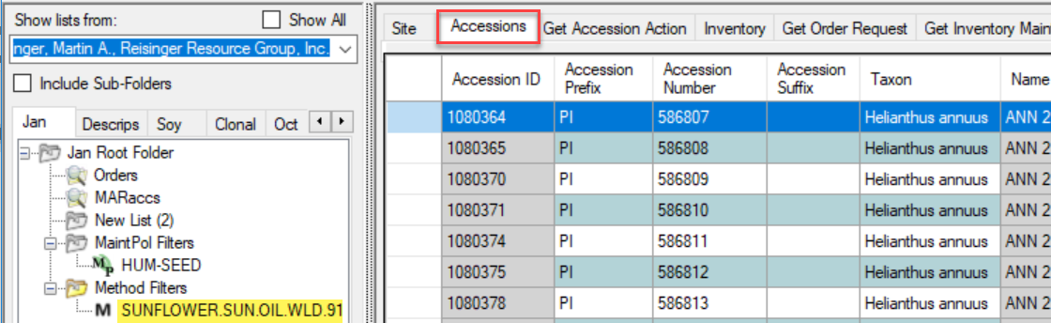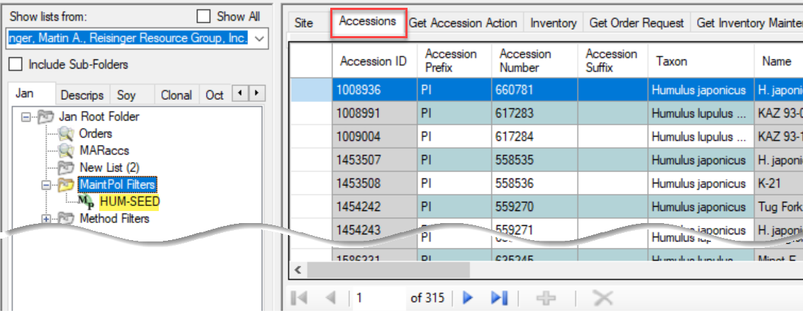.
Public Website users can also search accessions by Method. To do so, the user must select a Crop. The Crop page has a Methods link:
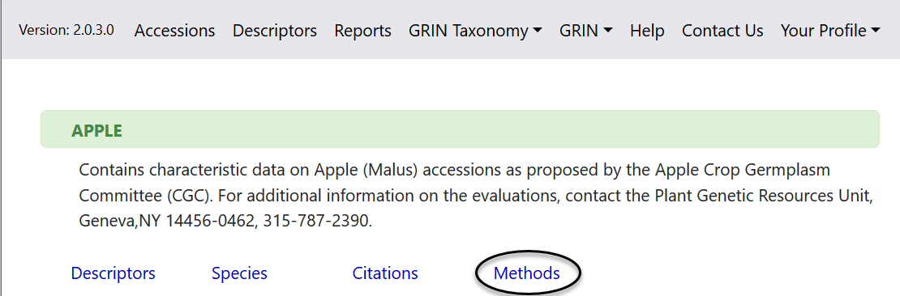

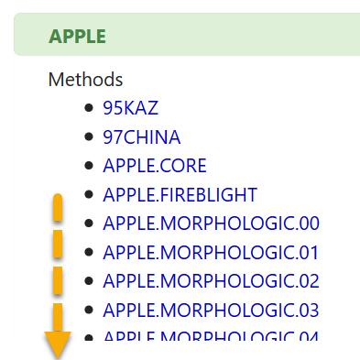

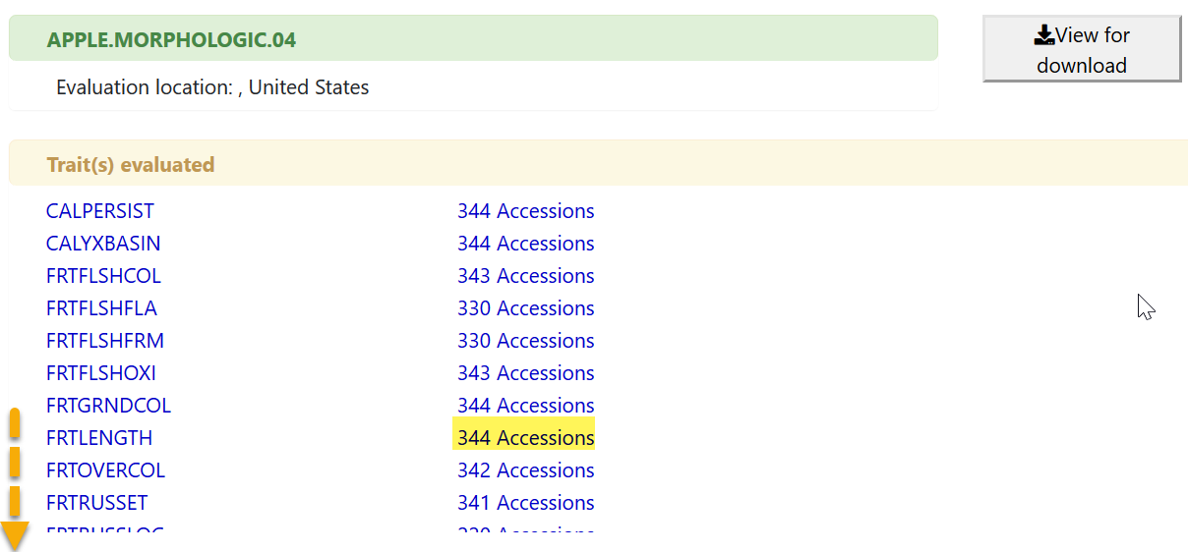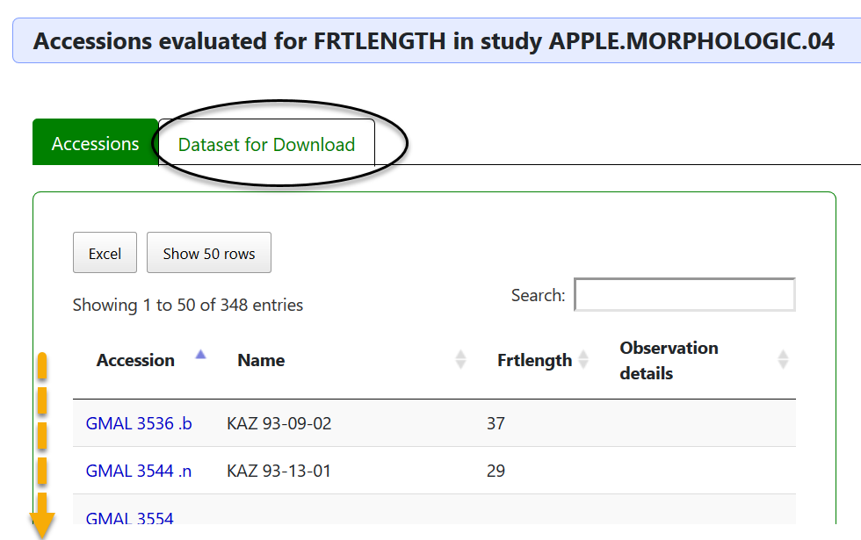

Core Descriptor Group
Besides the grouping methods described above, GRIN-Global has a capability for grouping accessions by using Descriptors (“Crop Traits”). A curator can decide which accessions would be a representative group of accessions and add them to a CORE group. Under descriptors, a researcher can select that group and get a list of pre-defined group of accessions.

Shown below is the Crop APPLE in the NPGS system A CORE Descriptor had been defined.
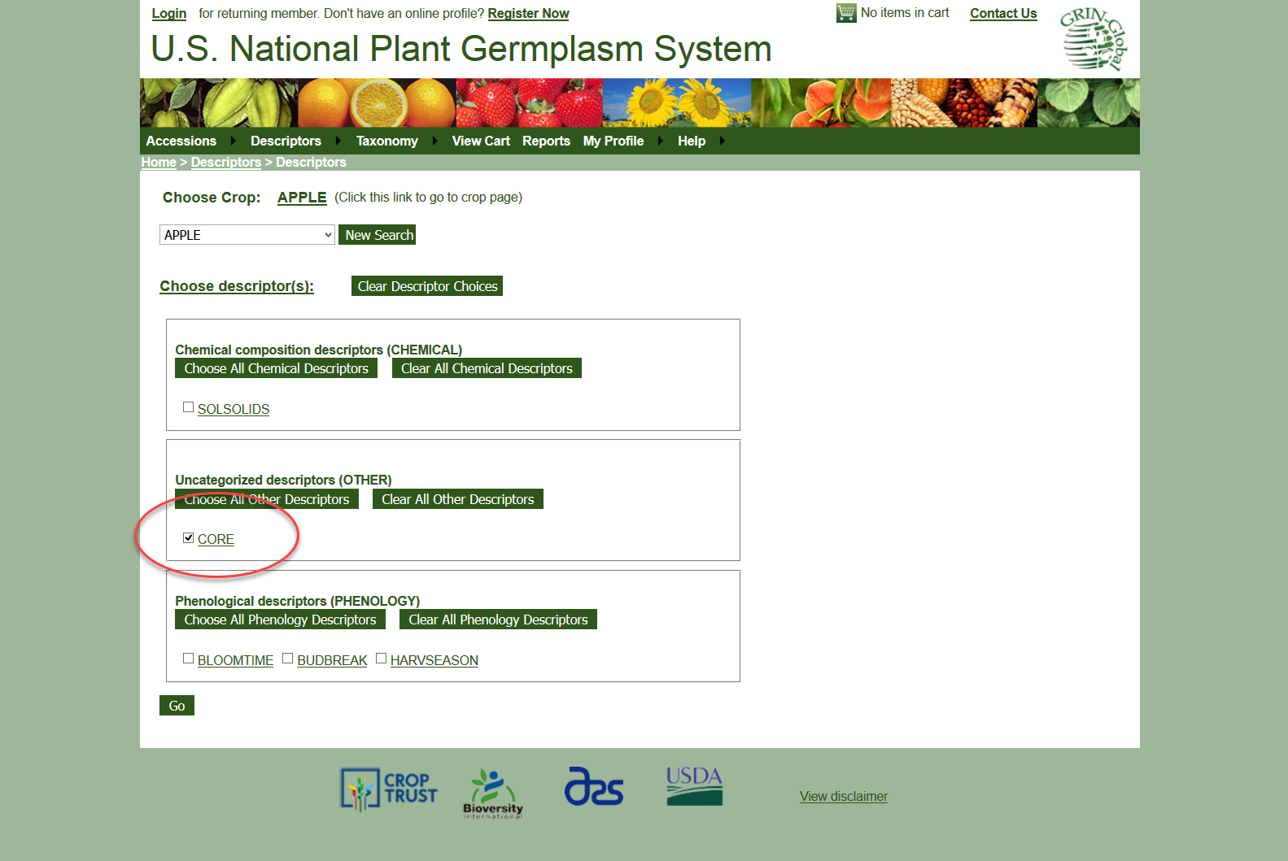

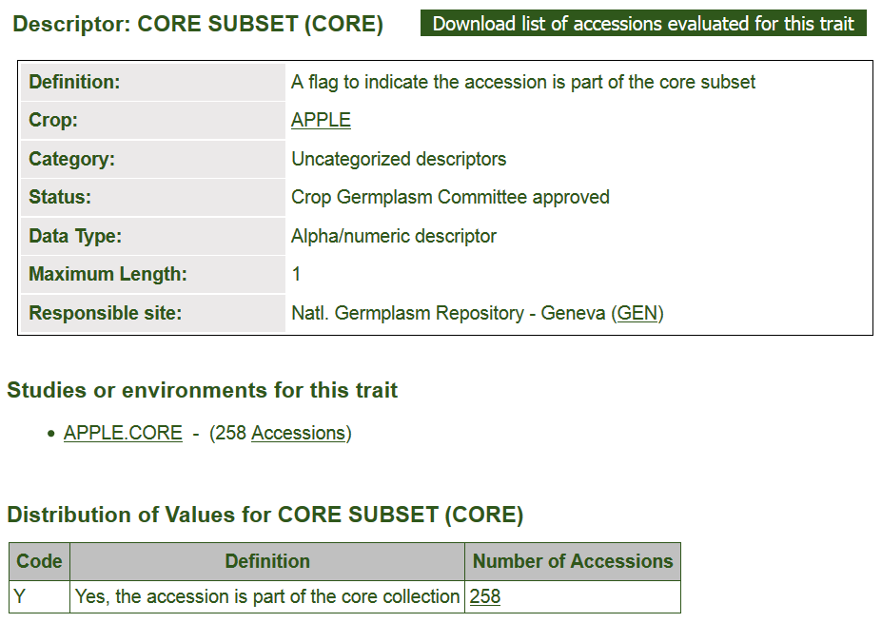
The recommended way to set up a core group is to create a coded trait for the crop.
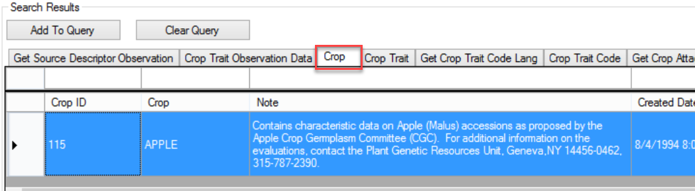
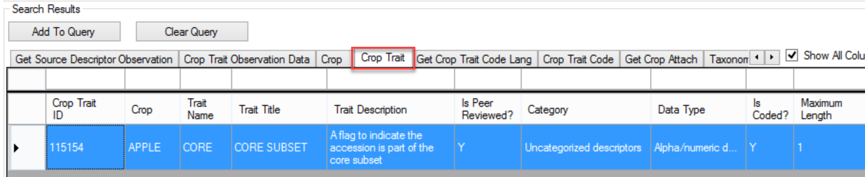
Only one code record is needed:
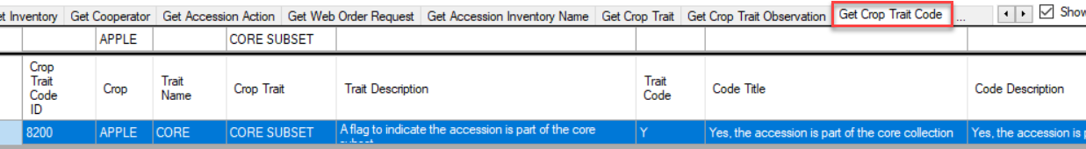

To have an accession included in a core group, the curator creates an observation record. In the Crop Trait Observation dataview, the curator selects an inventory, the crop, the trait, in this example “CORE SUBSET,” and selects the Coded Value field from a lookup picker. (Not shown – a Method must also be selected.)
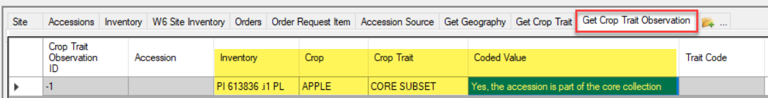
When saved, the new record displays, including the “Y” in the Trait Code field:
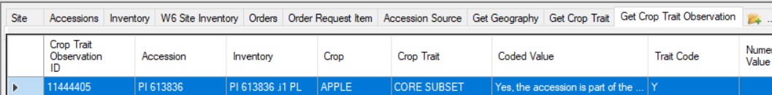
The result in the Public Website was shown on the previous page.
You can also use TRAITS with a specific value to act as a filter in the Curator Tool:
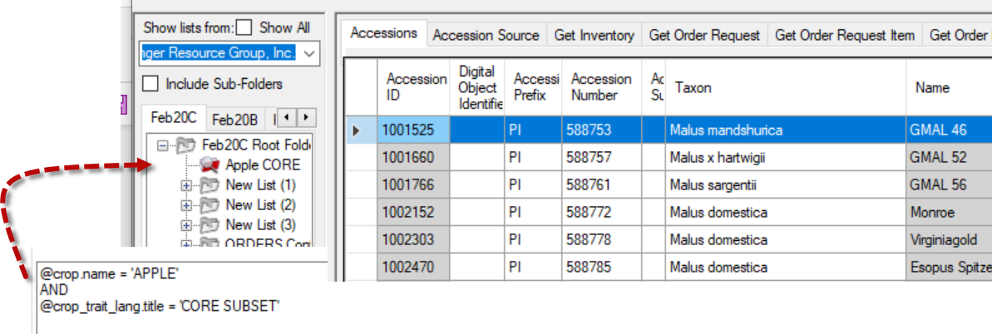

In the legacy GRIN system, a trigger was set up to create “CORE” observation records whenever the Accession field Is Core? was selected. That is not the case in GRIN-Global, selecting Is Core? on the Accession record does not generate a CORE observation record for the accession.
The CORE trait must be manually set up; then the curator must create observation records for the accessions that are to be considered “CORE.”
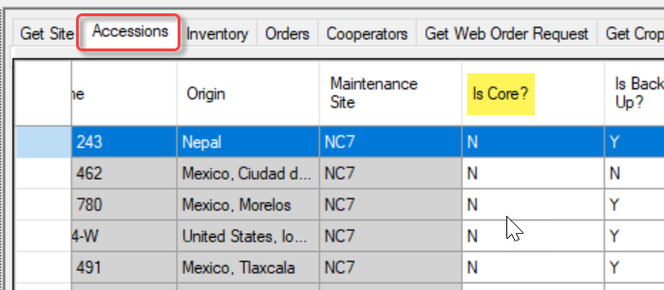
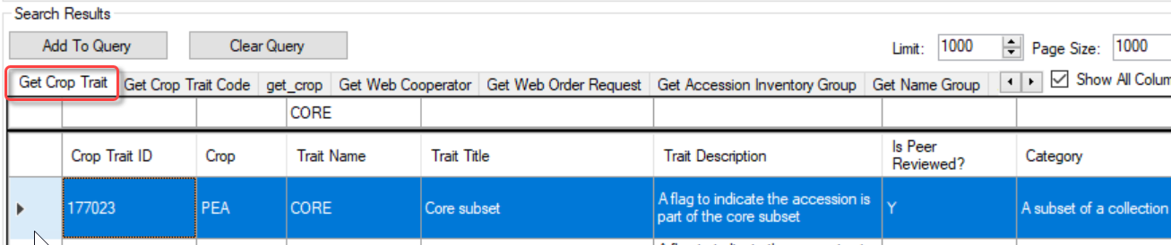

Appendix A: Document Revision Notes

– October 25, 2023
- examples of the Name Group dataview were modified/added, as this dataview name has changed intro table on page 2

– August 27, 2020
- modified intro table on page 2
- added text for Method searching in the Public Website
- added screens from PW2
- added note re Is Core? not tied to CORE descriptors

– March 3, 2020
- edited text in comparison table of Accession Inventory Group and Name Group

– October 6, 2019
- edited text on using Method as a filter

– December 1, 2018
- edited text and replaced images in the Core Subset section

