Geography in GRIN-Global

Revision Date
June 7, 2019

This guide provides details on Geography, as used in GRIN-Global. The Appendix contains change notes pertaining to this document.

Author
Martin Reisinger

Comments/Suggestions:
Please contact mar@rrginc.com or feedback@ars-grin.gov with any suggestions or questions related to this document. This and other GRIN-Global–related documentation can be downloaded from the GRIN-Global documentation site – see https://www.grin-global.org/userdocs.htm.

Table of Contents

Geography Overview 3
Where does the geography information appear? 4
Geography Dataviews Overview 5
Geography Dataviews 5
Geography Lookups 8
Geography Codes 9
GEOGRAPHY_ADMIN1_TYPE and GEOGRAPHY_ADMIN2_TYPE 9
GEOGRAPHY_COUNTRY_CODE 10
Public Website SQL Query to Display Country Codes 11
Appendix: Document Change Notes 12

Geography Overview
Many tables are dependent on the Geography Table including accession_source, cooperator, and method, taxonomy, among others.
The following screen is taken from the GG Admin Tool. It shows the tables dependent on the geography table.
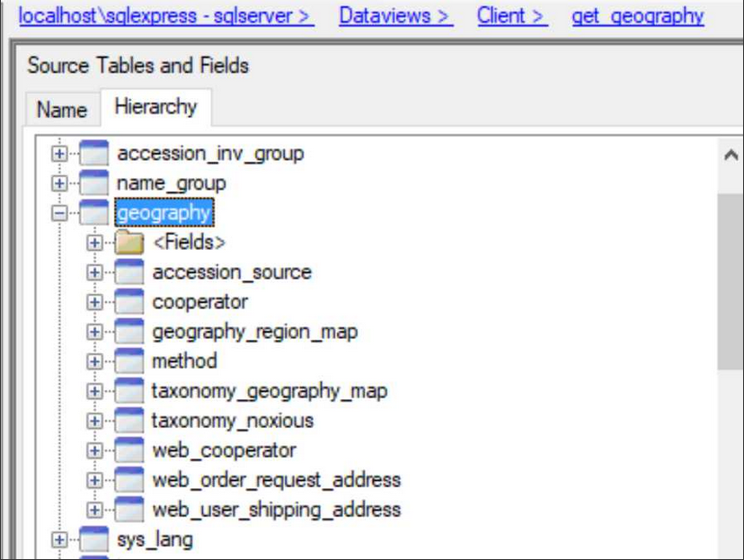
The Geography table is used in a foreign key in many other tables where it acts as a standard so that the user must choose from a preset standard list of countries and states. This helps eliminate data entry errors on spelling country or state names since the user is selecting from a list rather than typing each time. This means that it is important that the organization installing GG needs to get the geography table data initially correct since is fairly important –regular users won’t be able to choose a country and state that aren’t already in the geography table.

The geography table is designed so that only country is required. Additional levels of administrative divisions, such as states and provinces, are optional. Since a geography link is used in all the address fields, it is ideal to have all the adm1 state data loaded so proper information can be entered for mailing addresses.

The geography table also includes adm2 and fields for subdivisions, but in the US NPGS they have not been used and how useful they are has yet to be determined.

When an organization installs GG, the administrator can optionally load the Geography table which has the same data as used by the NPGS. The NPGS is currently in the process (Autumn, 2018) of incorporating an ISO file to include the ISO Country and ADM1 data. New GG installations will include this revised geo data, but that doesn’t help existing GG organizations that have been using GG. The NPGS will make the geography file available as an Excel sheet for organizations who can decide to update their Geography table or not.

Where does the geography information appear?
On data entry in the Curator Tool, the geography information displays on a list. For example, in the accession source dataview the Geography field uses the lookup picker to select which country/state is wanted. It looks like this:
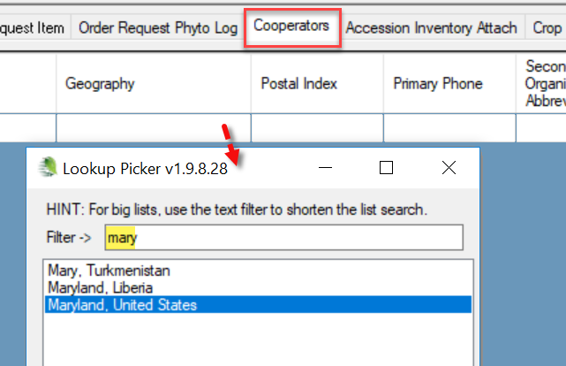

In the Accession Source dataview, the user sees multiple geography records for the country United States, each with a different state in the Adm1 field.
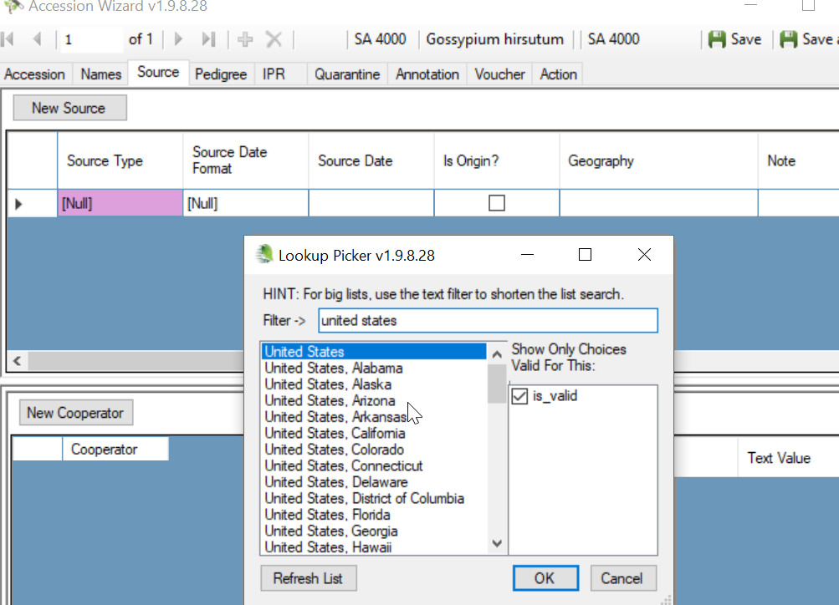

The output of the public web pages will show United States, Arizona for an accession with that as the source.
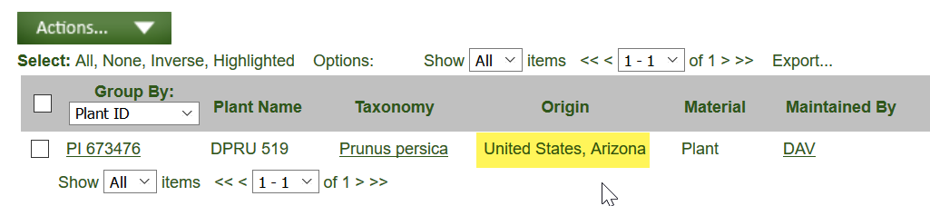

In this Source History section from the details page on the Public Website, the format is Adm1, Country:
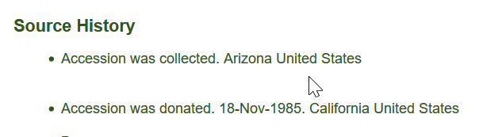

Geography Dataviews Overview
Keep in mind that a dataview and a table are not equivalent. A dataview can be used to display all of a table’s fields, but often a dataview displays fields from more than one table. In the Curator Tool, in Edit Mode, dataviews will allow editing from only one table at a time; the fields from related tables that are displayed with a gray color cannot be edited in that particular dataview.
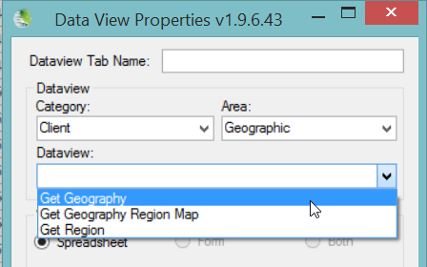

Geography Dataviews
- Geography
- Region
- Geography Region Map

Geography Dataview
Shown below is part of the Geography table used by the US NPGS. Note that many of the records only have a Country field. In this example, at least one state has its county data completed.
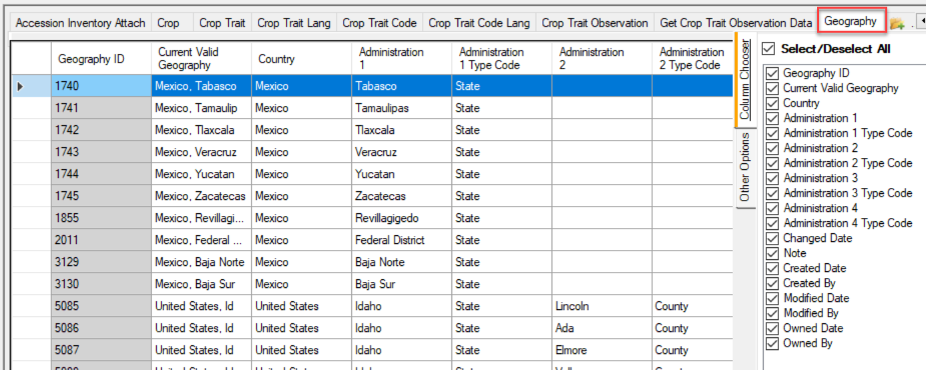
ISO 3166-2 (state) codes were added to the Geography table in server release 1.10.4 in March, 2109. Also added was an Is_Valid(ISO 3166 Compliant) flag field to the dataview.
In this release, several changes were made:
Six US entities (Puerto Rico etc.) were removed to be US outlying areas and removed the separate country entries.
For China three main country entries (Taiwan, Macao, Hong Kong) were left as countries, but also left in the new “state of China” version. If you look at the state version under China for Taiwan and the others it says “'Taiwan Sheng (see also country entry under Taiwan)” leaving both options available.
For the USA counties, there is a new checkbox in the CT to screen them out by default.
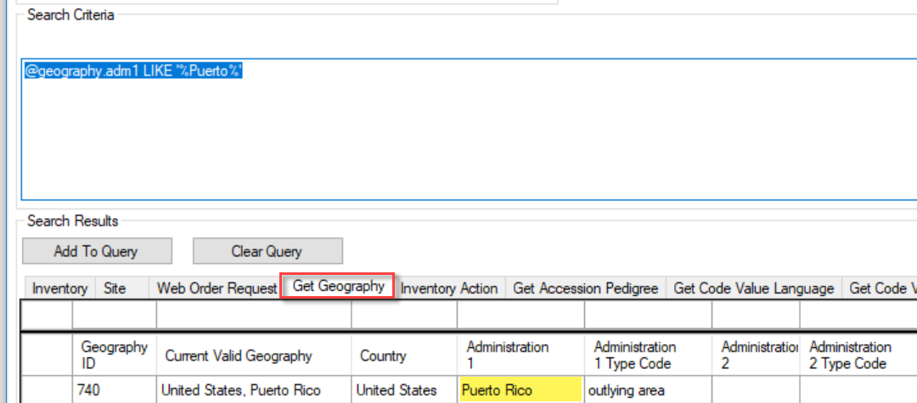
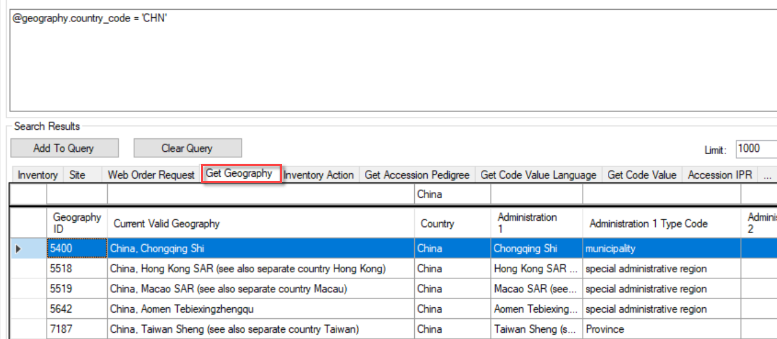

Region Dataview
The Region table used by the NPGS contains only 63 records. Several are shown here as examples:
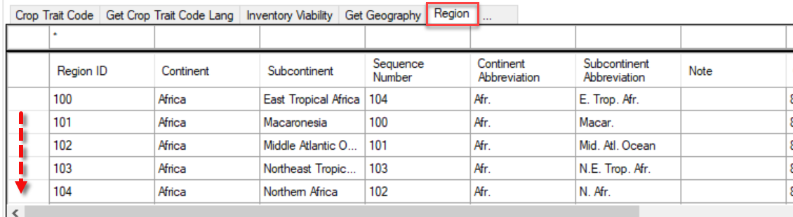
This dataview accesses the Region table, which includes world regions and continent information. The region table is used by the geography_map table to group countries into regions.

Geography Region Map
This dataview accesses the geography_region_map table. (Map tables accommodate many-to-many relationships; in this case, regions with geography.)
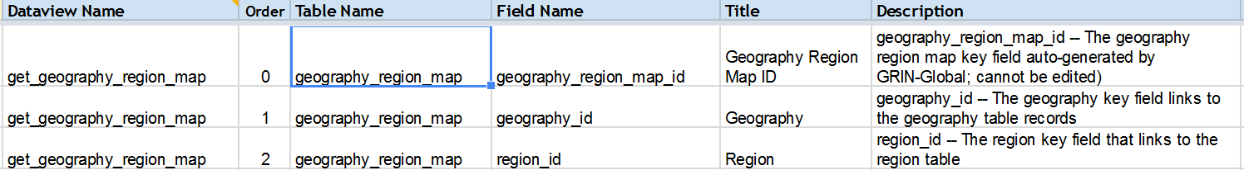

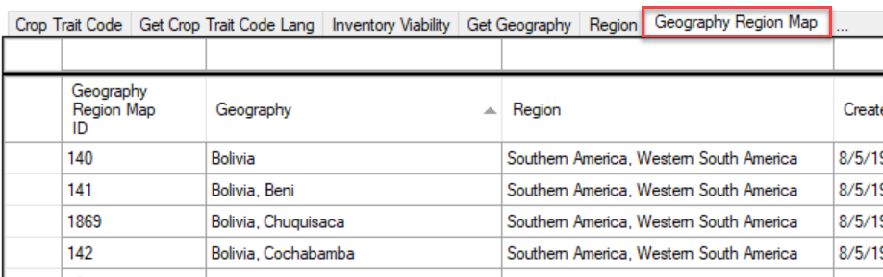

Geography Lookups
When reviewing geography information in lookup pickers, it may be obvious that the data is formatted two different ways. The format displayed by the lookup picker is determined by the lookup dataviews. There are actually two different geography lookups in GG.
In the case of the Source dataview, the geography_lookup is used. In the case of the Cooperator dataview, the mailing_geography_lookup is used. This was done so the geography could be presented differently for address purposes where generally state is listed first, then country.

SQL Code Behind the Formatting
For the regular geography_lookup, the order is country name then adm1 and adm2.

LTRIM(RTRIM(COALESCE(cvl.title, g.country_code) +
CASE COALESCE(CONVERT(NVARCHAR, g.adm1), '') WHEN '' THEN '' ELSE ', ' + g.adm1 END +
CASE COALESCE(CONVERT(NVARCHAR, g.adm2), '') WHEN '' THEN '' ELSE ', ' + g.adm2 END)) AS display_member,

For the mailing_geography_lookup it is adm1, then country, no adm2 (county) since this seems irrelevant on an address.

COALESCE(g.adm1 + ', ', '') + COALESCE(cvl.title, g.country_code) AS display_member

Geography Codes
Three Geography-related Code Groups exits:

GEOGRAPHY_ADMIN1_TYPE and GEOGRAPHY_ADMIN2_TYPE
The two type code groups are used to indicate what the respective ADM division is.
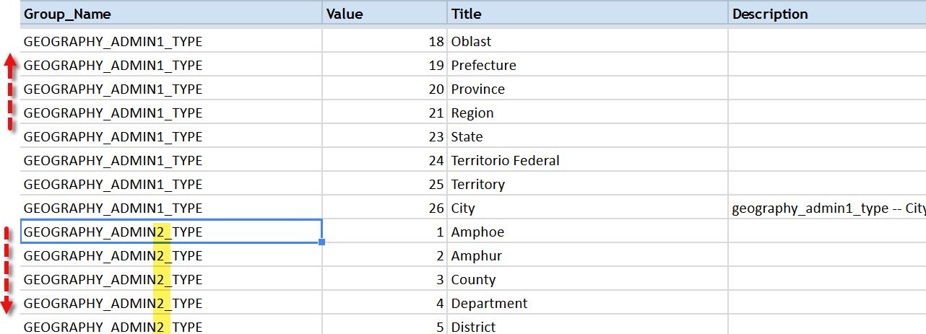
In the Curator Tool, when adding a new Geography record to the database, when indicating the ADM levels 1 or 2, you select a code from the dropdown. These codes are coming from the two respective code groups.
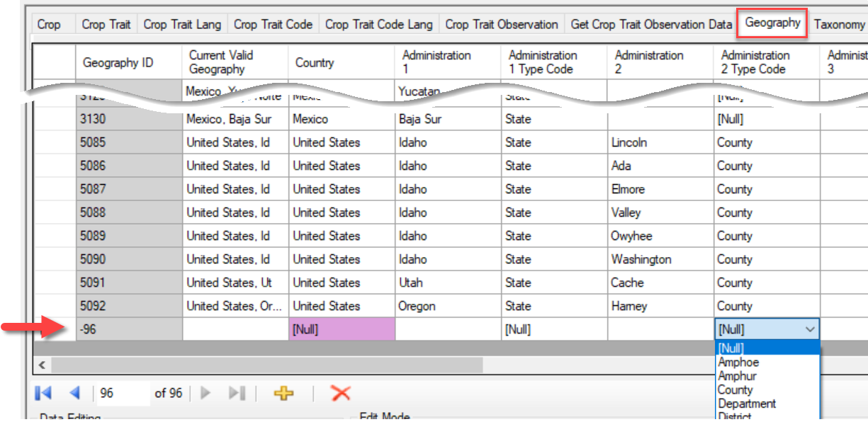

GEOGRAPHY_COUNTRY_CODE
The Code Group GEOGRAPHY_COUNTRY_CODE is used to keep historic country names as well as current ones. When the default data stored in this group is examined, note that the entries with numeric Values are used for historic names, whereas the three letter Values represent current country names.
Note: organizations may find the historic references handy since some of their accessions may have historic source information reflecting historic country names.
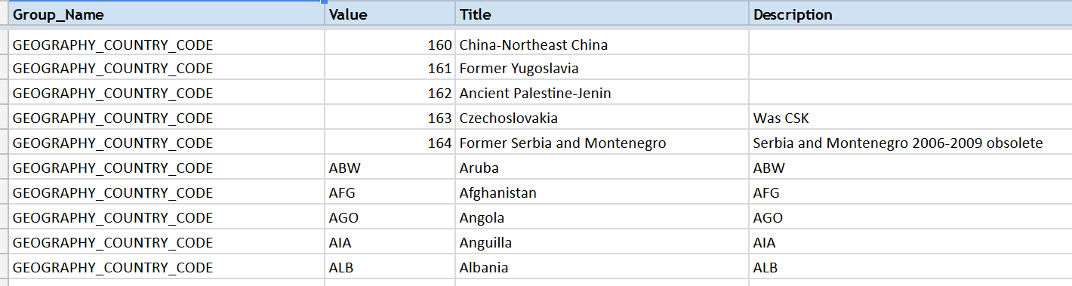
When new Geography records are created, the dropdown for the country field comes from the Title in the code record.
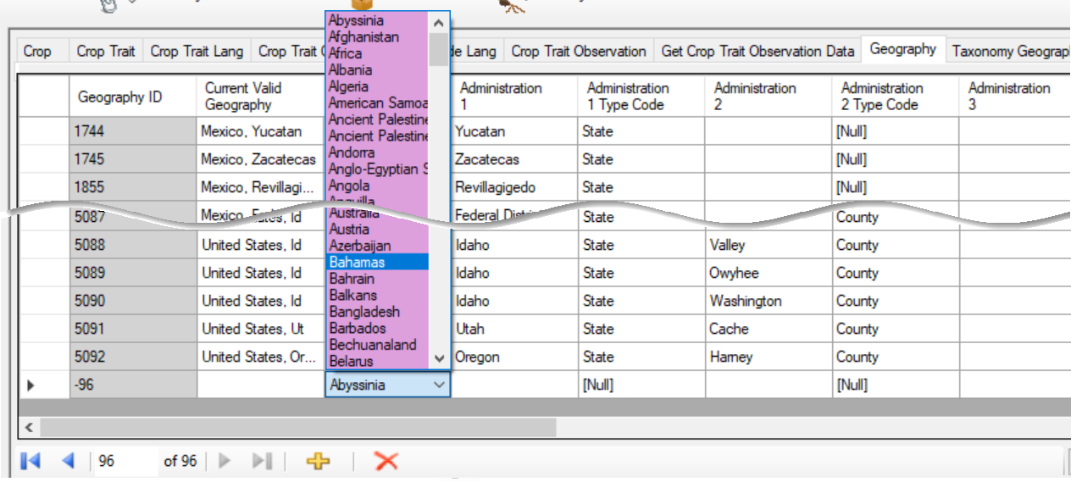

Public Website SQL Query to Display Country Codes
Use the following SQL in the Public Website to get a listing of the codes:
SELECT
cv.code_value_id,
cv.group_name as group_name,
cv.value, cvl.title, cvl.description
FROM
code_value cv
LEFT JOIN code_value_lang cvl ON cv.code_value_id = cvl.code_value_id
AND cvl.sys_lang_id = 1
/* use the WHERE clause to search for a specific code – examples: */
WHERE cv.group_name = 'geography_country_code'
/* WHERE cv.group_name LIKE 'germplasm%' */
ORDER BY group_name, cv.value

Sample Output: Use the Download All Rows option to produce a spreadsheet list:
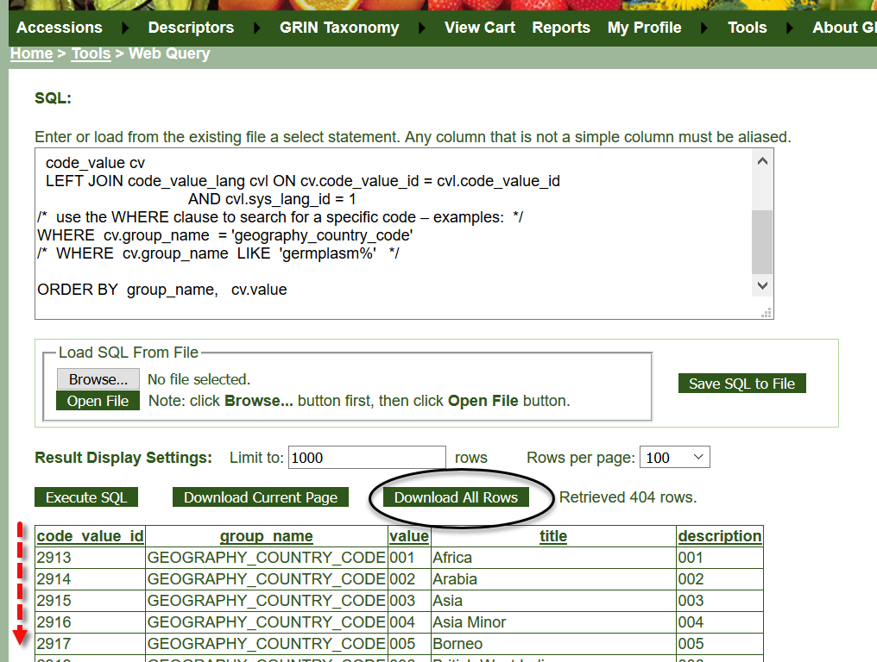

Appendix: Document Change Notes

– June 7, 2019
- Included changes from Release 1.10.4 when the ISO standards were incorporated into GG

– October 17, 2018
- Document completely rewritten/edited

– September 7, 2016
- new document

