DOIs & GRIN-Global

Revision Date
May 8, 2024

Author
Martin Reisinger

Review the Table of Contents which contains links to the document’s sections.

Table of Contents
Overview 2
FAO Guidelines 2
NPGS Implementation 2
Additional DOI Resources 2
GRIN-Global & DOIs 2
DOI Format 2
Using Name Records to Store DOIs in GG 3
DOIs in the Public Website 4
Genesys and DOIs 5
Future DOI Enhancements and Fixes 6
Index Needs to be Manually Updated 6

Comments/Suggestions:
Please contact feedback@ars-grin.gov with any suggestions or questions related to this document. This document is a work-in-progress.
Complete documentation on many aspects of GRIN-Global is available online at the GRIN-Global website: https://www.grin-global.org/

Overview

FAO Guidelines
DOIs are used as Permanent Unique Identifiers (PUID) in the context of the Global Information System (GLIS) of Article 17 of the International Treaty on Plant Genetic Resources for Food and Agriculture (ITPGRFA).
FAO’s comprehensive guide “Digital Object Identifiers for Food Crops” is online at http://www.fao.org/3/I8840EN/i8840en.pdf
Guidelines for the optimal use of Digital Object Identifiers as permanent unique identifiers for germplasm samples are found at http://www.fao.org/3/a-bt114e.pdf

NPGS Implementation
The “guides and guidelines” listed above represent the views of the FAO ITPGRFA Secretariat and some CGIAR Centers. The USDA/ARS NPGS implementation and use of DOIs differ from the preceding “guides and guidelines.” NPGS personnel should follow the NPGS’s instructions for implementation and use of DOIs in the context of NPGS germplasm. Presently, the NPGS is not using the DOI field.

Additional DOI Resources
Some additional DOI resources which you may find useful:
- https://www.genebanks.org/resources/dois/
- http://www.fao.org/plant-treaty/areas-of-work/global-information-system/faq/en/ (FAQs)
- https://vimeo.com/258264024 (video)
- https://youtu.be/o2Gg4H2QxWo (video)

GRIN-Global & DOIs
In server release 1.10.4, a schema change was made to add the Digital Object Identifier (DOI) field to the Accession table. Also, the field was added to the Accession dataview. 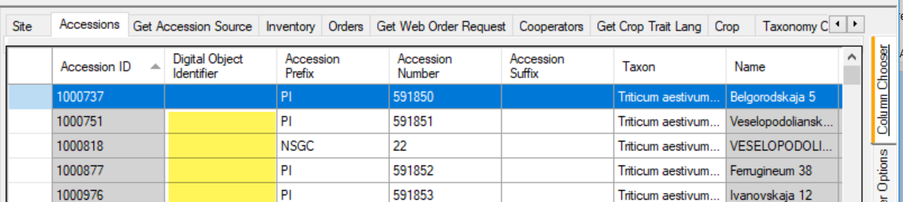

DOI Format
A DOI, by itself, is not a URL. However, it can be easily converted to a URL by using the form: https://doi.org/<doi> (e.g. https://doi.org/10.1109/5.771073). When converted to a URL, the DOI points to the landing page provided by the system that registered the DOI.

Using Name Records to Store DOIs in GG
If an organization had included DOI data before the DOI field had been added to the schema, (prior to server release 1.10.4), they had the option to add the DOI data as a Name record in the accession_inventory_name table. Some organizations running GRIN-Global have DOI data in their database. For example:
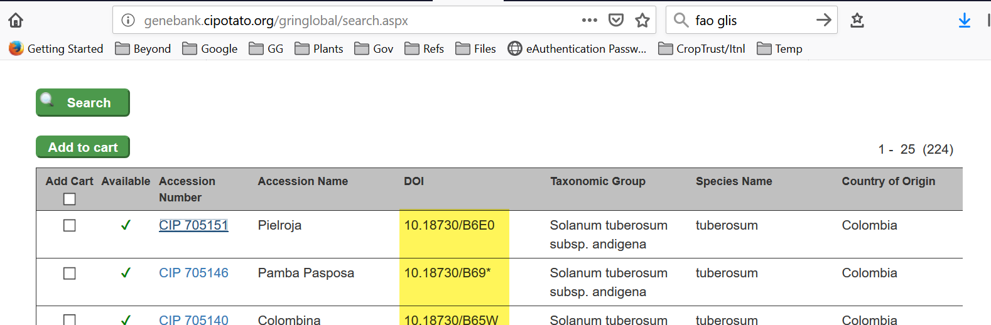
In GG, an accession’s DOI Name can be displayed on the Public Website accession detail page:
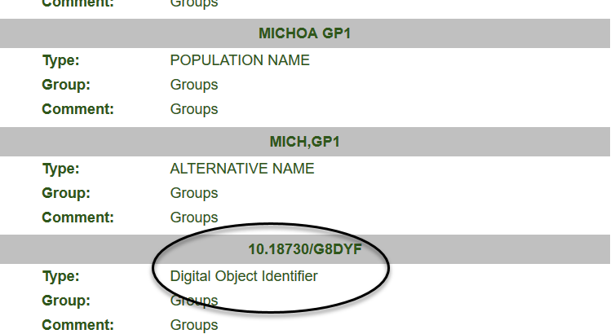
The corresponding Name record as seen in the Curator Tool:
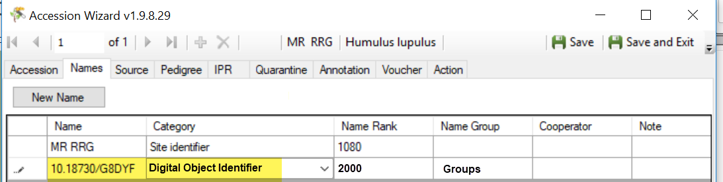
For complete information on Names records and directions for adding to the database, refer to the Names section in the online Accessions document at https://www.grin-global.org/docs/gg_accessions_and_passport_data.docx

DOIs in the Public Website

The DOI information as of Server Release 2.3.8 displays on the search results and the Accession Detail Pages:
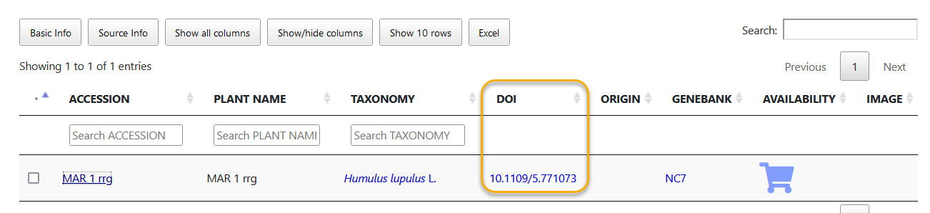
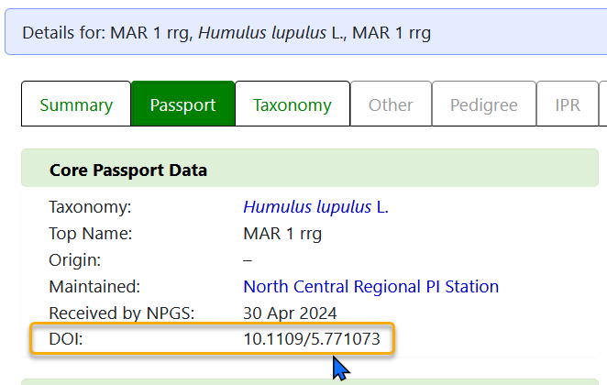

Genesys and DOIs
Genesys also uses the text “10.18730/1PGAP” as the link,
not the full URL. https://www.genesys-pgr.org/10.18730/1PGAP
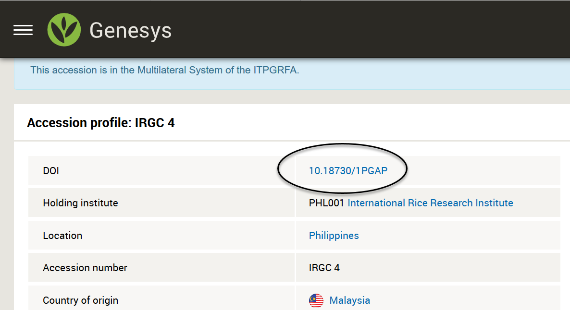

Appendix: Change Notes

May 8, 2024
- Added new DOI screens

The following text will be archived; no longer relevant in current versions.

Future DOI Enhancements and Fixes

Index Needs to be Manually Updated
An index fix is being reviewed and will be addressed in the next build to avoid the following error:
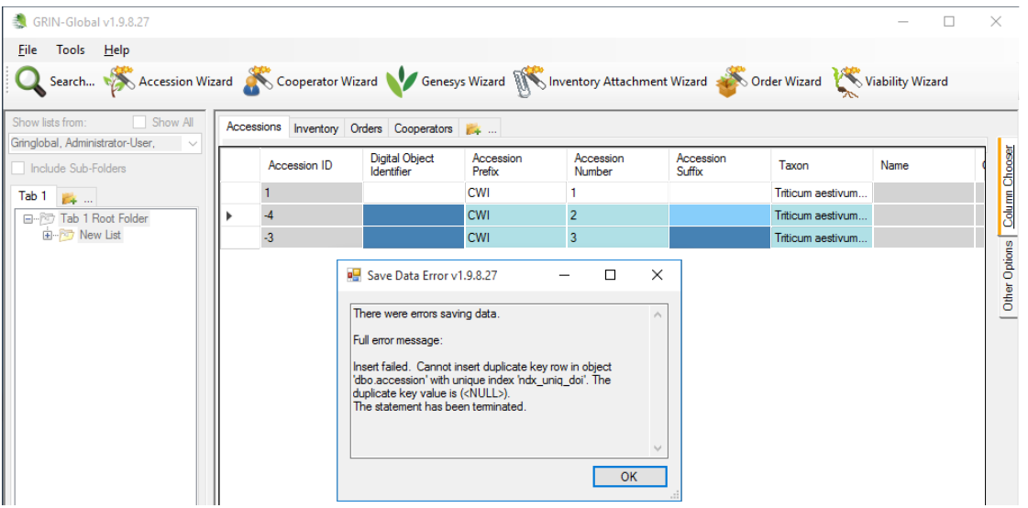

In the meantime, until that fix is available in a released build, the GG administrator should run the following in SSMS to rebuild the index correctly:

DROP INDEX accession.ndx_uniq_doi
-- need to use filter to allow multiple null rows
CREATE UNIQUE NONCLUSTERED INDEX ndx_uniq_doi
ON dbo.accession(doi)
WHERE doi IS NOT NULL;

