Curator Tool Self-Service Password Reset
URL: https://npgsweb.ars-grin.gov/ggtools/Login/RequestPasswordReset
Directions (images below):
1. Enter your Curator Tool username (username regularly used at the CT Login window)
2. & 3. An email with reset link will be sent to your email address; open the email; click the link.
4. & 5. Input a valid password (twice); click the Save button. Confirmation window displays.
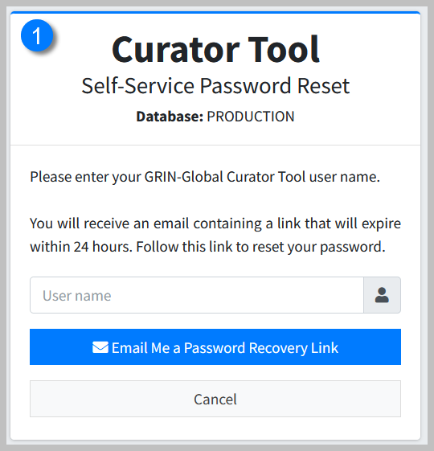 | 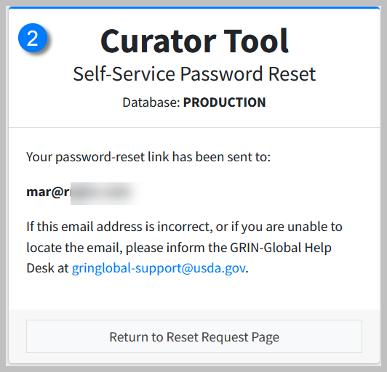
You will receive an email with a link:
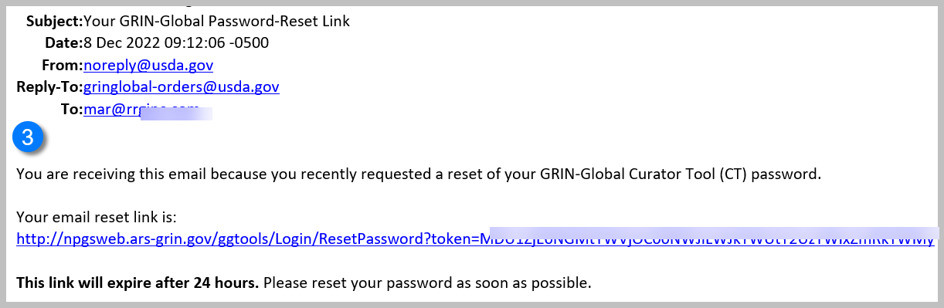
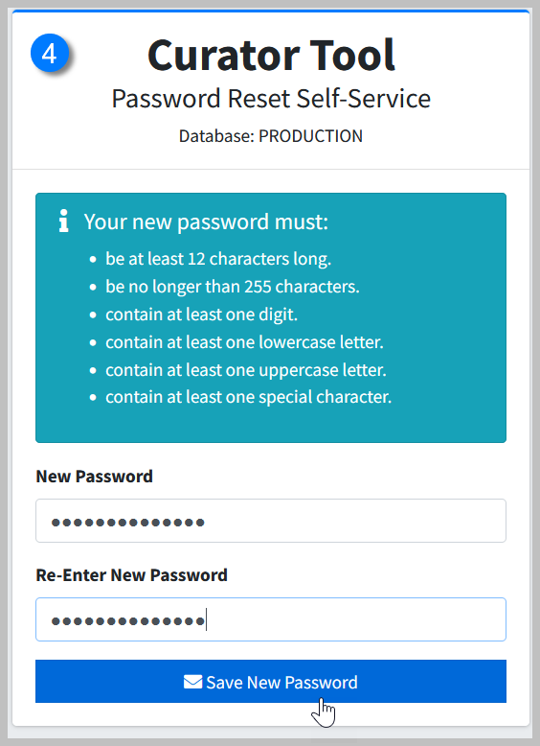 | 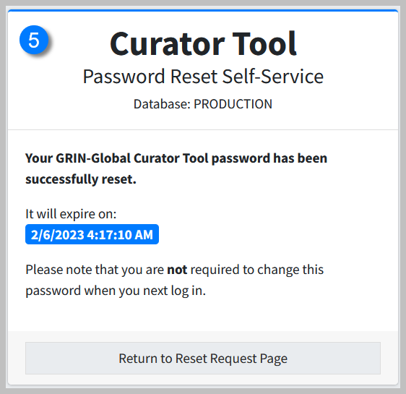
See also:
CT Login Guide: http://grin-global.org/docs/gg_CT_login_guide.pdf
Connecting to GG Servers: http://grin-global.org/docs/gg_connecting_to_servers.pdf

