## Installation of Curator Tool Reports



Revision Date

February 9, 2024

Author

Martin Reisinger

|  |  |
| --- | --- |
|  | Reports produced within the Curator Tool require pre-designed report files to be installed on the user’s PC. A Curator Tool user does not have the capability within the CT to create these report files. The files are created, typically by software developers, using other software tools.  This guide explains how to:   * install the report files * edit the text files needed to coordinate the CT with the report files |

TOC

Background 3

Available Report Files 3

Initial Step – Common to all report files 4

Copy the Crystal Report (.rpt) Files onto a User’s PC 4

New Report Filenames: report names never used previously 5

Mapping CT Reports to work with specific dataviews 5

Report Manager Background 6

Steps When Using Report Manager to Map Reports with Dataviews 8

Manually Editing the ReportsMapping.txt (Reports Manager Alternative) 10

Examples of ReportsMapping.txt Files 10

ReportsMapping.txt File (2nd Example) 11

Order Wizard Reports 12

AppSettings.txt 12

AppSettings.txt – Folder location 13

AppSettings Table on the Server 14

If the Reports are not Listed in the Order Wizard Printing Dropdown 15

Displaying a Curator Tool Report 15

Create Local Report Tables Feature (v1.9.9.8 and later) 16

Appendix A: Resolve the Order Wizard “Missing Reports” Issue 17

(Simplified instructions) 17

(Details) 17

Appendix B: Changing Options for Folders (so that they display (Show hidden folders)) 19

Default File Explorer Settings 19

Appendix C: Document Changes 21

2024 February 9 21

2021 May 18 21

2018 August 31 21

2017 December 5 21

2017 July 5 21

##### Background

When the Curator Tool is installed on a user’s PC, report files are automatically installed during that process. Later, it is possible to supplement or replace the report files without reinstalling the CT.

Some organizations running the GRIN-Global application may have created their own reports and may distribute them outside of the default CT installation. In that case, you should receive directions from your GG database administrator (DBA) on implementing these report files.

|  |  |
| --- | --- |
|  | The Curator Tool works with .rpt (“Crystal Report”) files and another report type – reports created via Microsoft’s SQL Server Reporting Services. |

The report files are not stored on the GG server. Besides ensuring the files are installed properly on the user’s PC as required by the Curator Tool, two other text files must be edited on the user’s PC to coordinate (map) the CT reports and its dataviews.

Beginning with v.1.23.1.26, a new feature, the Report Manager, helps with the mapping of the report files. Prior to this release, any changes or editing to the **ReportsMapping.txt** file were done manually.

##### Available Report Files

The following files are current as of January 2024. (NPGS)

The report files may be downloaded from:   
<https://www.grin-global.org/files/report_files_for_ct_2024feb06.zip>

Directions for Using Report Files with the Curator Tool

The steps taken to install and set up a report file depend on whether the file has a new filename and where the file is used within the CT. Three considerations:

* A report is updated, but it uses the same filename of an existing report
* New report file – the filename was never used previously by the CT – the new report filename must be mapped to a dataview
* The report is used within the Order Wizard

#### Initial Step – Common to all report files

All report files must be copied to a specific folder on the CT user’s PC. The Curator Tool report files are typically loaded in this folder:   
 C:\Users*user.name*\AppData\Roaming\GRIN-Global\Curator Tool\Reports

|  |  |
| --- | --- |
|  | Older versions of the CT used different folders. These directions apply to versions beginning with CT version 1.23.1.26 |

###### Copy the Crystal Report (.rpt) Files onto a User’s PC

Report filenames have “**.rpt**”for their extension. Copy the .rpt files to the folder:   
**C:\Users\ *username* \AppData\Roaming\GRIN-Global\Curator Tool\Reports**.

If any .rpt files have the same name as files already in that folder, when prompted, select **Replace**.

The report files may be downloaded from:   
<https://www.grin-global.org/files/report_files_for_ct_2024feb06.zip>

|  |  |
| --- | --- |
|  | Use Windows Explorer to unzip the files in this zip file. |

#### New Report Filenames: report names never used previously

New report files must be mapped to dataviews.

|  |  |
| --- | --- |
|  | When a developer designs a Curator Tool report, she designs it to work with one or more dataviews. Therefore, before running a report in the Curator Tool, you must have the respective dataview opened. |

When new reports are designed, a mapping step is required.

##### Mapping CT Reports to work with specific dataviews

*ReportsMapping.txt*

A text file, “**ReportsMapping.txt**,” controls the mapping of the report files to their respective Curator Tool dataviews. In other words, the .txt file settings are necessary to coordinate report files with the dataviews. Only dataviews with mapped reports will be abIe to be use a report.

This **ReportsMapping.txt** file is in the Curator Tool folder:

**C:\Users*username*\AppData\Roaming\GRIN-Global\Curator Tool\**

***Example of an Inventory Dataview Mapped to Reports***

Example: the Inventory dataview is active; the user right-clicked after selecting a few inventory records. After selecting the Reports menu option, five reports that have been associated with the inventory dataview are listed:   
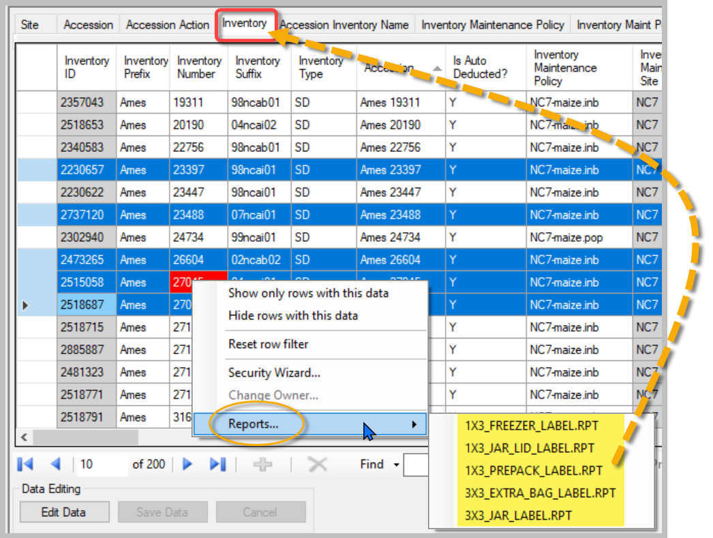

|  |  |
| --- | --- |
| image2449.png | When reports are displayed in the Order Wizard’s **Printing** dropdown, a second .txt file, *the* ***AppSettings.txt*** file, must also be configured.  See AppSettings.txt details. |

##### Report Manager Background

Beginning with v.1.23.1.26, a new feature, the Report Manager, helps with the mapping of the report files. Prior to this release, any changes or editing to the **ReportsMapping.txt** file were done manually.

|  |  |
| --- | --- |
|  | The **ReportsMapping.txt** file is stored in a specific folder -- C:\Users\***Marty.Reisinger***\AppData\Roaming\GRIN-Global\Curator Tool: (substitute with the valid ***yourusername*** relevant to your computer. In older versions, the folder was different.)  Graphical user interface, application, Word  Description automatically generated |

The Curator Tool’s **Report Manager** provides a graphical interface in which users can now associate report files, either Crystal Reports (.rpt) or SQL Server Reports (.rdic) files, with specific dataviews.

|  |  |
| --- | --- |
|  | However, the user still must *manually edit the* ***AppSettings.txt*** file if the report is to be displayed in the Order Wizard’s Printing dropdown. |

##### 

##### Steps When Using Report Manager to Map Reports with Dataviews

The Curator Tool’s Report Manager provides a graphical interface in which users can now associate report files, either Crystal Reports (.rpt) or SQL Server Reports (.rdic) files, with specific dataviews.

The Report Manager dialog box uses a score to sort the dataviews associated with a Crystal Report (.rpt). The score basically indicates how many of the required fields in the report are available in the dataview. 100% is ideal. Dataviews with scores less than 50% are not displayed automatically in the Report Manager, but a **Show All** option exists.

In the following example, the 3x3_Jar_Label.rpt is highlighted in the left panel. The right panel shows that it has been mapped to the “Get_Inventory” dataview.*

* Dataviews used by the CT are typically titled with the prefix “GET_“ as in GET_INVENTORY, whereas CT users will usually refer to them solely by the name following the prefix.

To associate a dataview to a report, highlight the report in the left panel and then click the checkbox(es) for the desired dataview(s).

In the following example, a specialized site inventory dataview, used by the NPGS W6 site, originally has no report files associated with it. In the second image, the user will select that dataview, and from that point onward, the report will work with that dataview, as shown in the 3rd image below.

##### Manually Editing the ReportsMapping.txt (Reports Manager Alternative)

Besides using the CT’s Report Manager option, the **ReportsMapping.txt** file can be manually edited to relate a .rpt file with a dataview. For example, the .txt file below was modified to associate the site_w6_inventory dataview with the 1x3_Freezer_Label report:

|  |  |
| --- | --- |
|  | When editing the statements, use a semi-colon and then the dataview name, as shown above. |

##### Examples of ReportsMapping.txt Files

The statements in the **ReportsMapping**.txt file indicate the relationship of the .rpt file to the dataview. In the example below, the **3x3_Jar_Label.rpt** file works with the **get_inventory** Dataview Name.

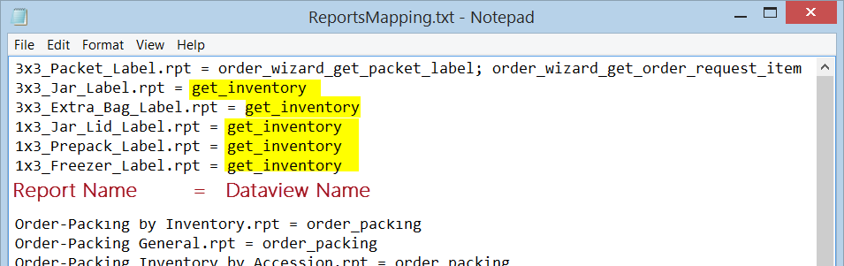

###### ReportsMapping.txt File (2nd Example)

The **ReportsMapping**.txt file statements indicate the relationship of the .rpt files to the dataview.

Remember to edit for the respective user name.

**C:\Users\Marty.Reisinger\AppData\Roaming\GRIN-Global\Curator Tool\Reports\1x3_Freezer_Label.rpt = get_inventory; site_w6_inventory**

**C:\Users\Marty.Reisinger\AppData\Roaming\GRIN-Global\Curator Tool\Reports\1x3_Jar_Lid_Label.rpt = get_inventory**

**C:\Users\Marty.Reisinger\AppData\Roaming\GRIN-Global\Curator Tool\Reports\1x3_Prepack_Label.rpt = get_inventory**

**C:\Users\Marty.Reisinger\AppData\Roaming\GRIN-Global\Curator Tool\Reports\1x3_Zebra_Viability_Label.rpt = viability_wizard_get_inventory_viability_label**

**C:\Users\Marty.Reisinger\AppData\Roaming\GRIN-Global\Curator Tool\Reports\3x3_Extra_Bag_Label.rpt = get_inventory**

**C:\Users\Marty.Reisinger\AppData\Roaming\GRIN-Global\Curator Tool\Reports\3x3_Jar_Label.rpt = | get_inventory; site_w6_inventory**

**C:\Users\Marty.Reisinger\AppData\Roaming\GRIN-Global\Curator Tool\Reports\3x3_Packet_Label.rpt = order_wizard_get_packet_label; order_wizard_get_order_request_item; get_inventory**

**C:\Users\Marty.Reisinger\AppData\Roaming\GRIN-Global\Curator Tool\Reports\Cooperator - Users at a Site.rpt = rpt_cooperator_by_site**

**C:\Users\Marty.Reisinger\AppData\Roaming\GRIN-Global\Curator Tool\Reports\Order-Packing General.rpt = order_packing2; order_packing; order_packing_nsgc**

**C:\Users\Marty.Reisinger\AppData\Roaming\GRIN-Global\Curator Tool\Reports\Order-Packing General_woSMTA.rpt = order_packing2; order_packing; order_packing_nsgc**

**C:\Users\Marty.Reisinger\AppData\Roaming\GRIN-Global\Curator Tool\Reports\Order-Picking.rpt = order_packing2**

_____________

#### Order Wizard Reports

##### AppSettings.txt

The **AppSettings.txt** file is an additional file that is needed to coordinate the Order Wizard with the .rpt files. This **AppSettings.txt** file affects various CT features, but here we are only interested in reports. This .txt file must indicate which .rpt files can be used by the Order Wizard’s **Printing** dropdown.

Near the bottom of the **AppSettings.txt** file, a line begins with a # Order Wizard … – that line is a comment. The reports listed in the Order Wizard Printing dropdown need to be indicated, separated by semi-colons, as shown above.

|  |  |
| --- | --- |
|  | if a .rpt file indicated in the **AppSettings.txt** file is not in the CT’s Reports folder, it will be ignored and not display in the Order Wizard’s dropdown. In the example above, that is true except for the three highlighted files: A screenshot of a computer  Description automatically generated |
| image2449.png | In addition to the CT Order Wizard **Printing** dropdown, the **AppSettings.txt** file is also used to control certain CT user settings such as customized treeview names, virtual node definitions, and a few miscellaneous application setting definitions. |

##### AppSettings.txt – Folder location

When the report is used within the Order Wizard, the report must also be identified in the **AppSettings.txt** file. This .txt file is also in the Curator Tool folder:  
**C:\Users*username*\AppData\Roaming\GRIN-Global\Curator Tool\**

The Order Wizard has a **Printing** dropdown feature that looks similar to the following (your report names may differ):  
The statement below, when included in the **AppSettings.txt** file, affects which reports will display in the Order Wizard dropdown:

**OrderWizardCrystalReports = Order-Packing by Accession Number.rpt; Order-Packing by Accession.rpt; Order-Packing Disclaimers.rpt; Order-Packing General with Origin.rpt; Order-Packing General.rpt; Order-Packing NSGC.rpt; Order-Picking.rpt; 3x3_Packet_Label.rpt**

In some situations, the **AppSettings.txt** file will have a **#** symbol preceding the code. (The # causes the code to be treated as a comment.) When that is the case, delete the leading # symbol and the code will work properly *after you restart the Curator Tool.* The Order Wizard Printing dropdown will display the reports included in the statement.

|  |  |
| --- | --- |
|  | AppSettings Table on the Server A table that contains some default settings that control each user’s individual settings exists on the server. When the user’s PC contains an **AppSettings.txt** file with similar statements, the user’s AppSettings.txt file statements supersede the statements in the server’s **AppSettings** table. |

##### If the Reports are not Listed in the Order Wizard Printing Dropdown

In the folder C:\Users*Marty.Reisinger*\AppData\Roaming\GRIN-Global\Curator Tool …

* Check that the .rpt files are in the folder **Reports**
* edit the file: **ReportsMapping.txt** (either edit manually, or use the Report Manager on the CT menu)
* edit the file: **AppSettings.txt** (manually edit)

_____________

#### Displaying a Curator Tool Report

To use a report with a dataview, you will:

* Switch to, or open the dataview that correlates to the respective report you intend to produce
* In the dataview, select the record(s) that are to be included in the report
* Right-click; select **Reports...**   
  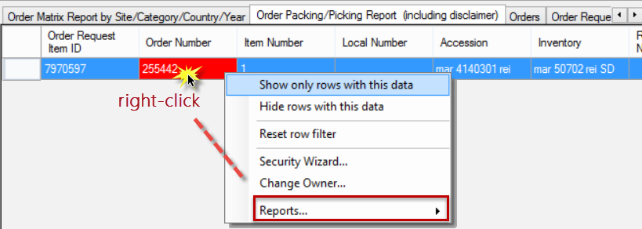
* Select the report from the list of relevant reports:  
  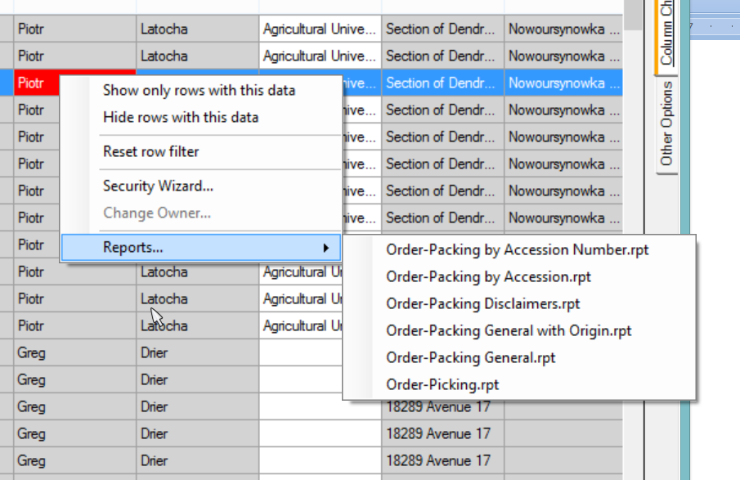

_________

#### Create Local Report Tables Feature (v1.9.9.8 and later)

|  |  |  |  |
| --- | --- | --- | --- |
| image2449.png | Beginning with CT version 1.9.9.8, a new feature was added to the Curator Tool. A screenshot of a computer  Description automatically generated  When the **Create Local Report Tables** option is selected, a copy of the records in the active dataview is saved to a database on your PC:   This screen was produced using SQL Server Management Studio. These sample data tables are now ready to be used by a tool such as Crystal Reports. The CT does not make reports directly.   |  |  | | --- | --- | |  | GG documentation does not include directions on how to create Crystal Reports files since this is beyond the scope of the typical genebank staff person. Resources on the internet are limited. | |

### Appendix A: Resolve the Order Wizard “Missing Reports” Issue

To fix the issue of reports not displaying in the user’s Order Wizard:

###### (Simplified instructions)

Edit the file: **AppSettings**.**txt**

Scroll through the file until Near At the bottom, there is a line that begins with a # symbol – delete the # symbol

the line should read:

**OrderWizardCrystalReports = Order-Packing by Accession.rpt; Order-Packing by Inventory with Origin.rpt; …**

###### (Details)

The Order Wizard has a **Printing** dropdown feature that looks similar to the following (your report names may differ):  
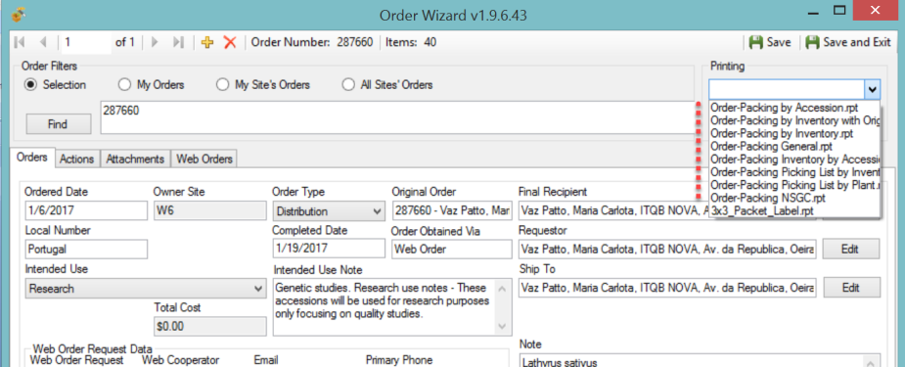

The statement below, when included in the **AppSettings.txt** file, affects which reports will display in the Order Wizard dropdown:

**OrderWizardCrystalReports = Order-Packing by Accession.rpt; Order-Packing by Inventory with Origin.rpt; Order-Packing by Inventory.rpt; Order-Packing General.rpt; Order-Packing Inventory by Accession.rpt; Order-Packing Picking List by Inventory.rpt; Order-Packing Picking List by Plant.rpt; Order-Packing NSGC.rpt; 3x3_Packet_Label.rpt**

In some situations, the **AppSettings.txt** file will have a **#** symbol preceding the code. When that is the case, delete the leading # symbol. If that code is not there, copy the highlighted text and place at the bottom of the **AppSettings.txt** file. The code should then work properly *after you restart the Curator Tool.* The Order Wizard Printing dropdown will display the reports included in the statement.

The **AppSettings.txt** file is in the PC's Users folder (in the example shown here, the user is MartyR):   
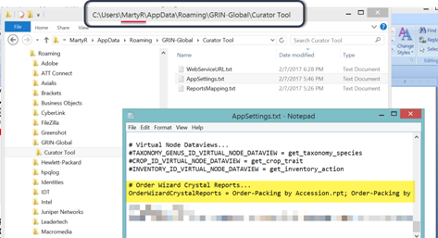

### Appendix B: Changing Options for Folders (so that they display (Show hidden folders))

Unfortunately, in its wisdom, Microsoft a long time ago decided to hide certain folders as well as file extensions.  In the default view, the folder **C:\ProgramData** is hidden:  
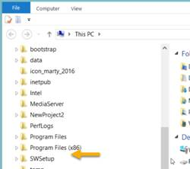

Whenever I get a new PC, I immediately change 3 of the default settings. I use File Explorer extensively, so I change the settings for "**Display full path**," "**Show hidden files…**," and "**Hide extensions for known types**"  to be able to see “hidden” folders and files.

##### Default File Explorer Settings

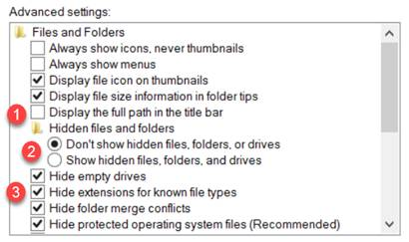

Preferred settings which you can make the default for the entire PC:  
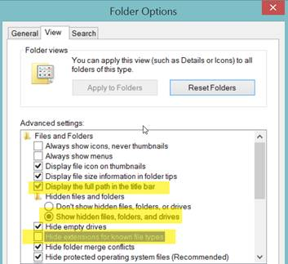

To make the display options apply to all folders, select the **Apply to Folders** button:  
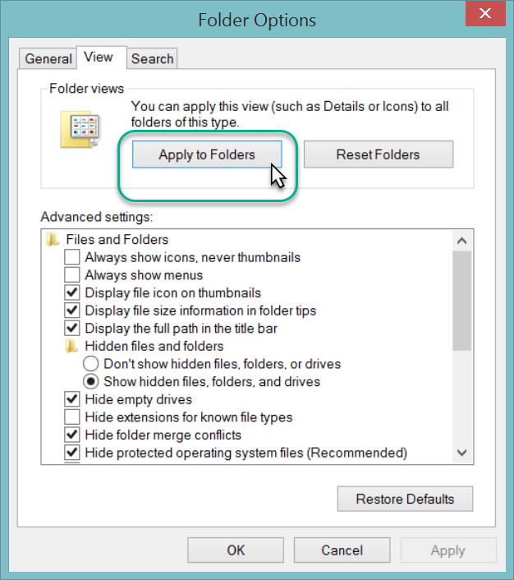

The **C:\ProgramData** should display. You may need to close the File Explorer window and then reopen it.  
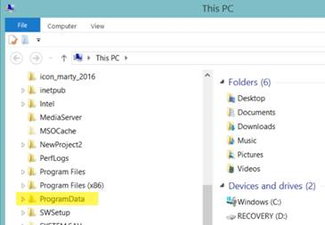

### Appendix C: Document Changes

##### 2024 February 9

* Updated text and the location of .rpt files
* Major reorganization of document to reflect Report Manager in CT

##### 2021 May 18

* Updated the location o f the ZIP file for the .rpt files

##### 2018 August 31

* Edited substantially to reflect the changes to a 64-bit platform and the move to different folders on the CT user’s PC

##### 2017 December 5

* changed the source zip file to https://www.grin-global.org/report_files_for_ct_2017dec05.zip

##### 2017 July 5

* changed the source location for the reports zip file to https://www.grin-global.org/…