Dynamic Folders

Revision Date
January 31, 2022

TOC
Comparison of Static and Dynamic Folders 2
Static Folders 2
Dynamic Folders 2
Static Folders: Advantages 2
Dynamic Folder Examples 3
Dynamic Folder Examples* 3
Methods for Creating Dynamic Folders 4
Refreshing a Dynamic Folder 4
Making Dynamic Folders More Readable 5
Use Text rather than Primary Key Numbers 5
Second Text Example: Specifying the Taxon and the Geography 6
Sample Queries 11
One Accession 11
Accession Range 11
Several Accessions 11
An Accession – by its name 11
One Species 11
Born in the USA 11
Collected -USA but not obvious 11
Looking for Origin 12
Pending Orders 12
Sorghum - KERCOLOR 2 4 12
Looking for available inventory 12
Looking for low inventory 12

Comparison of Static and Dynamic Folders

Static Folders
The original GG folder type – a static folder – contains a list of items referring to specific database records. The static folder is created at some point in time. If records similar to the records in the list are added later, the static folder does not automatically know about these new records. You would need to manually search the database using your original search criteria and then drag the newly found records to the CT list.
19 records are included in this highlighted folder: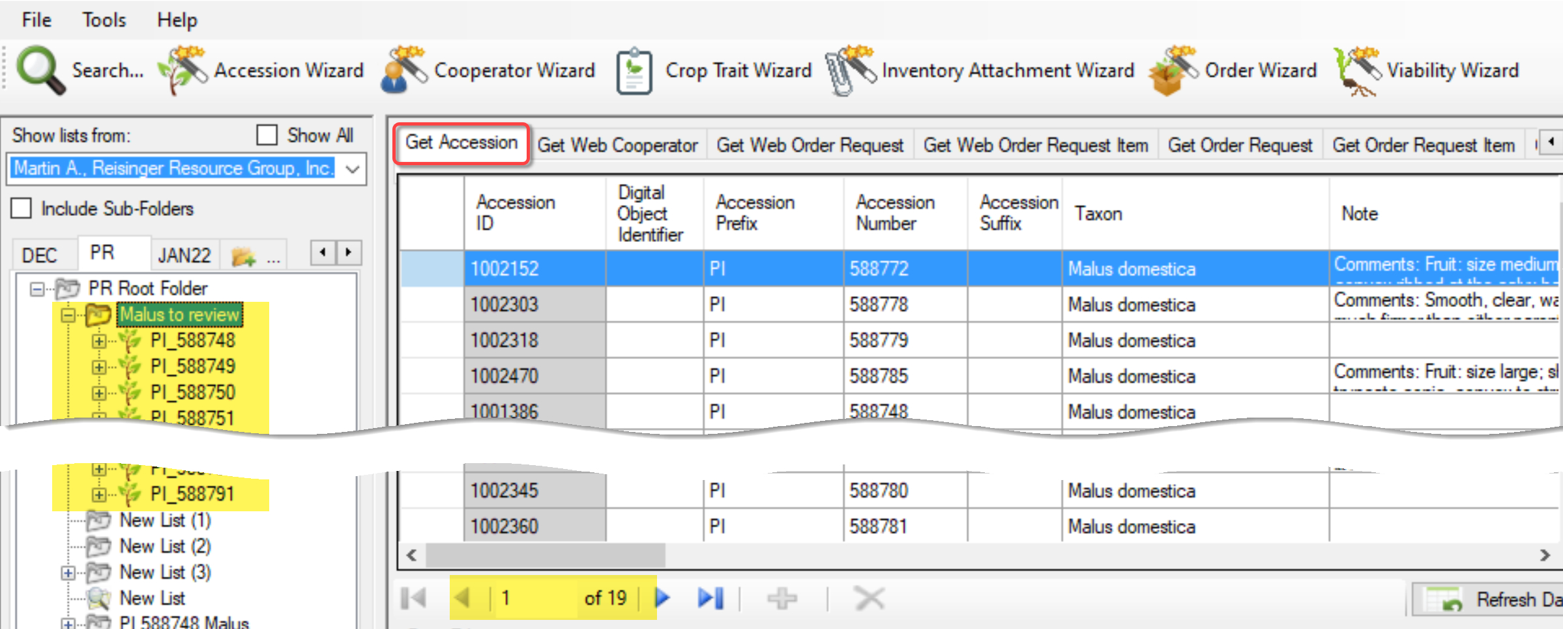

Dynamic Folders
Dynamic folders have an advantage that static folders do not have: a dynamic folder searches the database to ensure the list is current. (Under what conditions a dynamic folder refreshes is explained in detail later.) Another advantage of setting up a dynamic folder is that the folder retains your search criteria; it eliminates the steps of switching to the search tool and dragging desired records into the Curator Tool.
In this example, only one record met the criteria:
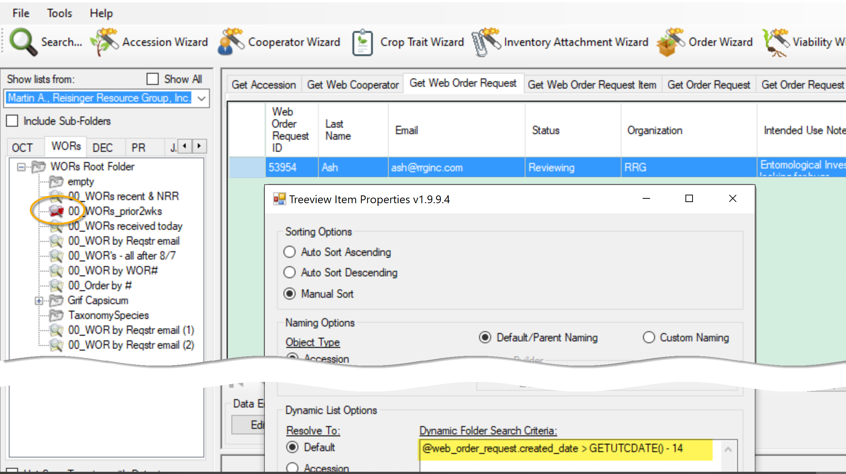

Static Folders: Advantages
So why use a static folder? First, they are simpler in some respect. Secondly, often you will want to review specific records, and only those records.
Listed below are a few examples of when each folder type is preferable:
Situation | Folder Type
Keep track of a list of records which you are working on from one day to the next – the list doesn’t change | Static
List of orders that had been submitted on a specific day  (although there would be a fixed number of records that match the date criteria – a static list would work – a dynamic list could point to that one date – later, the date could be edited to search for orders submitted on a different date) | Static  (or  Dynamic
Maintain a list of all accessions for a specific Taxon | Dynamic
Review a subset of a site’s inventory based on a certain criterion | Dynamic
Track orders based on criteria | Dynamic

Hybrid folders?
Not a good idea. That is, although it can work, it may be confusing to include list items in a dynamic folder:
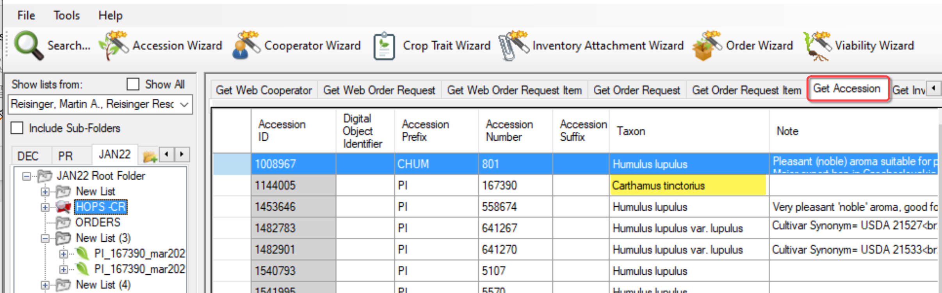
The folder HOPS-CR was established as a dynamic folder, but if you notice, there is a + (expand) icon to the left of the folder icon because an item was added (probably inadvertently). In the displayed list on the right, you might wonder what is going on since the folder was named HOPS. Clicking the + icon to the left of the folder name answers the question – an item had been added:
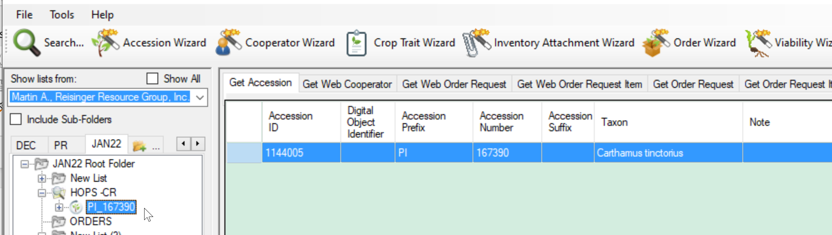

Dynamic Folder Examples

Dynamic Folder Examples*
Purpose | Code
Quick way to find an inventory record  (resolve to Inventory).  Since the record is in the CT, you can then edit it (rather than search in the Search Tool and drag the record over to the CT). | @inventory.inventory_number_part1 = 'PI' AND @inventory.inventory_number_part2 = 600000
Find inventory records created within a specific date range – in this example, between January 1 and January 21, 2022 | @inventory.created_date >= '1-Jan-2022' and @inventory.created_date <= '21-Jan-2022'
Find orders made in the year 2022  - for a site  - distributed orders only  - that are not complete  (they do not have a date filled for the COMPLETED_DATE field.  (resolve to Order Request) | @order_request.ordered_date LIKE '%2022%' AND  @site.site_short_name = 'NC7' AND  @order_request.order_type_code = 'DI' AND  @order_request.completed_date IS NULL
Find the records whose species is 'Phalaris arundinacea'  - the source type indicates records that were collected (as compared to developed or | @taxonomy_species.name = 'Phalaris arundinacea'  AND  @accession_source.source_type_code = 'COLLECTED'  AND  @geography.country_code = 'USA'
This search is looking for records at the NC7 site whose inventory availability status is low. | @taxonomy_genus.genus_name = 'Zea' AND @taxonomy_species.species_name = 'mays' AND @taxonomy_species.subspecies_name = 'mexicana' AND @site.site_short_name = 'NC7' AND @inventory.availability_status_code = 'LOW'
* When codes are involved, you need to know which codes are valid and can be included in the dynamic folder criteria. Perhaps the simplest way to find all of the existing codes at once is to open the Get Code Value Language dataview and then show only the records for your language.
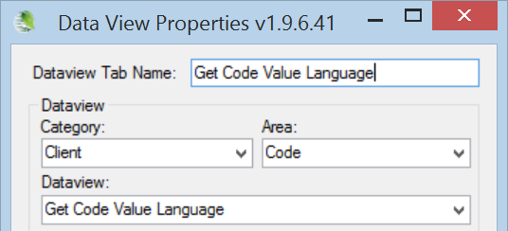

Methods for Creating Dynamic Folders
There are several methods for creating a dynamic folder. Each starts similarly: In the Curator Tool , create an empty folder.
A note about dynamic query criteria: The query text is just that, text. The criteria can be copied from a document, an email, etc. You can send someone query text and they can copy it into the properties box for a folder:
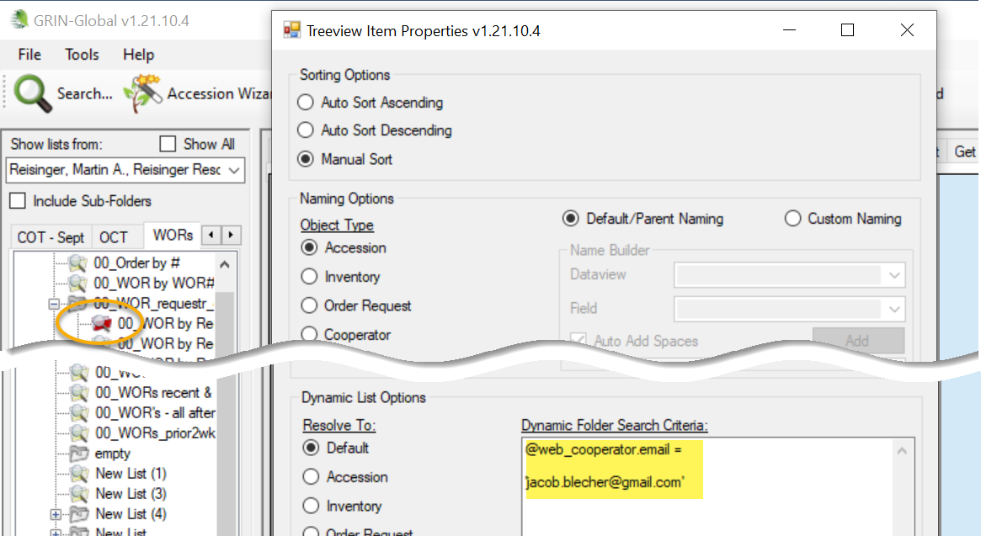

Method 1
Switch to the Search Tool; create a query. Drag the code in the large text box (generated by the QBE) onto the empty folder in the Curator Tool.

Method 2
While still in the Curator Tool, right-click on the empty folder. Select Properties from the menu. Switch to the Search Tool; create a query. Copy the code in the large text box (generated by the QBE) into the Dynamic Folder Search Criteria box in the Curator Tool.

Refreshing a Dynamic Folder
If any new records are added to the GRIN-Global database that meet the folder’s criteria, the records will be displayed when the dynamic folder is the active folder and has been refreshed. You can refresh a dynamic folder by invoking any of the following methods:
- right-click on the folder and select the Refresh List command
- switch to another tab and then back to the tab with the dynamic folder
- switch to another user and return back to the original user
- click the Refresh Data button in the right panel
- press F5
- start the CT

Making Dynamic Folders More Readable

Use Text rather than Primary Key Numbers
Try to have the dynamic folder criteria use text values as much as possible and avoid using the primary key ID numbers. (When the code looks similar to “@accession.taxonomy_species_id IN (27512, 27513, 27514),” it is using primary key numbers. You can usually replace that code with text alternatives by using tables in which the data is stored.
For example:
@order_request.ordered_date LIKE '%2022%' AND
@site.site_id IN (16) AND
@order_request.order_type_code = 'DI' AND
@order_request.completed_date IS NULL
It is difficult to know what @site.site_id IN (16) is really indicating. What site is represented by “16?”
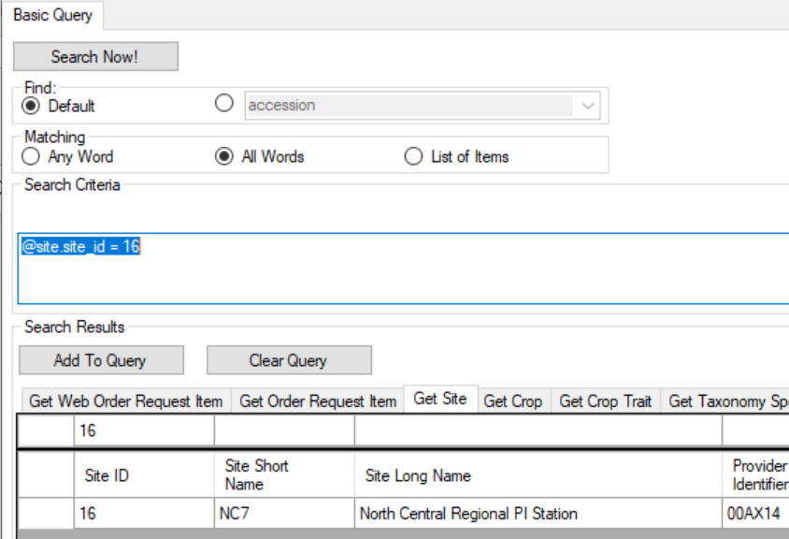

If we search by NC7...
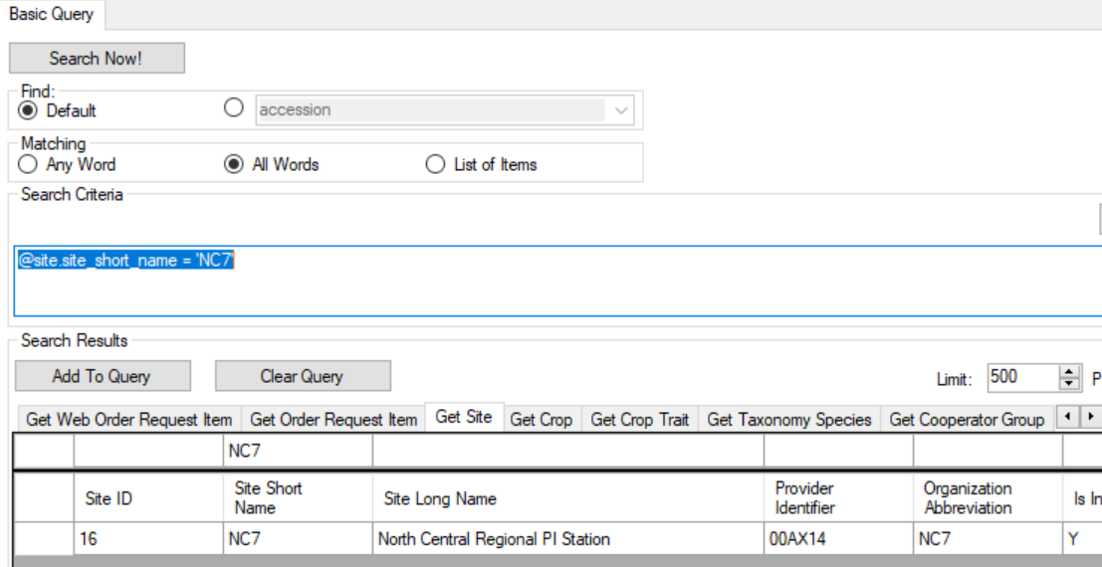
The same site record is found. Therefore, the two statements
@site.site_short_name = 'NC7'
@site.site_id = 16
are equivalent (but one is easier to read!)
Here is the new code:
@order_request.ordered_date LIKE '%2022%' AND
@site.site_short_name = 'NC7' AND
@order_request.order_type_code = 'DI' AND
@order_request.completed_date IS NULL
Later, if you want to search for orders for a different site, you can exchange the NC7 with the value of another site. For example, S9:
@site.site_short_name = 'S9' AND

Second Text Example: Specifying the Taxon and the Geography
The following dynamic folder works fine, but when reviewing the code, it is difficult to know what species the 27923 is referring to, or what the geography_id 1041 is referring to.
@accession.taxonomy_species_id IN (27923)
AND @accession_source.geography_id IN (1041)
AND @accession_source.is_origin = 'Y'
If we display the Accession dataview, we can deduce the species _id of 27923 is Helianthus annuus and the geography_id value 1041 must be referring to United States, South Dakota:
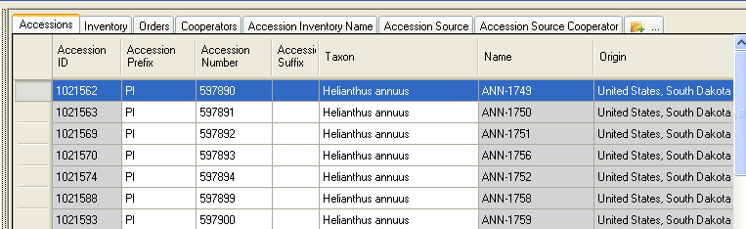
If we display the Accession Source dataview, we can confirm that the geography_id value 1041 is referring to United States, South Dakota:
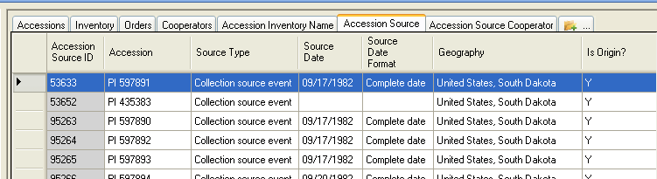

If you want to make the Dynamic Folder easier to understand when you review its criteria some time later, you can use the ID values and substitute for them actual text strings, using the appropriate fields.

For example, starting with @accession.taxonomy_species_id IN (27923), if you search in the taxonomy species dataview, the following record will display:
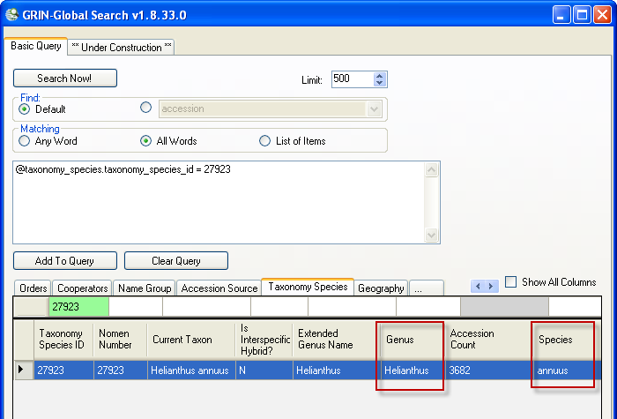

Notice the two fields for Genus and Species. You can execute a new search and use their QBE cells to generate the search string that uses their text:
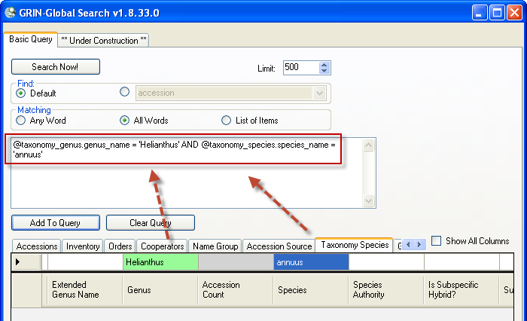
@taxonomy_genus.genus_name = 'Helianthus' AND
@taxonomy_species.species_name = 'annuus'
This search clause is essentially doing the same as
@accession.taxonomy_species_id IN (27923)
but the first statement is much easier to understand than the other.

Similarly, the following two statements are equivalent, but one is much easier (to a human) to understand:
@geography.geography_id = 1041
vs. @geography.country_code = 'USA' AND @geography.adm1 = 'South Dakota'

I use the Geography dataview to determine these field names and values.
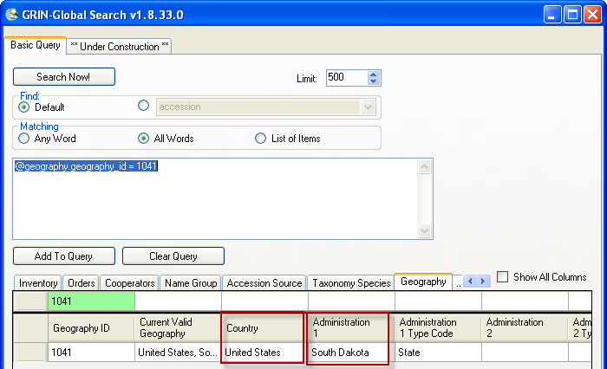
Do a new search, but now I use the Country and Administration 1 cells to run the query: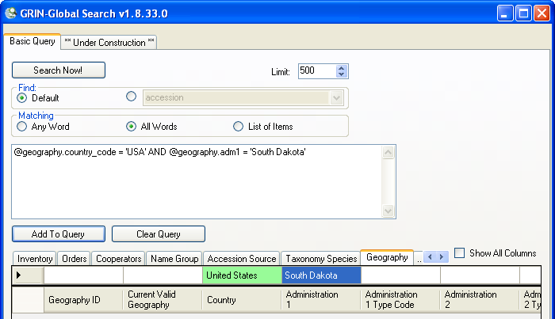

The codes that is generated in the search text box
@geography.country_code = 'USA' AND @geography.adm1 = 'South Dakota'
is equal to
@geography.geography_id = 1041

Back to the original statement at the beginning of this topic; we had:
@accession.taxonomy_species_id IN (27923)
AND @accession_source.geography_id IN (1041)
AND @accession_source.is_origin = 'Y'
Now, using what we learned in the examples above, we can assemble a much easier-to-understand statement and store this in the Properties | Dynamic FolderSearch Criteria box:
@taxonomy_genus.genus_name = 'Helianthus'
AND @taxonomy_species.species_name = 'annuus'
AND @geography.country_code = 'USA'
AND @geography.adm1 = 'South Dakota'
AND @accession_source.is_origin = 'Y'

In the future, you can edit the folder properties and replace any of the text values to find the desired records.

Sample Queries

One Accession
@accession.accession_number_part1 = 'PI' AND
@accession.accession_number_part2 = 600000

Accession Range
( @accession.accession_number_part2 > 500000 AND @accession.accession_number_part2 < 500100 )

Several Accessions
@accession.accession_number_part1 = IN ('PI' , 'CRIB') AND
@accession.accession_number_part2 > 500000

An Accession – by its name
EGR 1
(where EGR 1 is the Accession-Inventory name)

One Species
@taxonomy_species.name = 'Ribes cereum'

Born in the USA
@taxonomy_species.name = 'Helianthus tuberosus'
AND @accession_source.source_type_code = 'COLLECTED'
AND @geography.country_code = 'USA'

Collected -USA but not obvious
@accession_source.source_type_code = 'COLLECTED' AND @accession_source.geography_id IN (926, 1001, 1002, 1003, 1004, 1005, 1006, 1007, 1008, 1009, 1010, 1011, 1012, 1013, 1014, 1015, 1016, 1017, 1018, 1019, 1020, 1021, 1022, 1023, 1024, 1025, 1026, 1027, 1028, 1029, 1030, 1031, 1032, 1033, 1034, 1035, 1036, 1037, 1038, 1039, 1040, 1041, 1042, 1043, 1044, 1045, 1046, 1047, 1048, 1049, 1050, 1051) AND @accession_source.is_origin = 'Y' AND @accession.taxonomy_species_id IN (27512, 27513, 27514)

Looking for Origin
@accession.taxonomy_species_id IN (27923)
AND @accession_source.geography_id IN (1041)
AND @accession_source.is_origin = 'Y'

Pending Orders
@order_request.ordered_date LIKE '%2022%' AND
@site.site_short_name = 'S9' AND
@order_request.order_type_code = 'DI' AND
@order_request.completed_date IS NULL

Sorghum - KERCOLOR 2 4
@crop.name = 'SORGHUM'
AND @crop_trait.coded_name = 'KERCOLOR'
AND @crop_trait_code.code IN ('2', '4')

Looking for available inventory
@taxonomy_genus.genus_name = 'Zea' AND
@taxonomy_species.species_name = 'mays' AND
@taxonomy_species.subspecies_name = 'mexicana' AND
@site.site_short_name = 'NC7' AND
@inventory.availability_status_code = 'LOW'

Looking for low inventory
@inventory_maint_policy.maintenance_name LIKE 'NC7-maize.pop%' AND
@inventory.is_distributable = 'Y' AND
@inventory.is_available = 'Y' AND @inventory.availability_status_code = 'AVAIL' AND @inventory.quantity_on_hand < 1500

