Connecting to a GRIN-Global Database

Revision Date
October 25, 2023

Author
Martin Reisinger

Please send any questions related to the wizard to marty.reisinger@usda.gov or feedback@ars-grin.gov.

The Appendix contains change notes pertaining to this document.

Table of Contents

Introduction 3
GRIN-Global at NPGS 3
GRIN-Global Documentation Questions 5
Details 5
Default Server - localhost 5
Username and Password 6
National Plant Germplasm System (NPGS) Specifics 6
Other GRIN-Global Database Server Names 7
Connecting to a GG Server 7
NPGS Production Database 7
localhost 8
Training Server at NPGS 8
CT Error Messages 9
Public Website Settings 10
Curator Tool Passwords 10
Self-Service Password Reset Tool 11
NPGS DEV Server 12
Appendix: Documentation Notes 13

Introduction
When the Curator Tool (CT) is installed on a user’s PC, it does not point to a genebank’s server (database) unless the directions for installing the CT are completely followed.
This document explains how to connect genebank staff members’ Curator Tool on their PCs to a GRIN-Global database on a remote server. The document uses NPGS connections as examples. Other genebanks will have different connections settings. In any case, the genebank’s GRIN-Global administrator will be able to provide the specific server information.
This document also includes a brief reference to connecting to the GG Public Website.

GRIN-Global at NPGS
NPGS has two GRIN-Global (GG) databases – the “production” “NPGSWEB” and the training db “TRAINING.” When a new staff person starts at NPGS, they typically have two Curator Tool (CT) accounts for them.
These two CT accounts are completely distinct. Most likely you will have the same UserName, but the passwords could be different or get out of synch if you update one and not the other, etc.
There are also two GG Public Websites. Same idea – 2 separate profiles. You as the user can create these two profiles.
At NPGS, ultimately you may have 4 GG accounts:
Databases | Curator Tool | Public Website | URLs
NPGSWEB | 1 | 2 | https://npgsweb.ars-grin.gov/gringlobal/search
TRAINING | 3 | 4 | https://training.ars-grin.gov/gringlobal/search

The GG DBA, Benjamin Haag (or a cohort), must enable the PW accounts to be treated as “internal” staff accounts …so that you can run queries under the PW’s Tools Web Query option. As a staff person, you will also have access to Reports that are not available to the public.
From the New User’s checklist: http://grin-global.org/docs/NPGS_staff_entrance_and_exit_checklist.docx
…
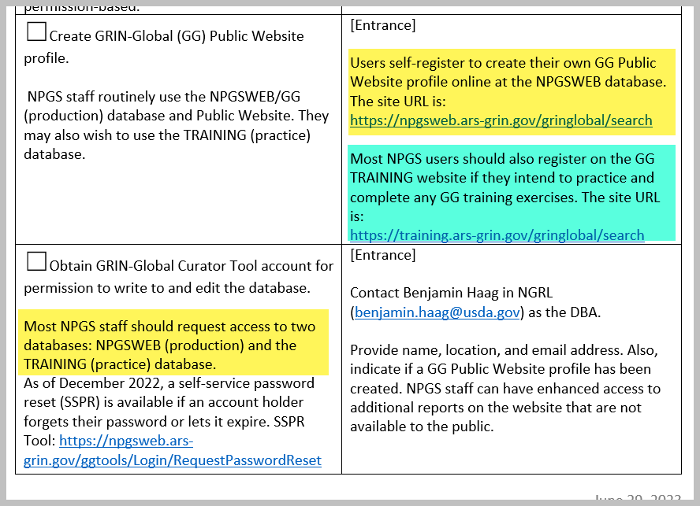
When I am a “public user” (in this case, I have not logged in yet):
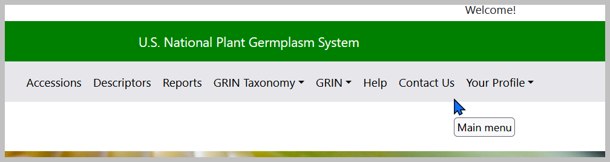
When I am logged in: the Tools option displays. Visibly, the Reports option is displayed both ways, but when I open the Reports option, I will see many more reports than what is seen by the public:
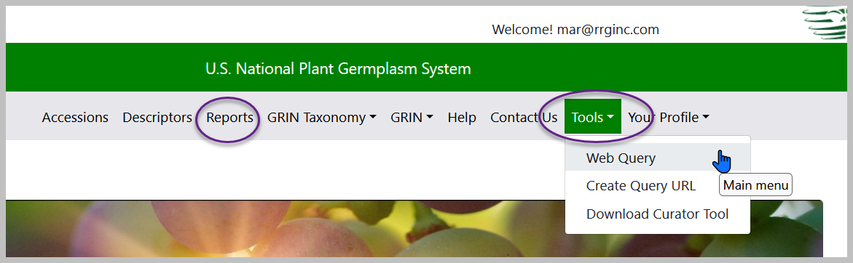
NPGS has additional GRIN-Global servers, but these are used by only a handful of people who are testing or developing the software.

GRIN-Global Documentation Questions
For any questions related to GRIN-Global at NPGS, please contact Marty Reisinger at marty.reisinger (at) usda.gov. The GRIN-Global website contains extensive documentation guides, videos, and other resources at:
- https://www.grin-global.org/userdocs.htm
- https://www.grin-global.org/NPGS_news.htm
- https://www.grin-global.org/videos.htm

Details

Default Server - localhost
When the CT is initially installed, the CT points automatically to a “localhost” server. Rarely is this a valid server. Most genebank staff need to connect their PC to a remote database server.
(The localhost setting is only valid when the GG database is also installed on the user’s PC, typically done by IT professionals doing testing.)

The default setting – not typically used:
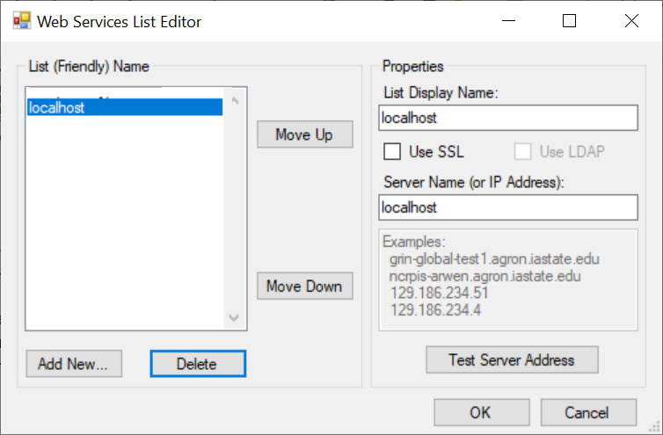

When other server connections have been established, the localhost entry can be deleted from the list if desired. It is also fine to leave it in the list.

Username and Password
Curator Tool users need a user account and password set up by the genebank’s GG database administrator. The following settings illustrate how to connect to the NPGS* production server.
Obtain your Username (often your email address) and Password from your genebank’s GRIN-Global administrator. For more password details. review the Curator Tool Password section.
Username:
Password:

National Plant Germplasm System (NPGS) Specifics
Note: - Benjamin Haag is the NPGS GG administrator. ( Benjamin.Haag@usda.gov) He will establish two accounts, one for production data “NPGSWEB” and another for practice “TRAINING.”
These two accounts are separate accounts. Most likely these accounts will seem identical to the user. That is, the accounts may have the same usernames and passwords. Eventually though, the passwords may be reset at different times and one account‘s password may differ from the other account.

Accounts
Each NPGS user may ultimately need four user accounts:
Server & Program | Username | Password
NPGSWEB & Curator Tool
TRAINING & Curator Tool
NPGSWEB & Public Website
TRAINING & Public Website

The database administrator (DBA) uses an Admin Tool to connect your CT account with the PW account (for each database).

Other GRIN-Global Database Server Names
GRIN-Global administrators determine the GG server information for their respective genebank. Users who will be using the Curator Tool need to know the genebank’s proper server information and should contact their administrator.

Connecting to a GG Server
Click the Edit Server List button to edit or add GG servers to a list:
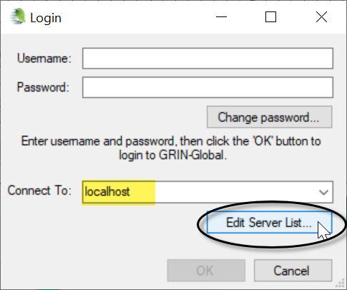

NPGS Production Database
As an example:
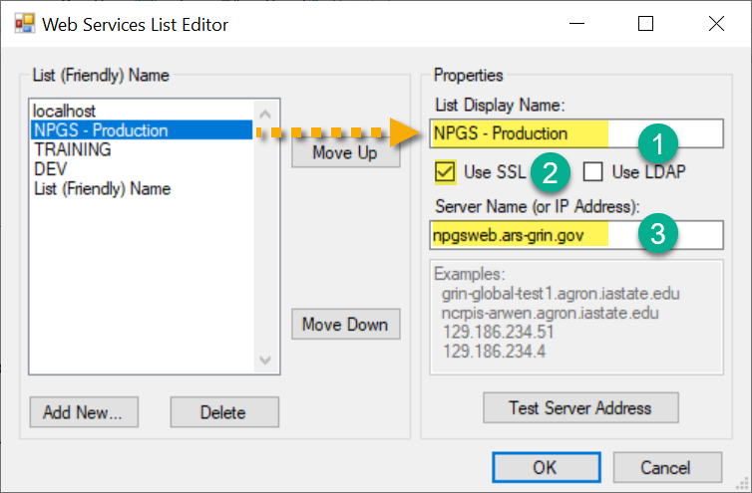
- In the List Display Name box, input a name as your friendly name for the database (can be any text).
- Some organizations, such as NPGS, will be using SSL.
- (If not NPGS) your genebank’s GRIN-Global administrator should provide the server information. It will either be a valid domain server name, or a string a numbers (an explicit IP address). For example, at NPGS, the production server is: npgsweb.ars-grin.gov
In the example image above, five server names are listed in the left box. When multiple names are listed, use the Move Up and Move Down buttons to order the server names as desired. Typically, the server you will primarily be using will be positioned at the top of the list.

localhost
Most people do not need the localhost connection. That connection can be deleted by selecting localhost and then clicking the Delete button. (localhost is a full GG database on the user’s PC. Most genebanks use a remote server and users must connect to that database.)

Training Server at NPGS
On NPGS PCs with a newly installed CT, the server information for all databases needs to be initially entered.* NPGS has a production server (NPGSWEB), and a training server, “TRAINING.”

Here’s how to connect the Curator Tool to the NPGS TRAINING database:
At the Login window, click the Edit Server List button
To include or delete servers from the list, click the Edit Server List button:
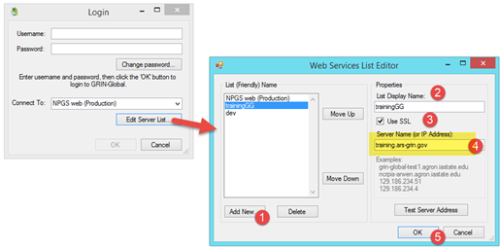
- Click Add New
- In the List Display Name box, input a name (can be any text) for the database.
- Some organizations, such as NPGS, will be using SSL.
- In this example: training.ars-grin.gov
NPGS is using Secure Sockets Layer (SSL) security. The Use SSL checkbox must be selected. The actual NPGS server address is shown here for the training database. Each genebank will determine its own Server Name / IP Address. Contact your organization’s GG administrator if you do not know what server name to use.
* CT Installers / Administrators: The text file WebServiceURL.txt is stored on a user PC when the CT is installed. Prior to CT Release 1.22.8.24, the folder was located under the ProgramData folder, but beginning with 1.22.8.24, the file is installed under the user’s Roaming folder (next two images). When setting up the Curator Tool on multiple PCs, you can copy this text file into the proper folder rather than manually connect with the steps listed above.

Prior to CT version 1.22.8.24
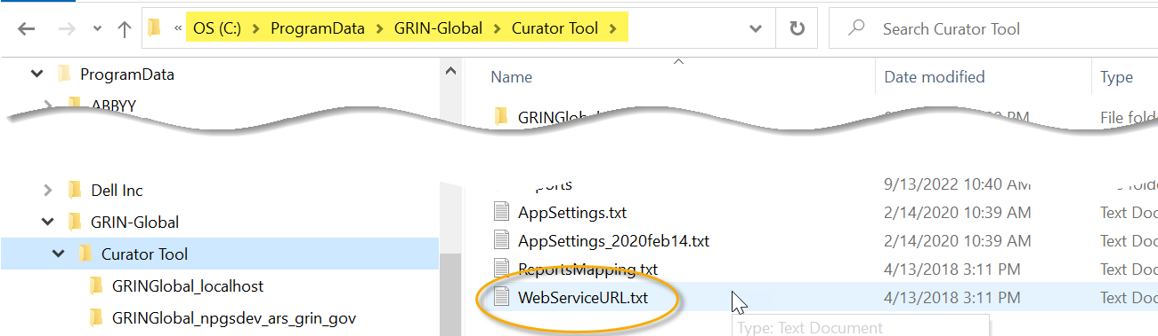

Beginning with CT version 1.22.8.24
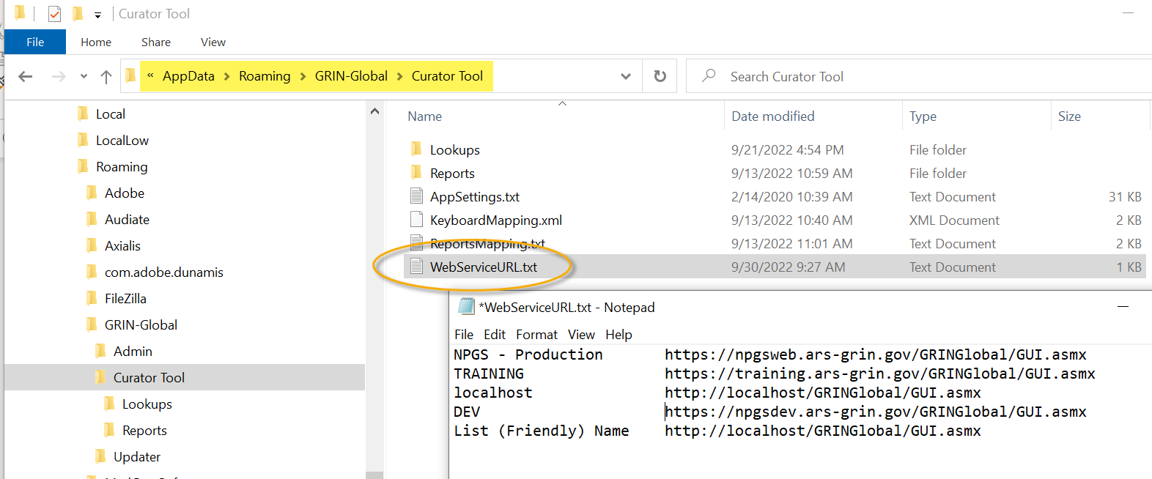

CT Error Messages
When attempting to log in, the message "Account locked due to password expiration" is indicating that the password is expired and needs to be reset.
When there have been too many failed password attempts (five) the error message is: "Account temporarily locked." If you wait fifteen minutes, you can attempt to login again.
If your password has expired, and your organization has the CT Password Reset utility set up, you can renew your password. See Reset Utility. Otherwise, contact the GG administrator for your organization.

Public Website Settings
Each database, NPGSWEB and TRAINING, has its respective Public Website (PW). Users themselves will create (“Register”) their two PW user accounts. After they have registered, let Benjamin know and he can associate the PW to the CT account so that certain “internal” privileges are possible for the staff person.
The URL’s are:
• NPGSWEB: https://npgsweb.ars-grin.gov/gringlobal/search.aspx?
• TRAIINING: https://training.ars-grin.gov/gringlobal/search.aspx?

Curator Tool Passwords
Organizations running GRIN-Global can adjust the Curator Tool password requirements, but generally, a password must begin with a letter, have at least 12 characters, and must include upper and lower case letters, at least one number and one special character. When you change a password, you are expected to change at least three of the characters.
Most genebanks have the password expire after 60 days and you must update it. If it has expired, you can still update by using the Change password button on the CT Login window:
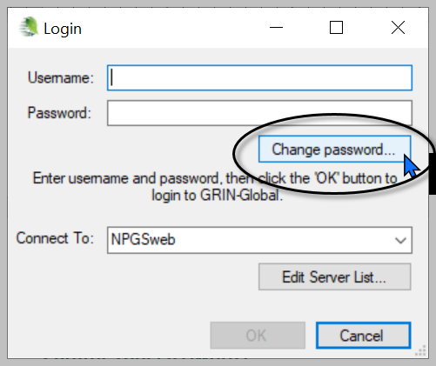 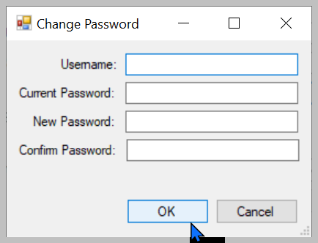

Self-Service Password Reset Tool
Note that some GG genebanks have implemented the CT Self-Service Password Reset tool. This is browser-based, so if your genebank has implemented this utility, you only need to indicate its URL.
[At NPGS, the URL for the “production” database, NPGSWEB, is: https://npgsweb.ars-grin.gov/ggtools/Login/RequestPasswordReset ].
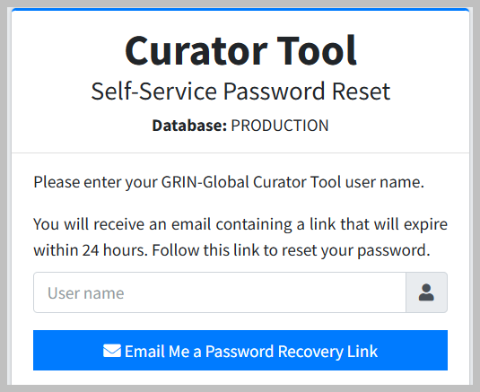

TRAINING Self-Service Password Reset Tool
The TRAINING database also has the self-service password reset capability in NPGS.
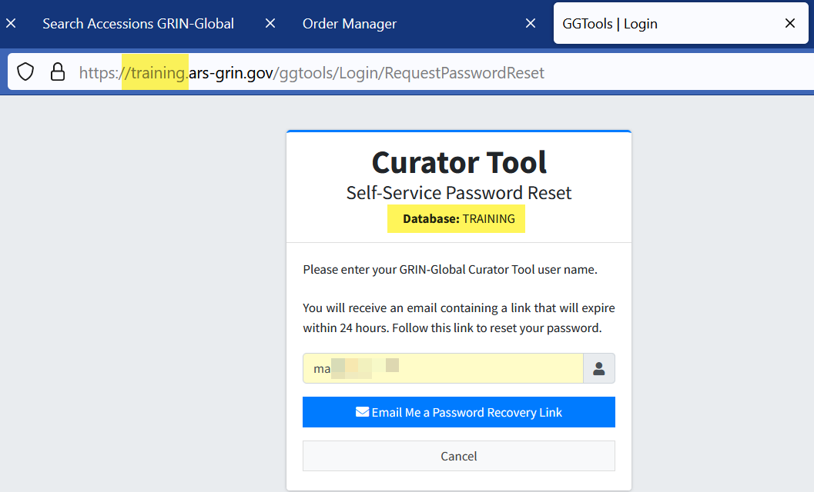

NPGS DEV Server
Sometimes people in NPGS are asked to test something on the DEV server (“DEV” for development). The URL for the DEV public website is: https://npgsdev.ars-grin.gov/gringlobal/search
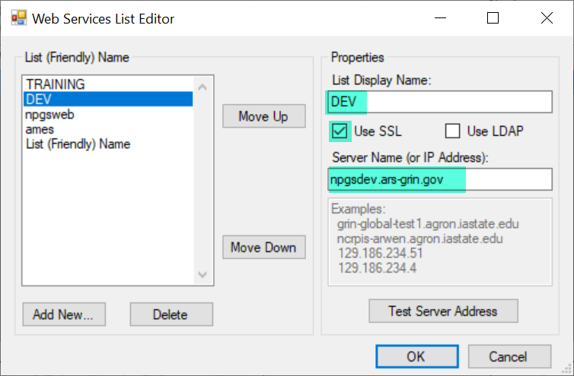

Appendix: Documentation Notes
- October 25, 2023
  - Added screen and info on the TRAINING password rest utility
- August 17, 2023
  - Added more info
- March 13, 2023
  - Added CT account error messages

