GRIN-Global Coded Descriptors

Revision Date
August 17, 2017

Refer to the online guide Observations and Descriptors at https://www.grin-global.org/docs/gg_observations_and_descriptors.docx for details on creating and using characterization descriptors. This document contains examples from NPGS, showing descriptors (traits) which use coded values and shows how they display when viewed in the Lookup Picker.
The Observations and Descriptors guide also explains English and ENG languages. Briefly, the English versions displays the code title, whereas ENG displays the trait code.

Contents
Examples 2
WHEAT (HABIT) 2
English Version 2
Eng Version 2
WHEAT (AWNCOLOR) 3
WHEAT (HESSIAN FLY) 4
English Version 4
Eng Version 4
MAIZE (NORTHERN LEAF BLIGHT) 5
MAIZE (NORTHERN LEAF BLIGHT RACE O) 6
MAIZE (VIGOR) 7
BACTERIAL STEM ROT (SWEET POTATO) 8
English Version 8
ENG Version 8
CHROMOSOME COUNT (SWEET POTATO) 9
FLOWERCOLOR (SWEET POTATO) 10
Developing Crop Descriptor Lists 11

Examples

WHEAT (HABIT)

English Version
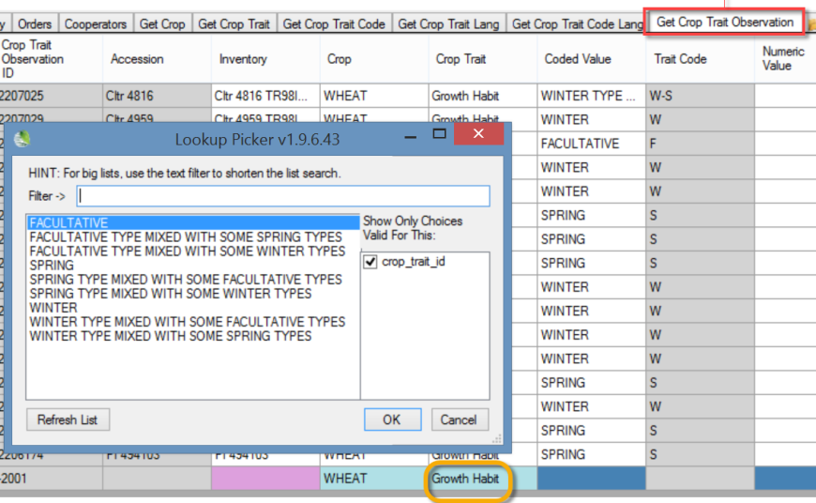

Eng Version

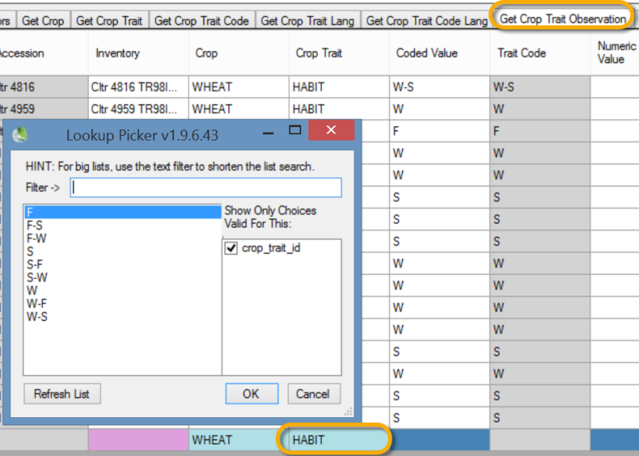

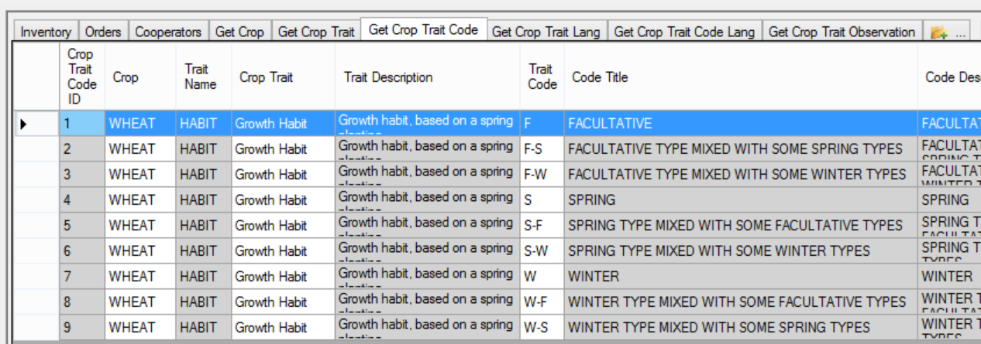

WHEAT (AWNCOLOR)
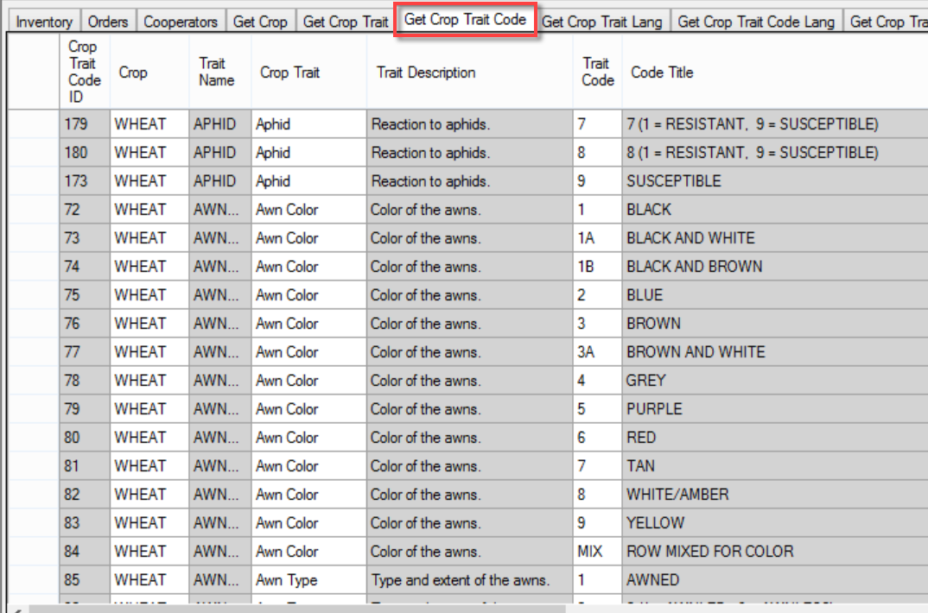
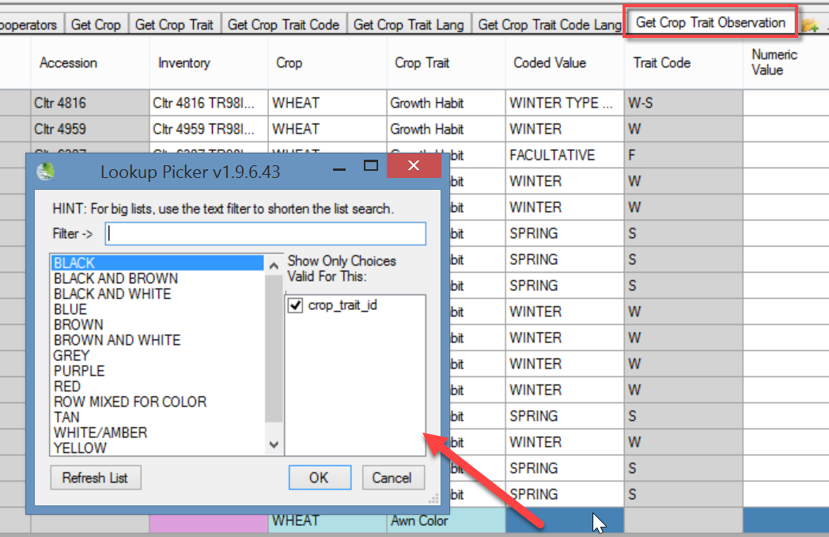

WHEAT (HESSIAN FLY)

English Version
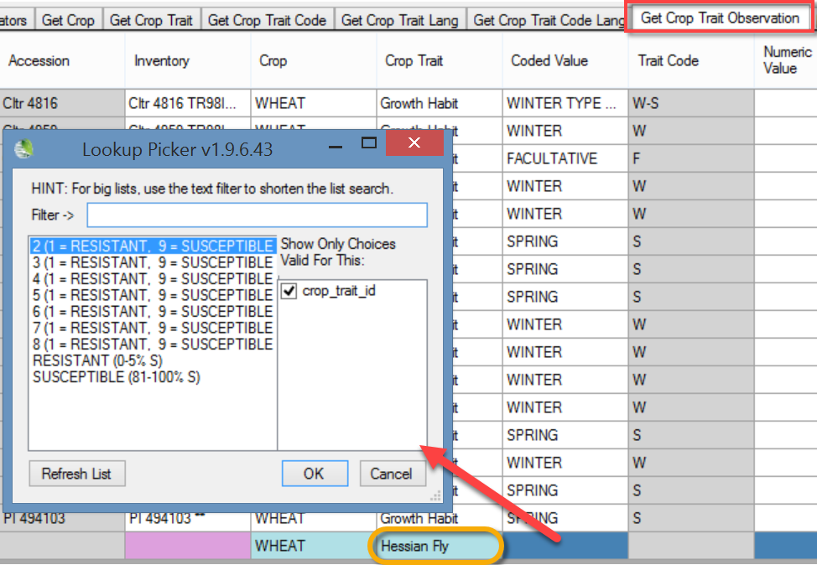

Eng Version
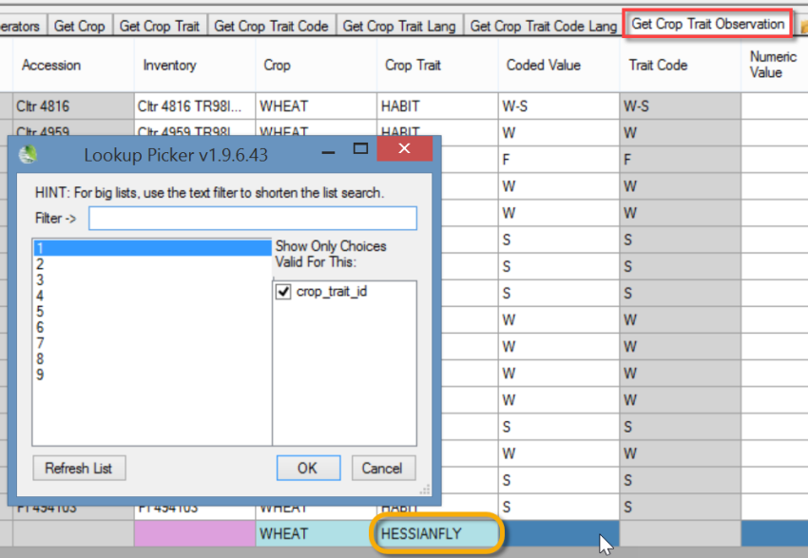
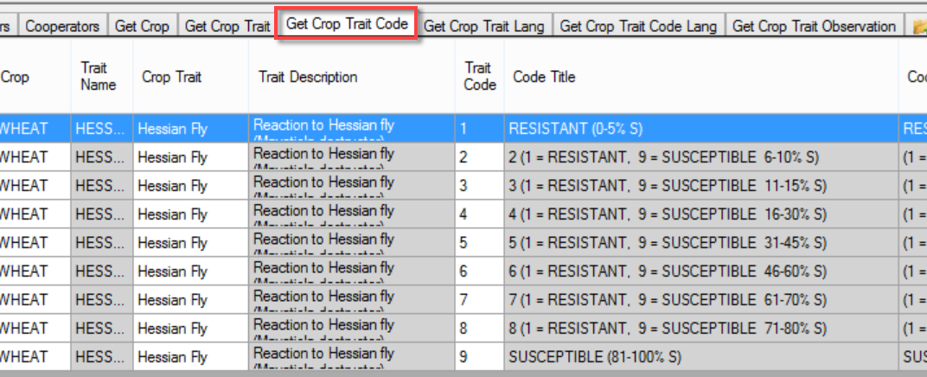

MAIZE (NORTHERN LEAF BLIGHT)
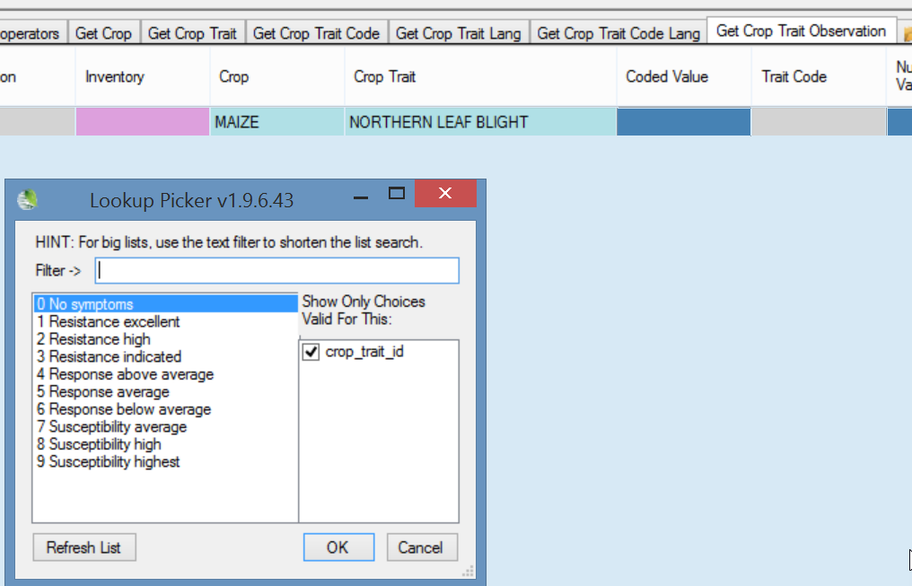

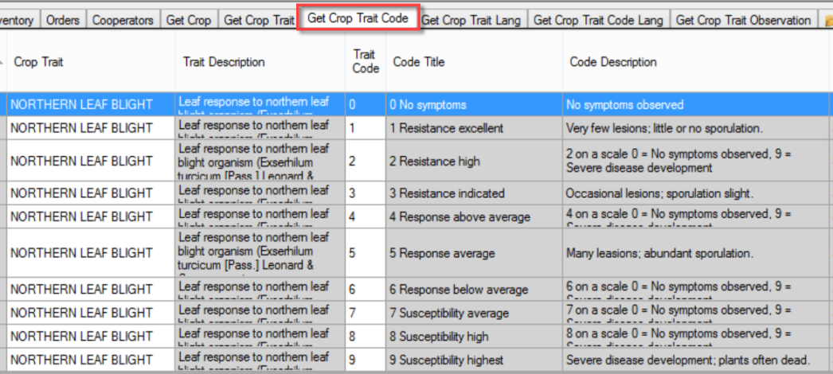

MAIZE (NORTHERN LEAF BLIGHT RACE O)
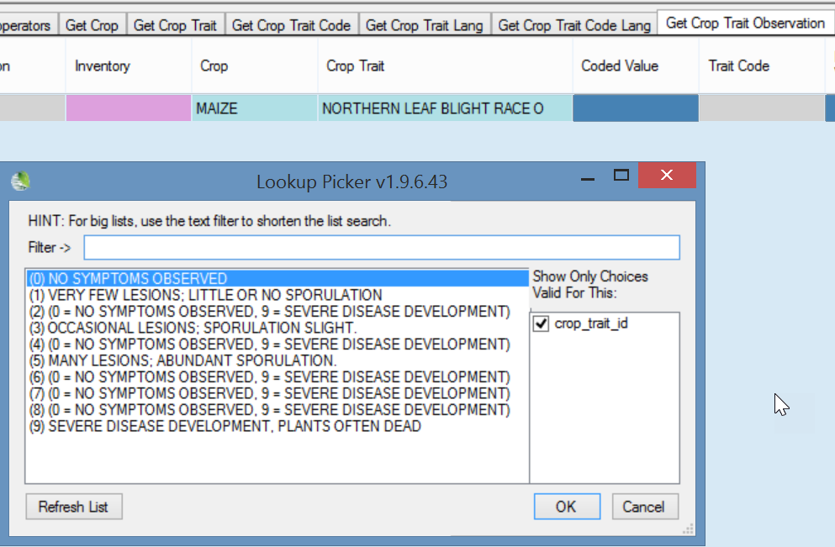
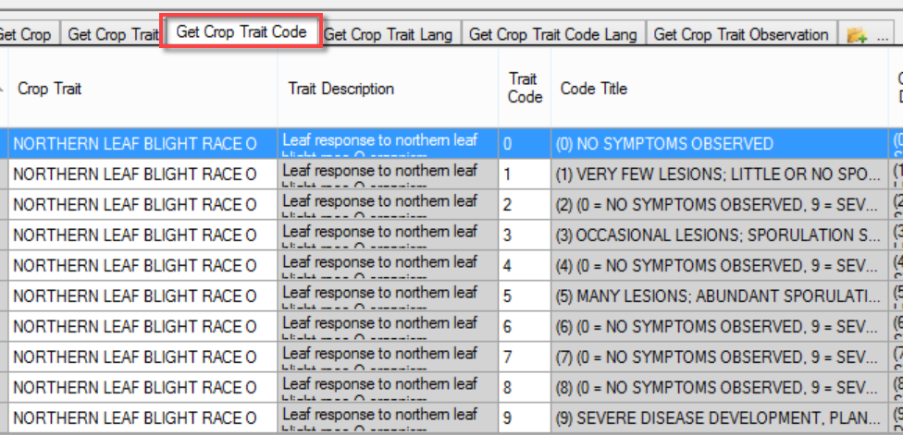

MAIZE (VIGOR)
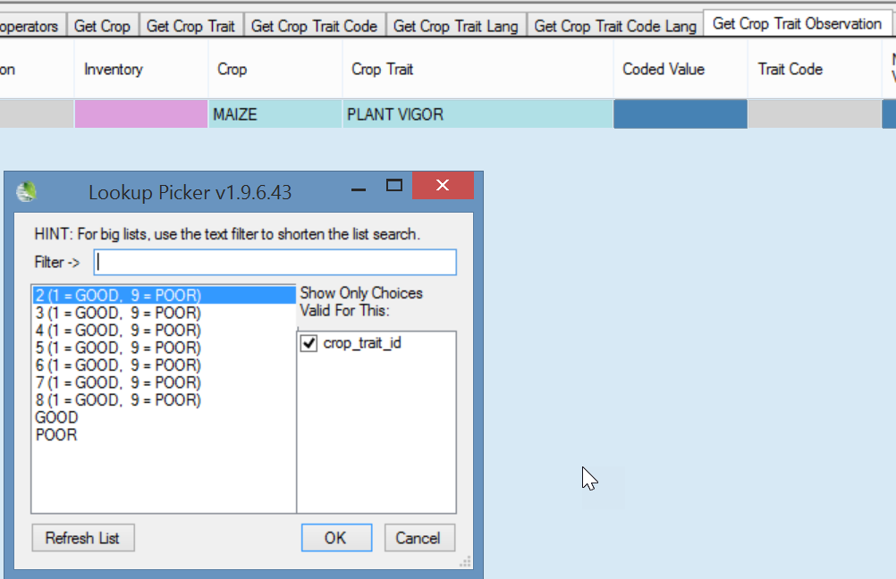

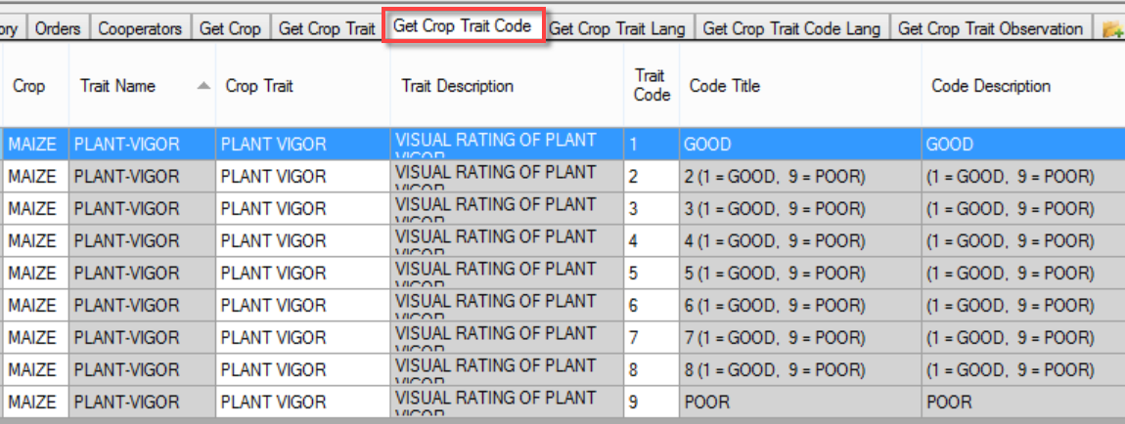

BACTERIAL STEM ROT (SWEET POTATO)
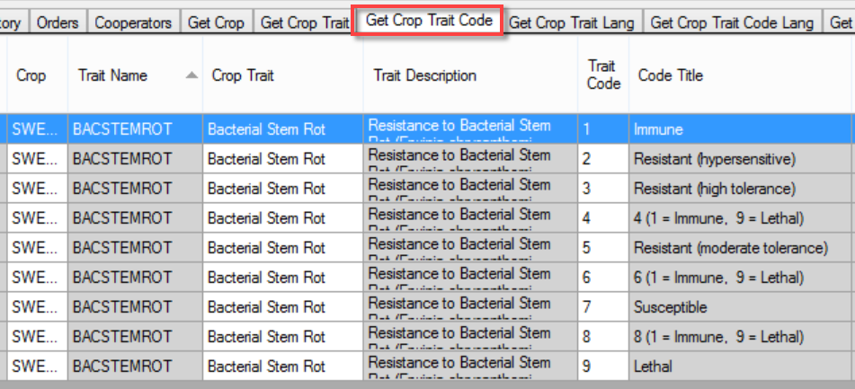

English Version
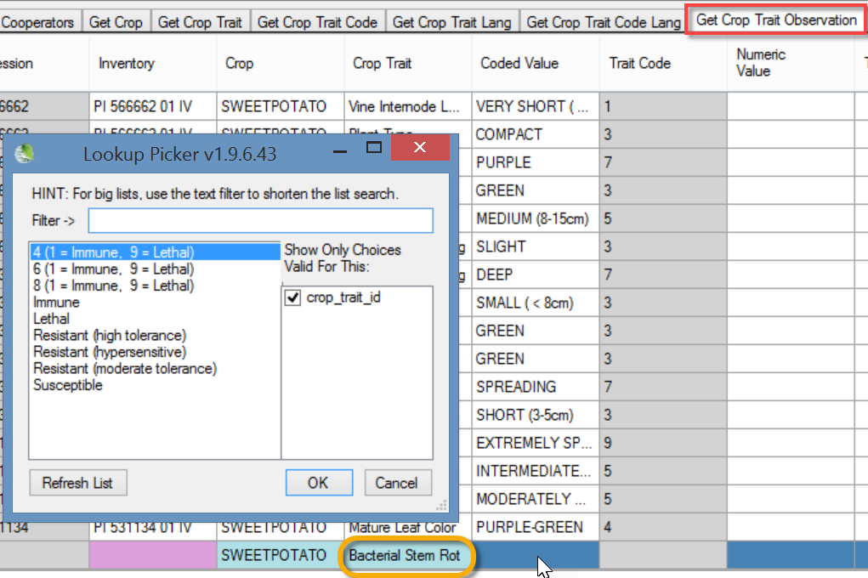

ENG Version
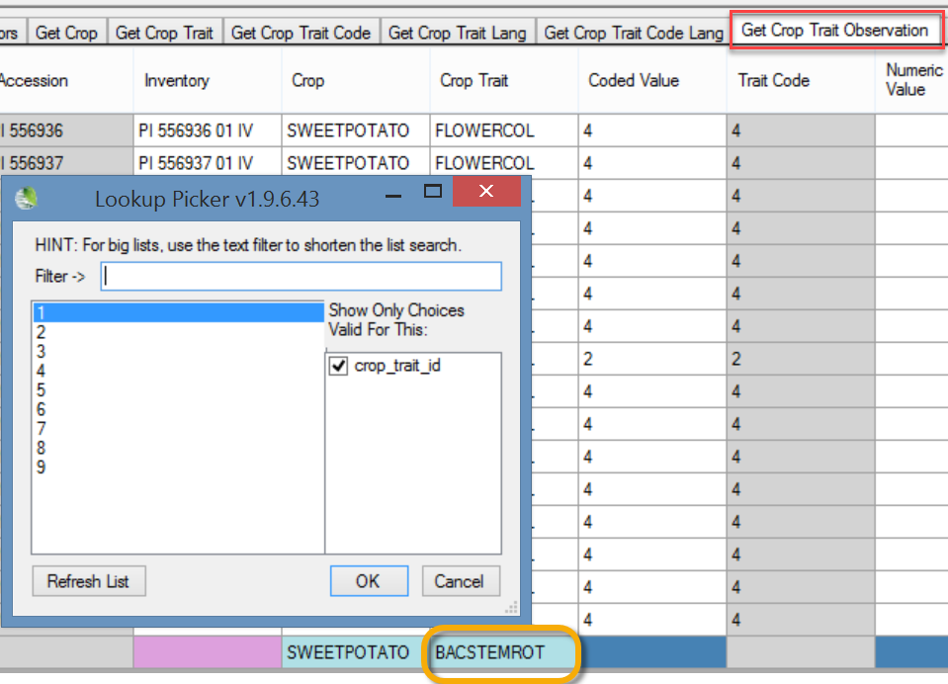

CHROMOSOME COUNT (SWEET POTATO)
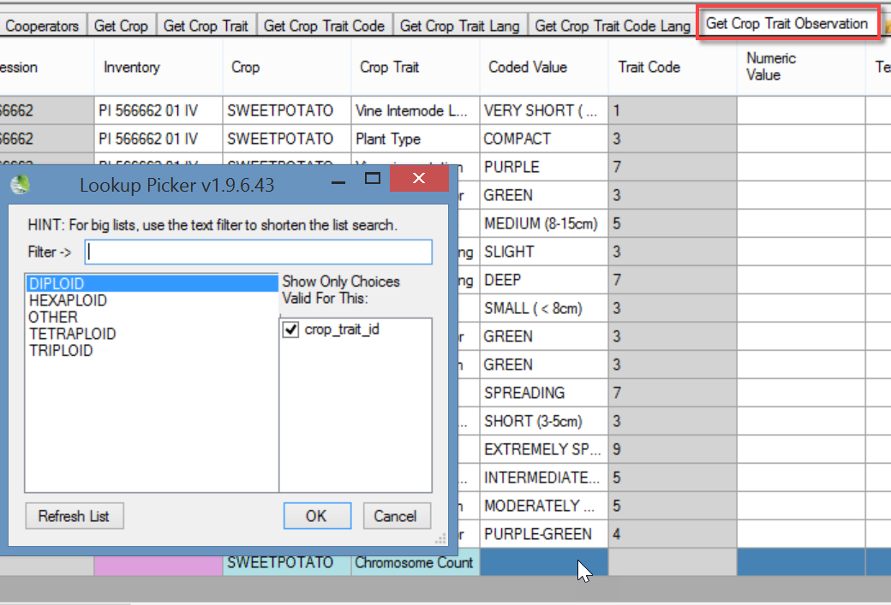
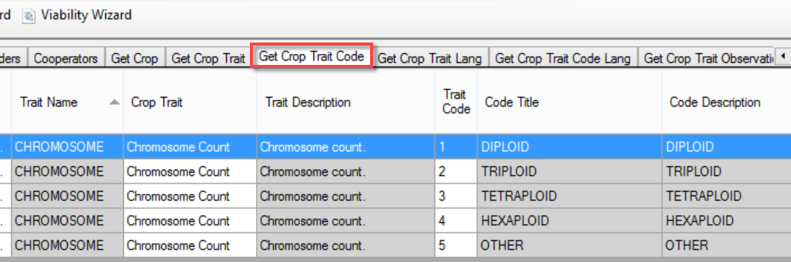

FLOWERCOLOR (SWEET POTATO)
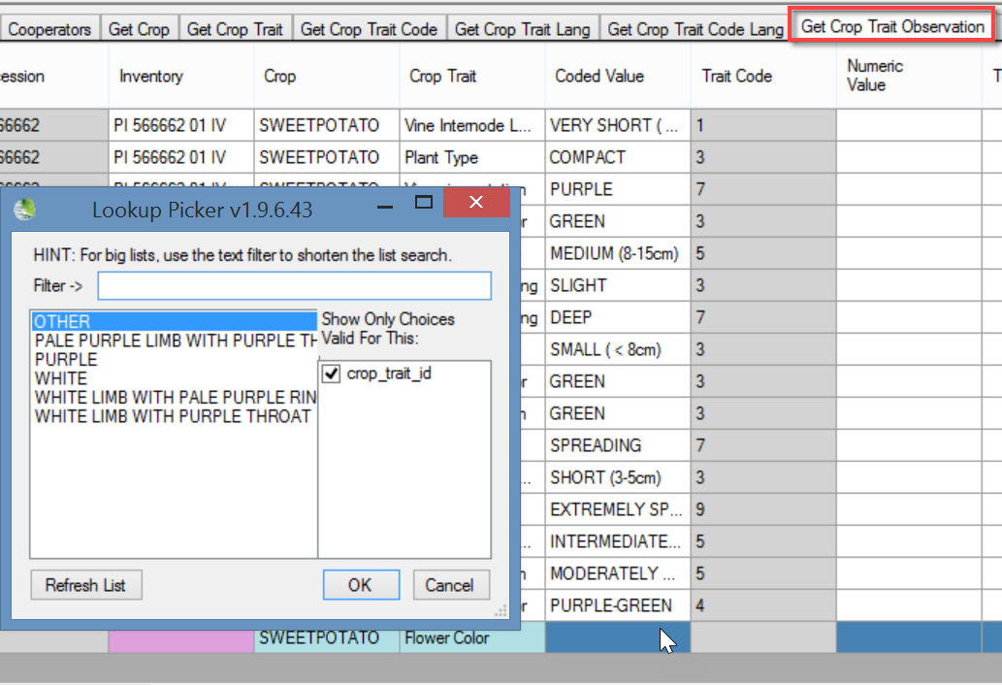
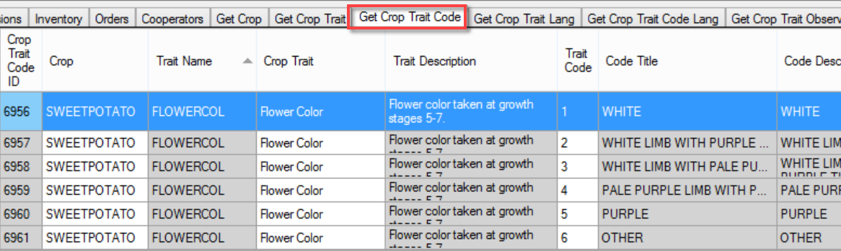

Developing Crop Descriptor Lists

Bioversity Technical Bulletin #13
http://www.bioversityinternational.org/e-library/publications/detail/developing-crop-descriptor-lists/
Page 26:
