Citations & Literature

Revision Date
April 3, 2024

Citation Documentation and Video Resources 3
Documentation 3
NPGS Q & A Session Recording 3
Dataviews Used with Citations 4
Entering Literature 5
Searching for Literature 5
Creating a Citation 7
Citation Dataview 7
“Specific” Citation Dataviews 7
Accession 8
Reference Type 8
Citation Year 8
Reference Title 8
Citation Title 8
Abbreviated Literature Source 9
Reference 9
Literature Source 9
Author(s) Name 10
DOI Reference 10
URL 10
Reference Description 10
Note 10
Searching for Citations 11
Citation Resolvers 12

Citation Documentation and Video Resources

Documentation
- This guide: http://grin-global.org/docs/gg_citations.pdf
NPGS Q & A Session Recording
NPGS's taxonomist, Melanie Schori, explained how to properly create citations and literature references in GRIN-Global.
- Recording (video): http://grin-global.org/qna/citations_2021may13_melsch.mp4
- Corresponding slides: http://grin-global.org/docs/citations_in_GRIN-Global.pdf

Dataviews Used with Citations

Question
How do I record a citation? Why is there a general Citation dataview and also other _citation dataviews?

Answer
There is one comprehensive citation dataview and eight specific citation dataviews; however, there is only one citation table.
You don’t need any dataview other than the Citation dataview to make and view citations, but eight other citation dataviews were designed to target specific citation types. They are recommended to be used when entering specific citations. For example, use the method_citation dataview when creating new citations for your methods.
The specific citation dataviews are not stored in one area. Generally, they are listed under their respective area. For example, accession_citation, accession_IPR_citation, and the accession_pedigree_citation dataviews are under the Accession area. The table below lists the areas for the citation-related dataviews:
Dataview | Area
accession_citation  accession_ipr_citation  accession_pedigree_citation | Accession
citation | Citation
genetic_marker_citation | Genetic
literature | Citation
method_citation | Method
taxonomy_family_citation  taxonomy_genus_citation  taxonomy_species_citation | Taxonomy

Each of the eight citation dataviews uses a key field to link to the respective data. Although there are no “required fields,” the field relating the record to its parent must be selected from a lookup table. In the case of the accession_ipr_citation dataview, the Accession IPR field must be completed.
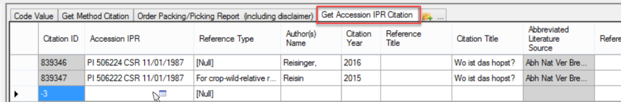

Entering Literature
Names of journals, books, and websites are stored in the Literature Table. When entering a citation, since the citation record is referring to an existing literature record in the literature table, the corresponding literature record must be first added to the Literature table.
Ideally each GG organization will have a designated manager who maintains this table. Requests for additions should be sent to the table’s manager. In NPGS, this is Melanie Schori, the Taxonomist.
If you will be creating many citations from a different type of work (thesis or dissertation, report), request that it be added to the table.
In the citation dataviews, the Literature Source field uses the literature_lookup table which relates to the entries table.

Searching for Literature
Use the Search Tool to check for a work in the Literature dataview. Enter text and wildcards in the Reference Title QBE field. Typically, the text is embedded within wildcards. For example:
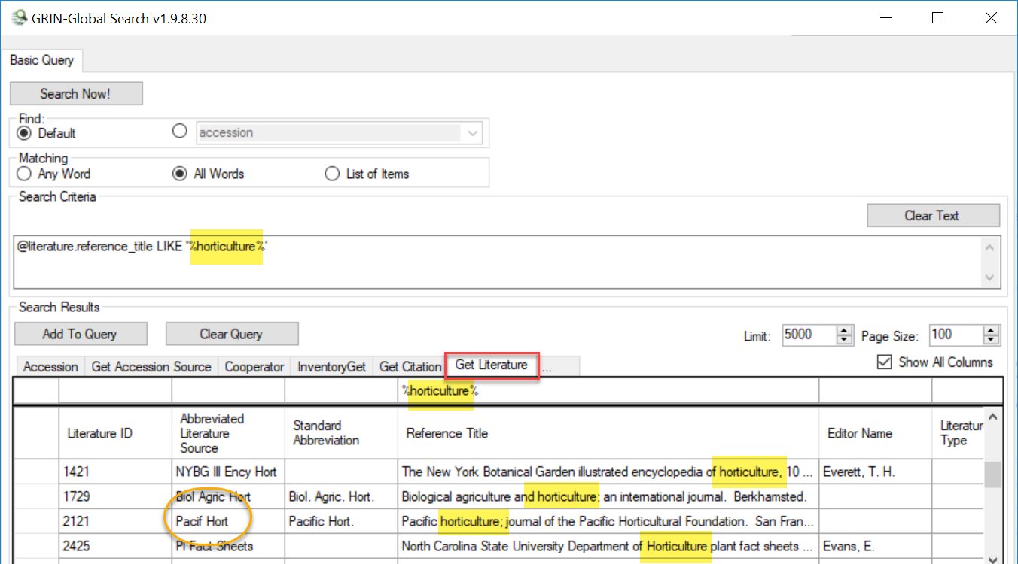
The data in the Literature table’s Abbreviated Literature Source field term will be used in the Lookup Table when entering Citations. The lookup links the Citation correctly to the Literature Table.
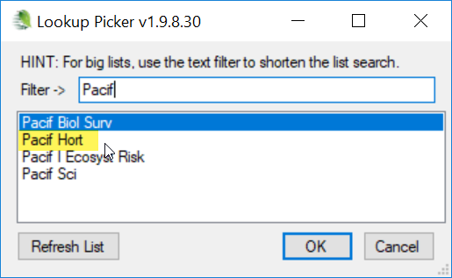
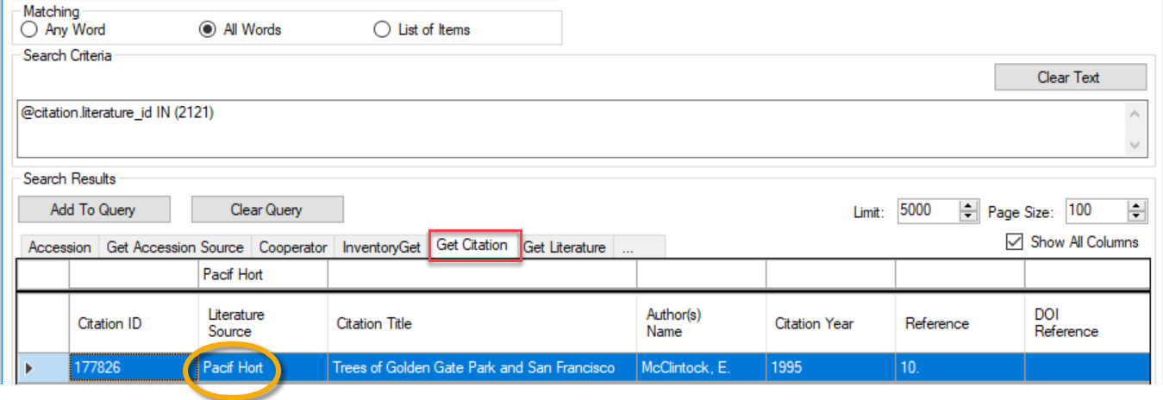

Creating a Citation
Rather than use the Citation dataview to input a new citation, use the citation dataview corresponding with the type of citation you are recording. For example, when recording an Accession IPR citation, use the accession_ipr_citation dataview.

Citation Dataview
The Citation dataview can be used to record any of the citation types, but it is simpler to use the respective dataview. When using the citation dataview, the citation type will be indicated by the completion of one of the eight numbered fields as shown in the second graphic below. The eight fields are mutually exclusive; complete only one of the eight fields. Each of these fields is a secondary key field that relates the citation to the respective record.
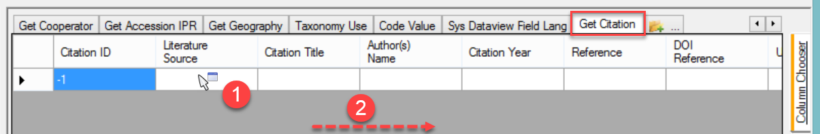
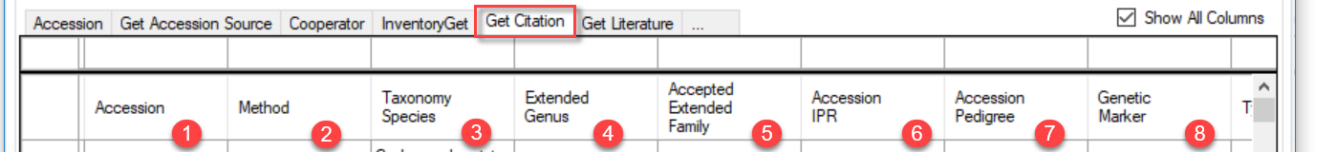
When citations are created in this Citation dataview, it is possible for a user to enter data in more than one of these fields. Definitely not desired because In the GG database, these fields serve as foreign keys and will not display properly in the GG public website.

“Specific” Citation Dataviews
The Accession Citation dataview is shown here as an example of the eight citation dataviews.
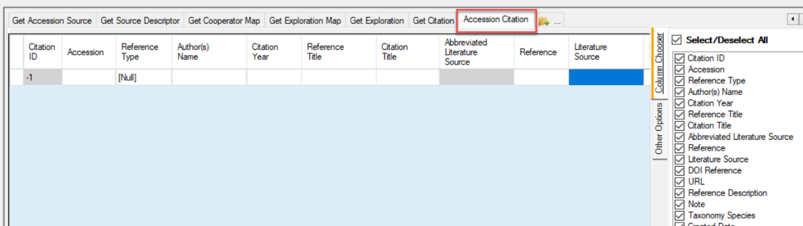

Accession
The Accession field is using the accession lookup table:
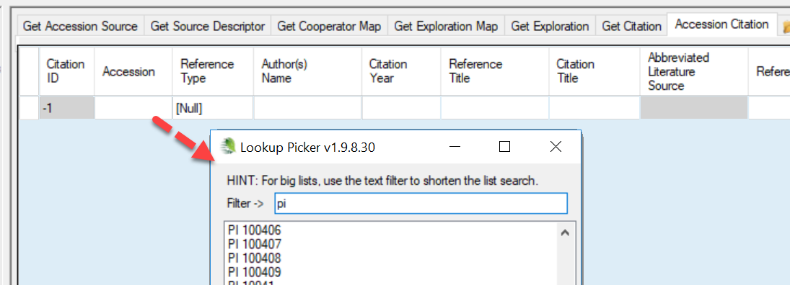

Reference Type
Uses a code from the Citation_Type Code Group. It should typically be Null as the other codes are used for certain taxonomy citations.
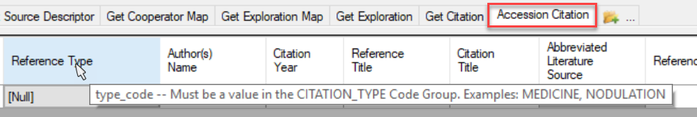

Citation Year
If you are entering an article from a journal, a citation from a series published over several years, or a work that is not in the Literature Table, add the year. If you are entering data from a book that is in the Literature Table and the date matches, you do not need to enter it as part of your citation. For display on the public website, the citation year will override the year(s) in the Literature Table.

Reference Title
This field is generally not used, but if you are citing a book, journal, or other work that is not in the Literature Table, the reference title (not the article or chapter title) should be entered here.

Citation Title
Enter article and chapter titles in this field. Capitalize the first word and any proper nouns (including genus), but make sure all other words are lowercase. Do not capitalize the first letter after a colon, and use only one space after a colon. Use italic html markups (<I>Rubus</I> or <i>Rubus</i>) around scientific names to have them italicized on the public webpage.
HTML code often uses beginning and ending tags. In this case, notice the italicize tags before and after the Rubus text. The beginning tag is an upper or lower case “i.” The ending tag </i> is similar to the beginning tag, but includes a forward slash, indicating the ending tag of a pair.

Abbreviated Literature Source
(Read only)

Reference
Enter the volume number, issue (optional), and page range here. Do not include the words “volume,” “vol.,” “issue,” or “no.” If the issue is a supplement, that should be indicated. If volume pagination is continuous, issue number is not required. If each issue or part is paginated separately, the issue number should be included. Enter the issue in parentheses directly after the volume, followed by a colon and the page(s) (no space). Use a period after the end of the page range or page. Do not enter DOIs here.
89:417-418.
34:e4702-1.
3(suppl.):26-29.
127(s1):117.

Literature Source
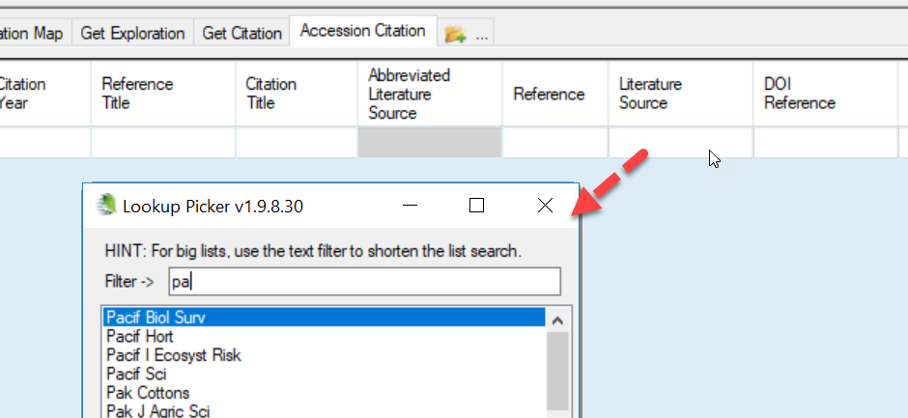
The Literature Source comes from the Literature Table. The field uses the lookup picker that searches for the abbreviated literature source value from the Literature Table. If you are not sure whether the work to be cited site has a corresponding Literature Table entry, or you do not know the abbreviation, use the search tool to query the table. (See To Search for Literature)
Requests for additions should be sent to the table’s manager. In NPGS, this is Melanie Schori, the Taxonomist. Names of journals, books, and websites are stored in the Literature Table. If you will be creating many citations from a different type of work (thesis or dissertation, report), request that it be added to the table.

Author(s) Name
Keep in mind that data are displayed exactly how you enter them in citations. For author names to be properly alphabetized, Smith, M. T. should be entered instead of Michael T. Smith. Diacritic marks (é, ñ, ö, etc.) can be entered directly using keyboard shortcuts or the character map feature of a computer.
For author names, use the standardized format below. Citations are alphabetized on the public website by the first word that appears.
Smith, A. R. – One author, last name first, period after each initial, single space between initials
Smith, A. R. & W. G. Fields – Two authors, ampersand between names, second author with initials preceding last name
Smith, A. R, W. G. Fields, & Y. Nakamura – More than two authors, use commas between authors and add ampersand before last author
Smith, A. R. et al. – More than two authors, another acceptable format, use period after “et al”
For authors with very common last names (e.g., Li, Y.), it is becoming acceptable to list the first name instead of abbreviating it (Li, Yichao). An article’s title or DOI are more useful search terms than a person’s first name.
Please do not just copy and paste author names from an article without ensuring they are in the correct format. Remember to remove asterisks or numbers that indicate corresponding author or author affiliations.

DOI Reference
Enter the raw DOI in this field. It should be a number that starts with “10.” The public website will automatically convert this into a link that will go to the appropriate site. URL prefixes change over time (http://; https://; http://dx.doi.org; http://doi.org) should not be entered here. Please do not store the DOI in any other field.

URL
If there is a website associated with the cited work, it can be entered here. Please do not provide a URL for the DOI. It is not necessary to provide a separate URL to an article or work that is available through the DOI.

Reference Description
This field is not generally used; however, it can be supplied for works that are not in the Literature Table.

Note
Other information that does not correspond to one of the other fields can be entered here. Please do not use this field for DOI or URL entries (unless you have multiple URLs associated with a work).

Searching for Citations
To find citations which you own, run the following query in the Search Tool; use the get_citation dataview as the active dataview. Determine your cooperator_id or use the davatiew to supply it:
@citation.owned_by = your_cooperator_ID
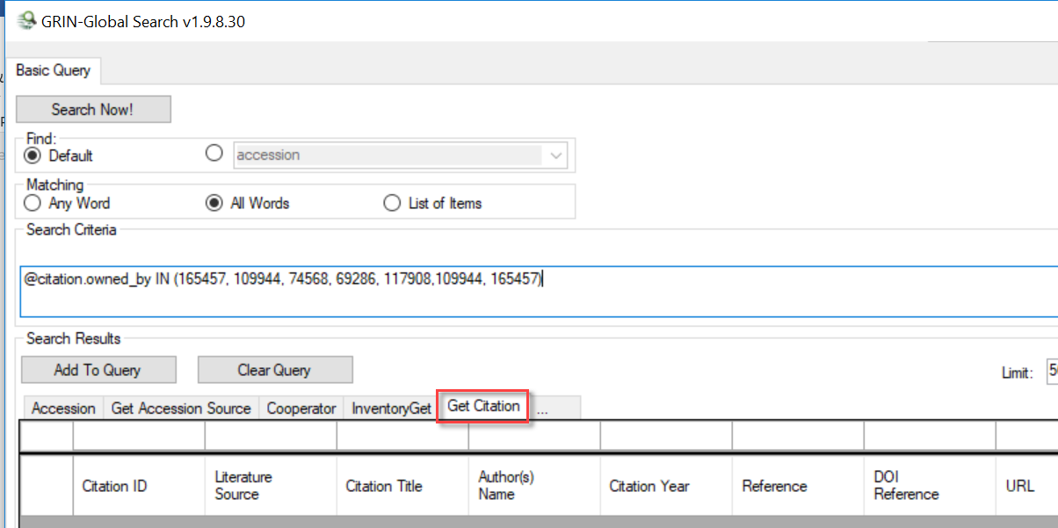
For most searches with the Search Tool, the Default query resolution works well, but citations are an exception – the linking is a bit complicated. When using “Default,” the Search Engine (SE) will link the accession to the citation by the accession link and only return accession citations, ignoring the others.
In order to return IPR citations, the SE needs to be told to provide the dataview with Accession IPR primary key IDs rather than the default citation primary key IDs (which is how the SE usually links directly to accessions). To provide the Accession IPR primary key IDs in the Search Tool, change the resolved to the Accession IPR table (accession_ipr):
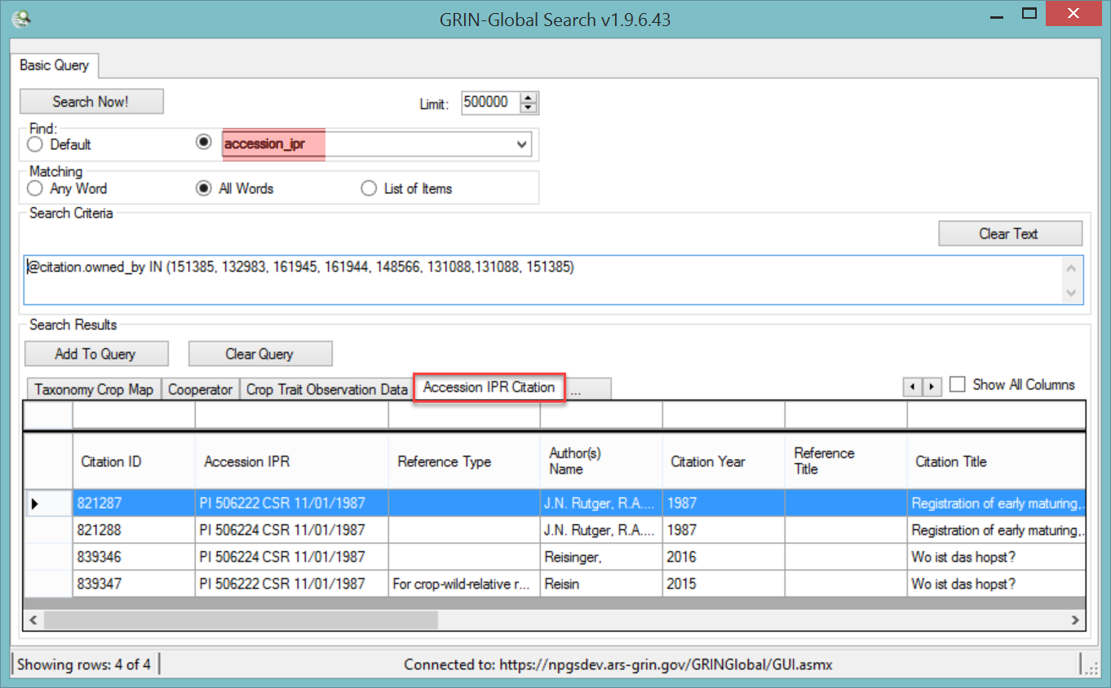
When you drag the generated code from the Search Tool’s text box to the Curator Tool, the resolver will be included in the dynamic folder properties:
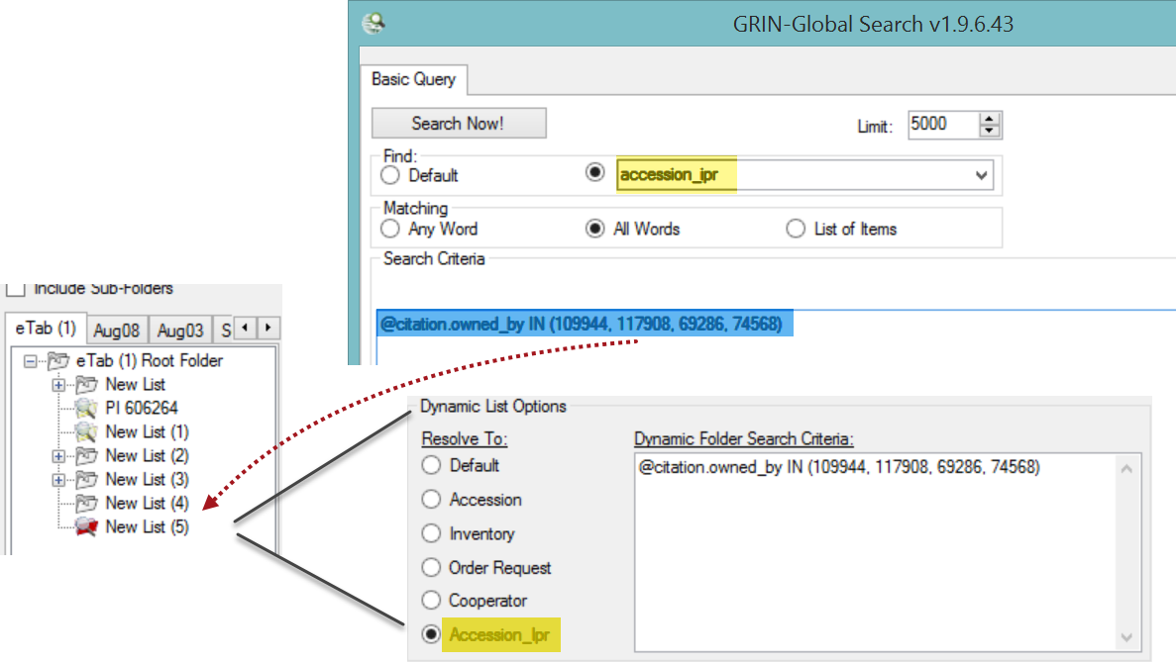

Citation Resolvers
The table below indicates what table to specify when searching for a particular citation type. Typically, you’ll select the dataview and the table name listed for the radio button.
Dataview | Typically Resolve to*
get_accession_citation | accession
get_accession_ipr_citation | accession ipr
get_accession_pedigree_citation | accession pedigree
get_genetic_marker_citation | genetic marker
get_method_citation | method
get_taxonomy_family_citation | taxonomy family
get_taxonomy_genus_citation | taxonomy genus
get_taxonomy_species_citation | taxonomy species
get_citation | (“Default”)
* the Find Radio Button option

Revision Notes

- February 5, 2024
updated citation record screens reflecting field changes
- May 28, 2020
Original document

