GRIN-Global

Curator Tool Login / Password Guide

Revision Date
December 8, 2022

Author
Marty Reisinger

This guide explains logging into the GRIN-Global Curator Tool (CT) and provides details for the CT as well as the organization’s GG administrator.
A browser-based, password utility for updating CT passwords is also explained.
Appendix A contains this document’s revision notes.
Review the Table of Contents which contains links to the document’s sections.

Comments/Suggestions:
Please contact feedback@ars-grin.gov or marty.reisinger@usda.gov with any suggestions or questions pertaining to this document.

Contents
Related Resources 3
GRIN-Global Documentation Website 3
Videos Illustrating Curator Tool Concepts 3
Starting up the Curator Tool 4
Starting the GRIN-Global Curator Tool 4
Starting Up the CT 4
Username and Password 5
(Optional) To add or delete servers from the Connect To list 6
Default Example 7
Changing Passwords 7
Locked out? 8
Password Guidelines 8
NPGS Password Guidelines 8
NPGS Passwords 8
Logging on to the CT 8
Reset Password Utility 9
URL 9
NPGS: https://npgsweb.ars-grin.gov/ggtools/Login/RequestPasswordReset 9
Submit a Curator Tool Password Reset Request 9
Common Error Messages 12
Invalid Username 12
Non-matching Passwords 12
Frequently Asked Questions (FAQs) 13
Q: Can I change my password immediately after changing it with the password utility? 13
Administrator Notes 14
Appendix A: Document Revision Notes 15
– December 8, 2022 15

Related Resources

GRIN-Global Documentation Website
Links to various GRIN-Global documents, videos, project history, etc.
https://www.grin-global.org/
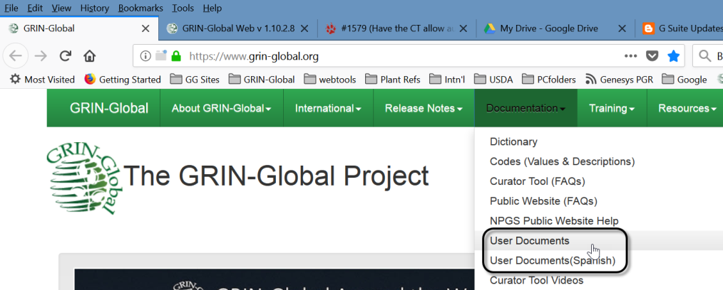
This and other GRIN-Global–related documentation can be downloaded from the GRIN-Global documentation website. See especially https://www.grin-global.org/userdocs.htm. Many topics discussed in this general user guide are explained in detail in their respective documents.

Refer also to the guide: “Connecting to GG Servers” at
http://grin-global.org/docs/gg_connecting_to_servers.docx

Videos Illustrating Curator Tool Concepts
These videos illustrate basic Curator Tools concepts and features:
https://www.grin-global.org/videos.htm

Starting up the Curator Tool

Starting the GRIN-Global Curator Tool
The Curator Tool (CT) must be installed on your PC. Complete instructions for installing the CT are online at the GG Project website. See http://grin-global.org/download_ct.html

Starting Up the CT
In a new CT installation, a default “localhost” might be displayed as the possible GRIN-Global server. 99.9% of the time, this is not a valid option. “localhost” is indicating that the GG database resides on the user’s own PC. Typically an organization installs the GG database on a separate remote server, so localhost is a rarely used option.
If the Connect To: dropdown does not indicate any other option, then contact your organization’s GG administrator. You need to know the specific server details and then add that to the CT’s server settings. (See Connect To: for examples.)
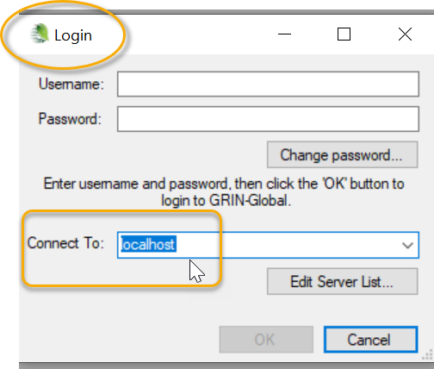

Username and Password
To access the CT, you need a Curator Tool Username and Password. The username may be your email address, but not necessarily. The username and password are assigned by the genebank’s GG Administrator.
GRIN-Global has two major user components: the Curator Tool (CT) (and the closely related Search Tool (ST)) and the GG Public Website. The CT and ST use the same user account and password; the Public Website uses totally different account information. Note that in some organizations, the two accounts may appear identical, but this is not always the case. For example, the CT and the PW may both use the user’s email address for the Username, but the CT and the Public Website can have two different passwords.

1. On the Windows Start window, select the GRIN-Global Curator Tool program button:
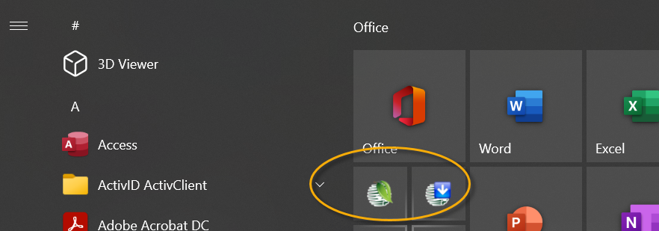
2. In the CT Login window, input Username and Password. Use the Connect To: box to select the database server’s name; click OK.

Most organizations typically have only one server listed, and users are limited to that server. A stand-alone document is online at https://www.grin-global.org/docs/selecting_gg_server_CT_PW.docx GG administrators can customize this document to include their specific server details.

In the following example, the user, a tester who accesses multiple databases, has DEV as his default server. (The user intentionally listed it first since he uses it more than the others.)
The List Display Name “PROD uction” is a user-created name that is meaningful to him. The actual server name for the NPGS production GG database is highlighted in yellow. Since NPGS is using Secure Sockets Layer (SSL) security, the Use SSL checkbox has been selected.
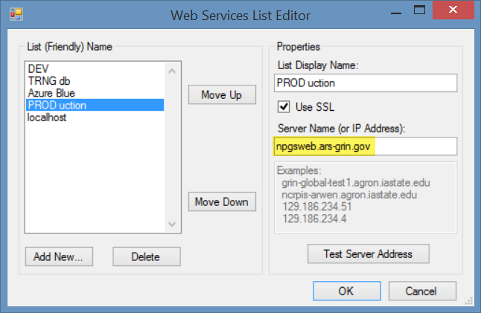
- List Display Name – input any text (meaningful to you) for this box
- SSL – GG administrator will indicate if SSL must be checked
- Server Name / IP Address – unique to each organization. Contact your organization’s GG administrator if you do not know what server name to use.

(Optional) To add or delete servers from the Connect To list
Click the Edit Server List button.
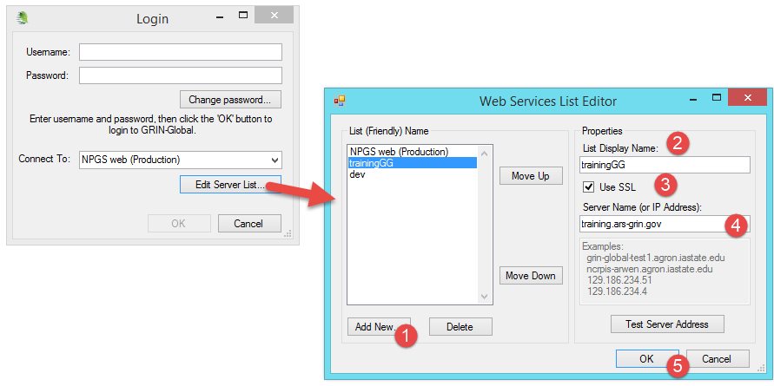
To add a server to the list: in the List Display Name box (2), input a meaningful name; select SSL if your organization is using SSL; input the correct server name or IP address (4); click OK.
To delete: click on the name in the list of names in the left box; click the Delete button.
Adjust the list’s order in the left box by selecting a server name and then clicking on the Move Up or Move Down buttons. Position the server which you will use most often at the list’s top. The top server displays as the default server when you log in.

Default Example
The default (or only) server will be listed in the Connect To: dropdown box. In the following example, the default server is  PROD uction:  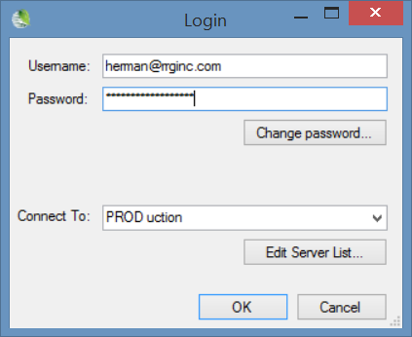 | However, when other servers are available, it is possible to select a different one from the dropdown. This example is from a Curator Tool tester who uses many different servers.  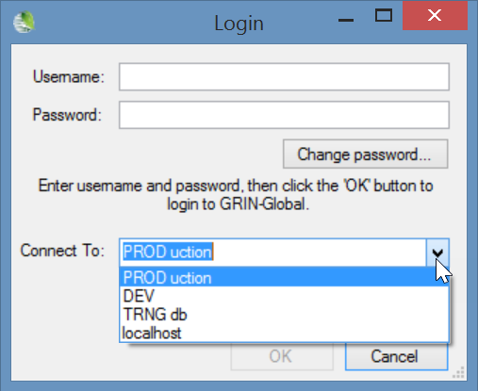

Changing Passwords
In the CT, if you do not know the password, contact your GG administrator. Also do so if the password has expired. However, some GG organizations have set up a password utility so that you can reset your own. See Reset Utility

Click the Change password button on the Login window:
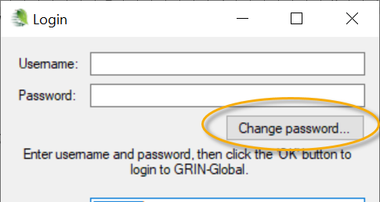
Alternatively, if you are already logged into the CT, select File | Change Password from the menu. 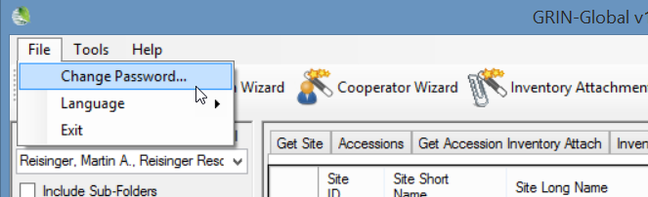
Complete the Change Password window.
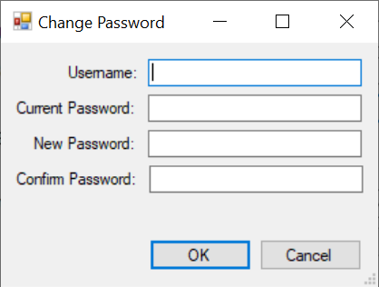

Locked out?
Each GG organization can establish how many failed login attempts are allowed before the user is locked out. After the specified number of failed attempts, the CT user will be prevented from logging in and the must wait a specified time. Organizations typically specify 15 or 30 minutes.

Password Guidelines
Organizations implementing GRIN-Global can determine their own organization-specific password requirements. The organization’s GG administrator controls the lockout time parameter and other password settings (via the Admin Tool) and should indicate the organization’s requirements to the Curator Tool users.

NPGS Password Guidelines
In NPGS, the username is often, but not always, the user’s email address.

NPGS Passwords
Passwords must follow the current ARS guidelines:
- 12 characters minimum
- at least one of each are required: upper case, lower case, digit, and special character
- passwords can change only once per day
- five failed logins initiate a temporary lockout for 15 minutes
If a password is forgotten, contact the GG administrator to create a new one.

Logging on to the CT
For NPGS, VPN or being on the ARS network is not required for the production or training databases, but VPN is required when testing and using the “DEV” database.

Reset Password Utility
A GRIN-Global password utility was created in 2022 to enable users to reset their Curator Tool password without requiring the involvement of the GG administrator. When an organization implements this utility, users can fill out an online form and ultimately change their password.
This utility is currently not bundled in the traditional GG build. If an organization intends to use this utility, please contact Benjamin.haag@usda.gov
To invoke the password utility, the steps are:
Directions (images below):
- In a browser window, user starts the password utility via its URL
- User submits a request to change the password;
a response screen displays an immediate confirmation (that the username is valid or not)
- Valid Curator Tool users will receive an email with a link
(an invalid username will generate a red warning; in that case, try again or contact the GG administrator [More details]
- When the user clicks the email’s link, the password form is displayed in which the user inputs the new password (twice); then clicks Save.
- A confirmation window displays.
At this point, the password is immediately effective for the number of days predetermined by the genebank GG administrator. For example, at NPGS, passwords expire after 60 days.

URL

NPGS: https://npgsweb.ars-grin.gov/ggtools/Login/RequestPasswordReset
Your genebank’s URL: (provided by the genebank’s GG administrator):

Submit a Curator Tool Password Reset Request
Input your CT username; click the email button:
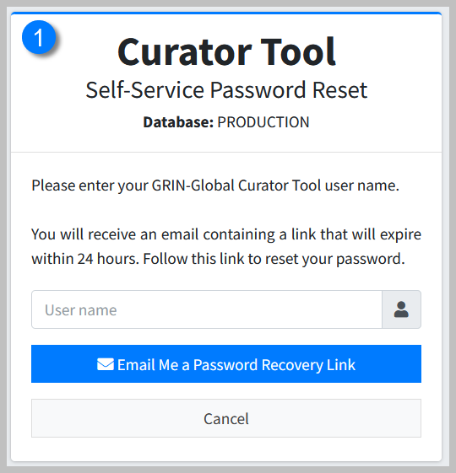

The browser screen should then immediately display a notice:
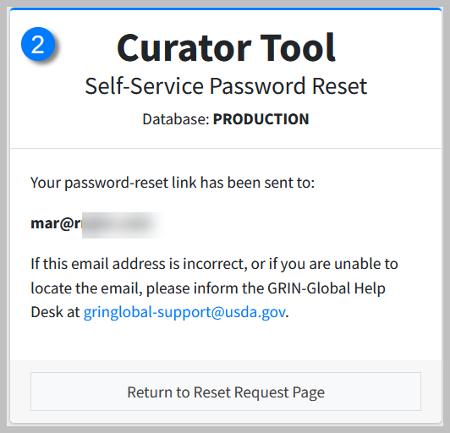
You will receive an email with a clickable link, similar to the following. Click the link.
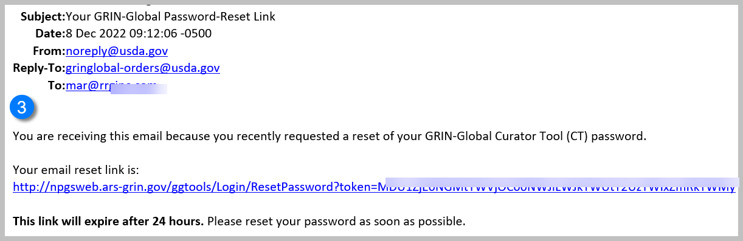
The form that displays will require you to enter your new password twice – do so; click the button to proceed. (Each GG has their own password requirements; they are listed on the form.) Click the Save button.
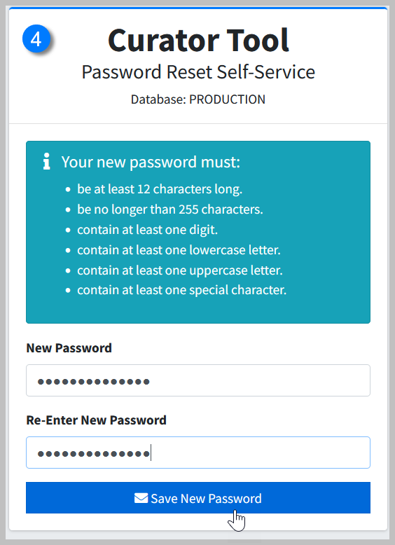
If successful, you will receive a confirmation screen:
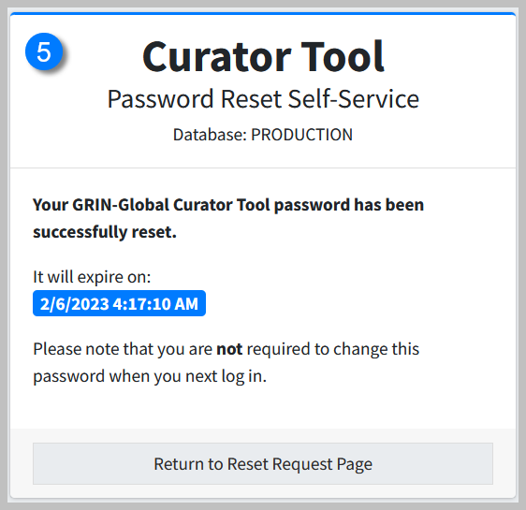

Common Error Messages
Invalid Username  The utility searches the database for a matching username; when it doesn’t find a match, the following message displays. In this case contact the GG administrator who can indicate what your username is.  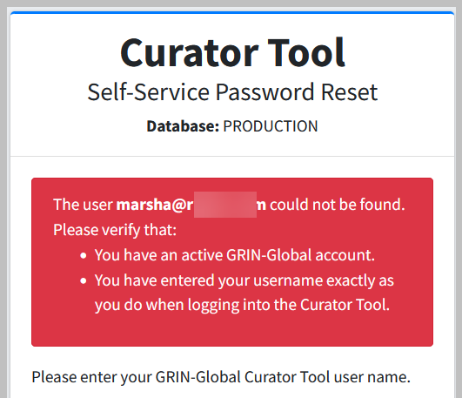 | Non-matching Passwords  You must enter the same new password twice. Try again!  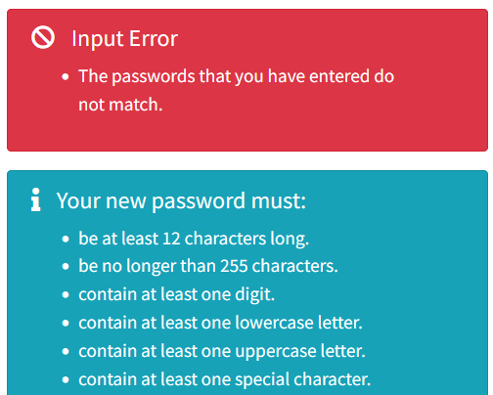

Frequently Asked Questions (FAQs)

Q: Can I change my password immediately after changing it with the password utility?
A: Yes.

Administrator Notes
Administrators: the web.config file contains various password parameters that can be modified, such as the number of required characters, number of attempts before locking out the user, etc. Refer to the GG Administrator’s Guide.

Appendix A: Document Revision Notes

– December 8, 2022
- new document

